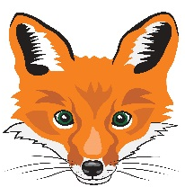
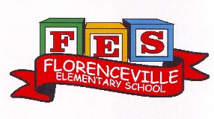
FLORENCEVILLE ELEMENTARY SCHOOL
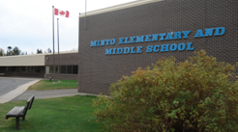
At FES our vision is to be a community where everyone is empowered to be lifelong learners.
PRIMARY HOME LEARNING PLAN

Grade: | 1/2
TEACHER | Andree Charlebois : andree.charlebois@nbed.nb.ca
Sarah Mahar  Bridget Nugent | Principal: sarah.mahar@nbed.nb.ca; Vice-Principal: bridget.nugent@nbed.nb.ca;
Cindy Crowhurst | Resource: cynthia.crowhurst@nbed.nb.ca
Dianne Lord | Guidance: dianne.lord@nbed.nb.ca
School | florencevilleelementary@nbed.nb.ca

In accordance with the communication sent from our NB Minister of Education, Dominic Cardy, on April 2, 2020 Home learning opportunities to support literacy and numeracy outcomes will be made available online weekly by teachers.

Families are encouraged to:
-support your children to complete the options below for an average of one hour per day
-read aloud with their children daily
-consider daily physical activity and free play as an important part of their child’s mental health and skill development.

Subjects | Description of Learning Activities – Week of June 1st – 5th  **PLEASE FEEL FREE TO RE-VISIT ACTIVITIES FROM PREVIOUS WEEKS**
Literacy | Activity 1: Continue to read, read, read!! There are hundreds of books on the following sites:  https://www.getepic.com/  https://www.abcya.com/  https://www.starfall.com/h/  www.kidsa-z.com  Activity 2: Continue to enjoy “From 3 To 3” rhymes/oral stories. Feel free to watch both grades!  Kristina Little (Gr. 1): https://www.youtube.com/watch?v=76Rs98IaE0s&feature=youtu.be  https://www.youtube.com/watch?v=pFlxBGalcoE&feature=youtu.be  https://www.youtube.com/watch?v=HCFaLL1Zmqg&feature=youtu.be  Karah Rhymer (Gr. 2): https://drive.google.com/file/d/1dw_5EqIDtpGLdELtacdbG7y6Nx9bBFQn/view  Read aloud: “King of the Birds”  https://drive.google.com/file/d/1SBT-zErL2EYTTy94RhMwC4V8MGks2_oB/view  Activity 3: Reading Response:  Enjoy the book “Rot, the Cutest in the World” by Ben Clanton”:  https://www.youtube.com/watch?v=suFLIvLvmgU  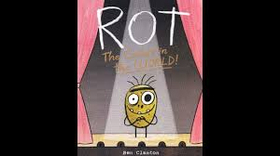  Read this book and talk about it with a family member. What is beauty? What things do you find to be beautiful? Do you think your ideas are the same as other people’s ideas of what is beautiful?  Look around you, look out your window and look into your imagination. What do you see that is cute or beautiful?  Write 4-5 things that you think are beautiful. Create a book and draw a picture of each beautiful object on your list. Does it have to be an object? Could it be a feeling or experience? Write what it is that you find beautiful underneath your picture.  Share your pictures or booklet with others!  Activity 4: Writing  Option 1: Continue working on your choice of Life cycles (insect, animal). Once you are done your picture or book, please email it to me!! I would love to see it!  To help with your research, use the child-friendly search engine Kiddle: https://www.kiddle.co/  Option 2: Persuasive Writing  Continue writing if you started this last week…. Again, I would LOVE to see what you have written. Please take a picture and email it to me!!!  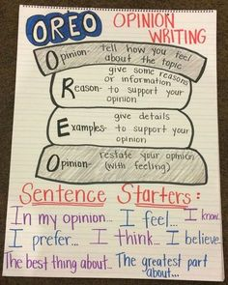  Activity 5: Sight Word Fun!  Sight Word Puddle Jumping:  Write your sight words on a piece of paper (it doesn’t have to be blue!) and place them on the pavement outside. Jump on them and say them. Afterwards, spell them on your whiteboard with erasable marker!! Have fun!  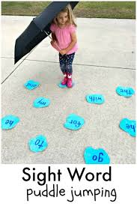  BAM! Your child has played this in class and they love it! Get some popsicle sticks, write some sight words on them and have 5-6 sticks with the word BAM on it (write the words at one end of the stick). Put the sticks in a cup (make sure you can’t see the word). The picture has the word “Dynamite” instead of BAM (in case you are wondering if that is a sight word – it’s not!).  Rules:  - Take a stick and say the word (close your eyes)!  - Take turns. If you take a stick with the word BAM on it, you have to put ALL of your sticks back.  - Partner with the most sticks wins (but we all win).  - Challenge: at the end of the game: turn all popsicle sticks over and spell them! Have fun!  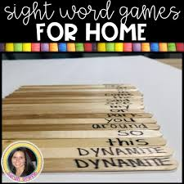  With sidewalk chalk, create a hopscotch. Write some sight words in each square and play!  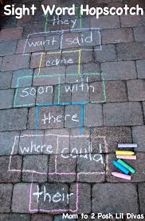
Numeracy | Activity 1: Continue having fun playing math activities from the following site!  Math Playground.com: https://www.mathplayground.com/math-games.html  Activity 2: Mental Math (doubles + or -2) We have played this in grade 2 only but if your grade 1 child wants to practice it, great!  See the attachments to this email. Print the Tic-Tac-Toe game and if you don’t have a printer, write it on a piece of paper.  Put the game in a plastic pocket and use your erasable markers. Have your child explain their strategy before putting their X or O.  Example : Doubles plus 2 strategy: 7 + 9 =  Think : 7 + 7 = 14  I don’t want to just add 7 to the 7, I want to add 9 which is 2 more  So 14 + 2 = 16  OR  Think: 9 + 9 = 18  I don’t want to add 9 to the 9, I only want to add 7 which is 2 less  So 18 – 2 = 16  ***The following link gives another good explanation for the strategies of Doubles +/-1 and Doubles +/- 2! https://www.youtube.com/watch?v=1YQQijRE8CY&list=RD1YQQijRE8CY&start_radio=1  Activity 3: Students (from either grade!) can choose any activity from the following:  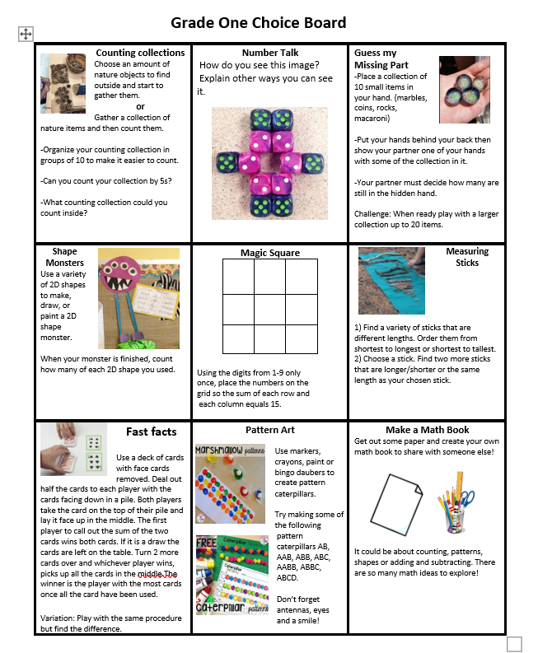  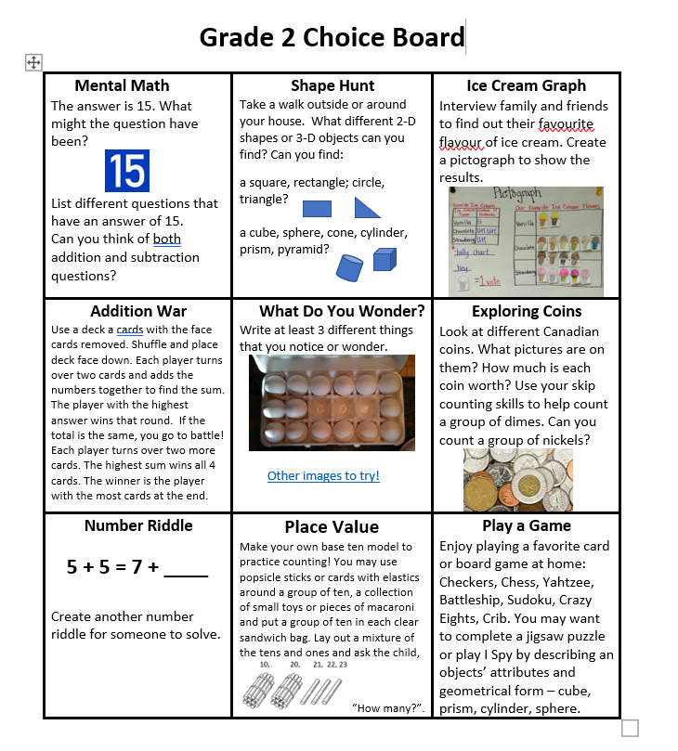  Activity 4: Partner Numbers to 10 Game:  First enjoy the “Friends of 10” Jack Hartmann video:  https://www.youtube.com/watch?v=73av5oijolU  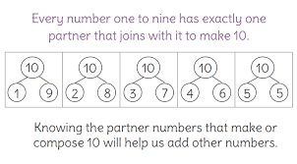  This is a very important concept!  Rules: Get 10 counters (macaroni, beans, anything small that you can find in your house).  *1 partners puts some counters in each hand (max. of 10) while the other partner closes their eyes  *the partner opens their eyes and points to a hand  *that partner shows the counters and the other person guesses what is in the other hand  Example: 3 counters are shown so he/she guesses 7 in the other hand!  Have fun!!!  Activity 5: Addition Game outside  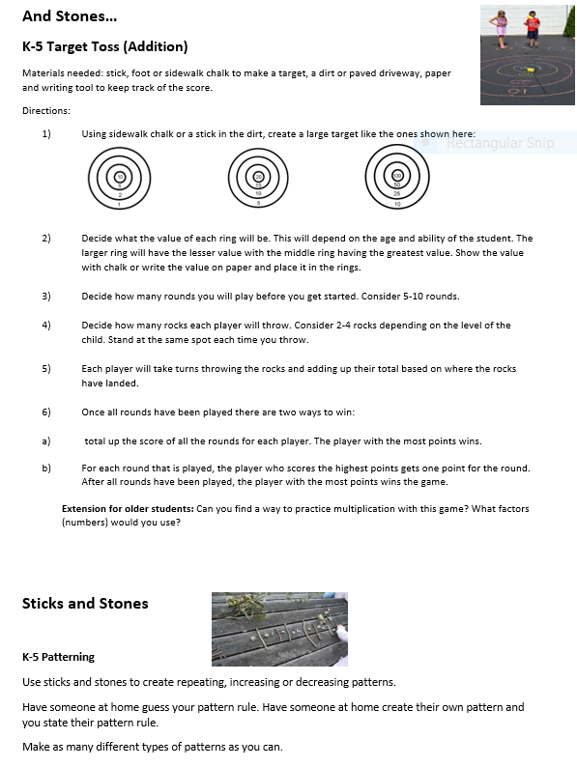
Other areas of interest/learning experiences | Enjoy this French video “Learn French for Kids: Food, Activities and Animals  https://www.youtube.com/watch?v=CN6ttL6MhQY  Phys Ed:  It’s Heart Healthy Week!  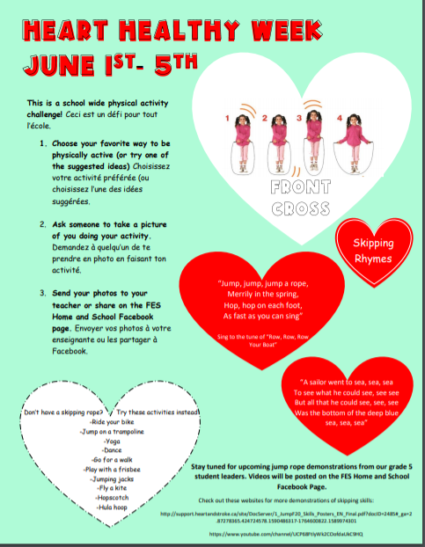  Move with Jack Hartmann (new video)  https://www.youtube.com/watch?v=8jMmZaFvRpE  Popcorn and the Pirates / A Cosmic Kids Yoga Adventure: https://www.youtube.com/watch?v=T_0P5grVoyg
 | 