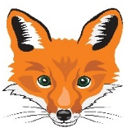
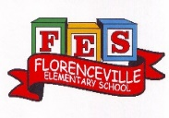
FLORENCEVILLE ELEMENTARY SCHOOL
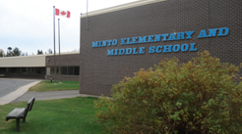
At FES our vision is to be a community where everyone is empowered to be lifelong learners.
HOME LEARNING PLAN
May 4- May 8 2020

class | 5B
Teena Bishop | teena.bishop@nbed.nb.ca
Sarah Mahar  Bridget Nugent | Principal: sarah.mahar@nbed.nb.ca; Vice-Principal: bridget.nugent@nbed.nb.ca
Cindy Crowhurst | Resource: cynthia.crowhurst@nbed.nb.ca
Dianne Lord | Guidance: dianne.lord@nbed.nb.ca
School | florencevilleelementary@nbed.nb.ca

In accordance with the communication sent from our Minister of Education, Dominic Cardy, on April 2, 2020 Home learning opportunities to support literacy and numeracy outcomes will be made available online weekly by Teachers.

Families are encouraged to:
-Support their children to complete the options below for an average of one hour per day.
-Read aloud with their children daily; and
-consider daily physical activity and free play as an important part of their child’s mental health and skill development.

Subjects | Description of Learning Activities
Literacy
Oral Language- Listening to music and shows in French is a great way to review and develop your oral language. Here are some suggestions of things that you can listen to and watch. (You can slow the speed of videos down when you are watching YouTube.)  Listen to these songs:  Savez-vous planter les choux  https://www.youtube.com/watch?v=iAGV2pcLaAg  L’arbre est dans ses feuilles https://www.youtube.com/watch?v=ZE6tuXy4Xfw  Le printemps, Matt Maxwell https://www.youtube.com/watch?v=yKKWNJ8qsss  J’aime les fruits -Alain le Lait https://www.youtube.com/watch?v=nJ03KjwiIVM  Videos/shows to watch:  Do you want to challenge yourself? Watch ‘’C’est pas sorcier: les fruits et les légumes’’  https://www.youtube.com/watch?v=OiD2vU9QqmQ | Reading – (Students are encouraged to read in both French and English throughout the week). Talk about books that you read (or movies that you watch) by discussing some of the following questions:  - If you had to pick two main characters in the story, who would they be?  - If you could change the ending to your story, what would you make it?  - What is the main message of the story?  - Are you able to tell me what happens in the beginning, in the middle and in the end?  Here is a French book that you can listen to on YouTube called Le jardin voyageur.  https://www.youtube.com/watch?v=wn7d-HrRJZw  If you do not have French books at home, there are websites that you can access French books. Explore these and read (or listen to) French books that are a “good fit” for you (not too hard, not too easy). https://boukili.ca/fr  https://www.readinga-z.com/worldlanguages/french/leveled-books/
Word Work:  -Visit this website to play an archeology deciphering game. (you must first identify the letters associated to the image and then find the word in the grid).  https://www.lumni.fr/jeu/archeocode  -Using the gardening word list below (or word wall list) to practice 5 words a day by rolling a dice and following the instructions: | Writing – Here are a few writing ideas for this week.  You can choose one to work on throughout the week or a different one each day. If you want to go back to last week’s ideas, please do so. Don’t forget to make sure that you use capital letters and punctuation where they belong. Think about who will enjoy (or learn from) reading your writing after you are finished.  - Think of your dream garden. Make a list of seeds you might need to make it a reality. Organize your list in categories and in alphabetical order. (example of categories; fruits, vegetables, flowers, trees)  - Create a comic strip (template sheet is available at the end of the document or you can create your own) about the steps you might have to take to create your garden.  - Create a crossword puzzle using the new vocabulary words that you have been learning about gardening.  - Create a card for your mother or grand-mother or even for a special lady in your life for Mother's Day!

Numeracy  Material needed for this project:  -Paper  -Pencil  -measuring tools  -seed packets (optional) | Planning a Garden:  This week your challenge is to begin planning a garden. As you begin to make your plans, consider the following questions:  - What type of garden will it be? (Flower, vegetable, herbs, indoor/outdoor)  - How big will your garden be?  - What will you plant in your garden?  - Will you plant seeds or plants?  - How far apart do you need to plant your seeds/plants? (How will you find out this information?)  - What do you need to do to get ready to plant your garden?  - If you are using seeds, are there any that will need started inside beforehand?  Sketch out the plans for your garden and include as many details of the above details as possible.
 | Math Games | Math Challenge  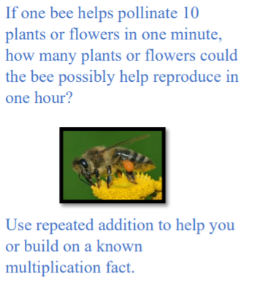
Twenty -one
Material needed: 1 to 3 die, paper and pencil
- Roll 3 dice or a dice three times.
- Using the numbers rolled you can add, subtract, multiply or a combination to make a total as close to 21 as possible. Record your number sentence.
- Earn 1 point if your number is closer to 21 than your partner’s.
- Earn 2 points if you get exactly 21.
- After 5 rounds winner has the highest score.

French Online Math Games:
https://www.jeuxmaths.fr/jeux-de-maths-en-ligne.html

Other areas of interest/learning experiences  Science & Arts: | Science:  This week we will be planning a garden. You might already have seeds that are ready to be planted inside your home. Maybe your parents bought seeds from the store, or you collected some while eating fruits or nuts. Or maybe, you went outside and found seeds from dried out flowers or trees.  - What will you use to plant them in? Will it be plastic containers, newspapers, egg cartons or eggshells maybe? Let me know what you came up with to plant your seeds.  - What will you use to get your seeds to start sprouting? Will it be soil you can buy in a bag or dirt you can get outside? Do you even need soil to get your seeds to sprout? Think or research different way you can get seeds to sprout and try it out.  - Don’t forget to water them!  Here are some videos to watch to learn more about planting and growing plants, fruits and vegetables.  - The magic school bus gets planted  https://www.dailymotion.com/video/x6vejxv  - These ones are my most favorite ones to watch. It’s called garden answer. I learn so much from watching these videos.  https://www.youtube.com/watch?v=x58akTXlmsY  Art:  Using recyclable material, make some labels to write to name of the seeds you will be planting and stick them in the soil with your seeds.
English Language Arts | Reading:  Try to read at least 30 minutes each day. I know many of you love to read, so keep it up!  If you run out of books at home, don’t forget about soraapp.com. You can use the website version or download the free app on your tablet or phone. You will need your school username and password to access the books. (*school name is New Brunswick Department of Education and Early Childhood- not Florenceville Elementary). Send me an email if you need help!  (this is what the app looks like)  Writing:  Since Mother’s Day is this coming weekend, it would be nice if you did a little something special for the mothers and/or grandmothers in your life. Here are a few ideas. Use your creativity.  - Write a poem for her  - Write a letter telling her what you appreciate about her  - Make a comic strip story about her  - Write clues to a treasure hunt for her  - Write a song for her  - Make a card for her  - Make coupons for her  - Write a list of some of the best memories that you have with her  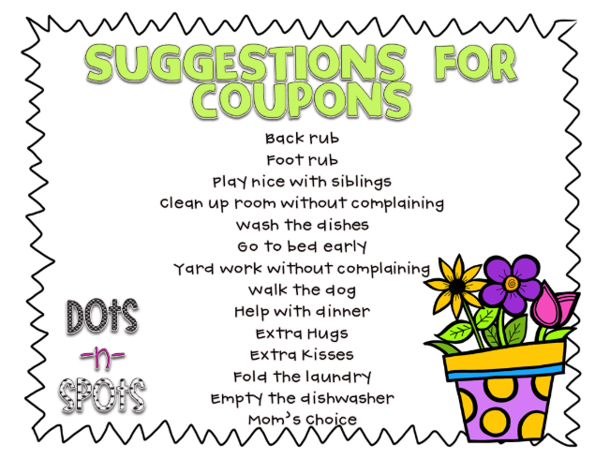  Here are some examples of poems:  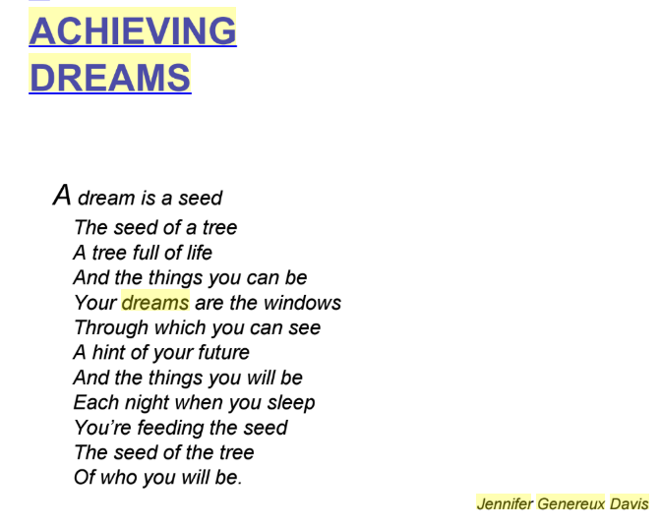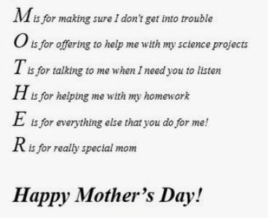  I would love to hear from you. If you can, send me an email at sarah.mahar@nbed.nb.ca. Tell me how you have been passing the time, what you are reading or even share some writing! Take care- miss you all.
Mindfulness | Here are three ideas of things you can do to help you feel calm, relax and mindful during spring.  - Turn-on your “Spidey senses,” or the super-focused senses of smell, sight, hearing, taste, and touch that spiders use to keep tabs on the world around them. Pause and focus your attention on the present, open your awareness to the information you are sensing.  - Have a ‘mindful’ snack by describing the smell, texture and taste of the food.  - Explore gratitude by going back and forth with a family member (for as long as you can!) to name as many things possible that you are grateful for.

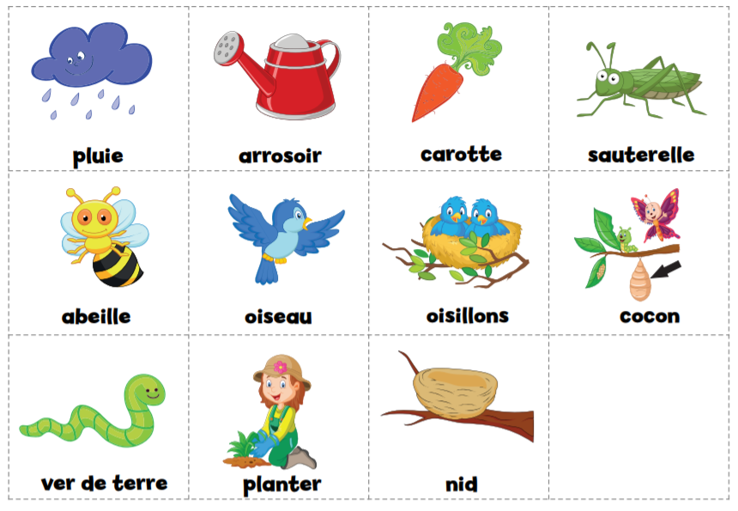
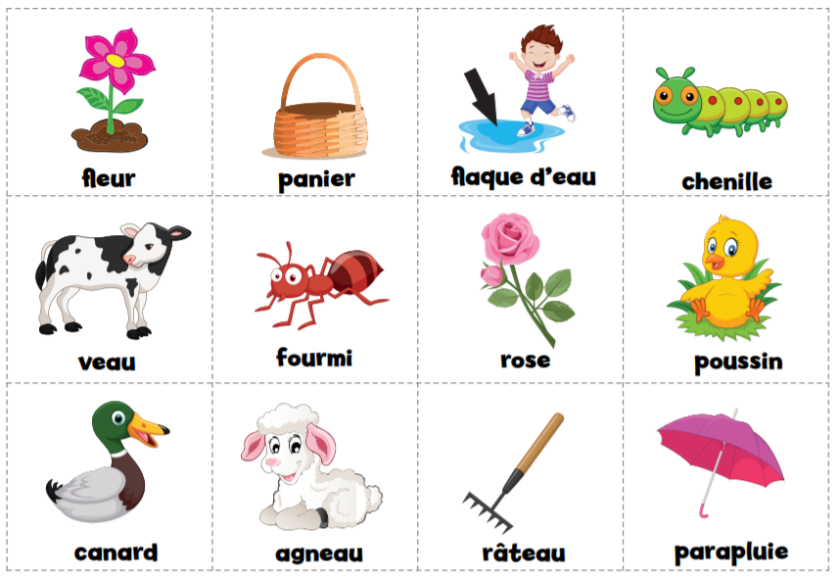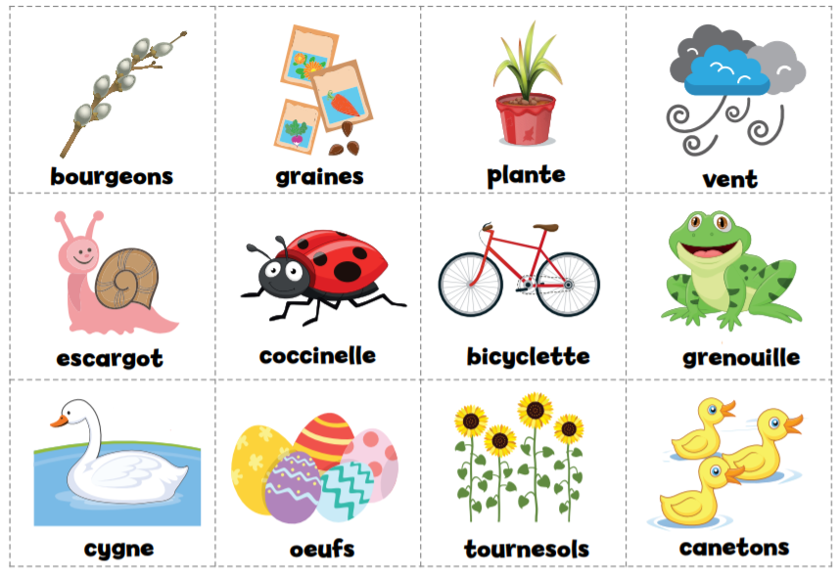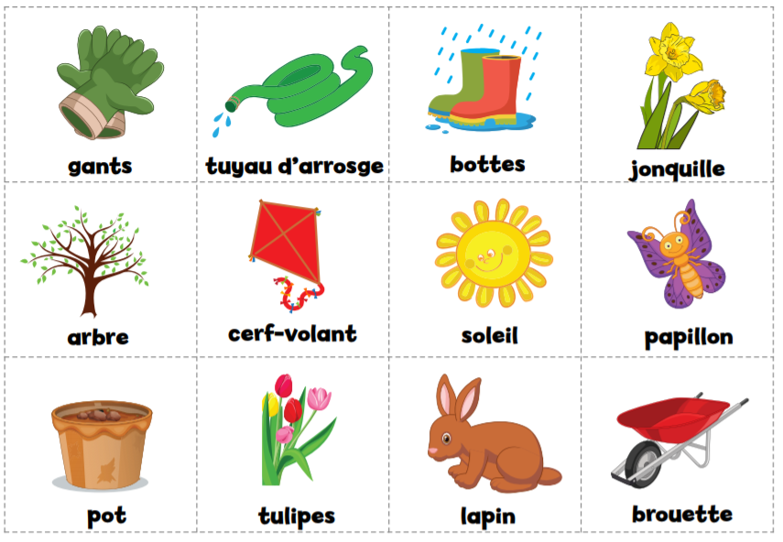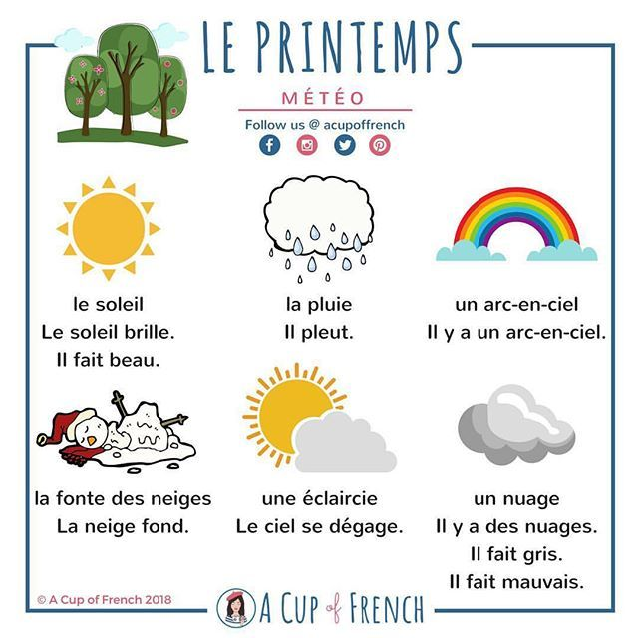

Crossword Puzzle Grid

