Create a3D structure that resembles a robot using any items around the house. You could use blocks, lego, boxes, recyclables, get creative!  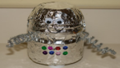 | Gather some blocks, lego, boxes. Place a deck of cards between you and a partner. The first player flips a card and begins a tower using the number of blocks that was on the card.  The next player flips a card and adds that many blocks to the tower. Continue playing until the tower topples!  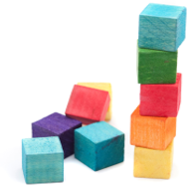
Go outside and record on a graph how many birds, bugs, worms, butterflies you see.  Birds  worms  bugs  butterflies  Which has more? Which has fewer? Do any have as many as? Make a true statement using the word more/fewer? 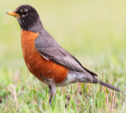 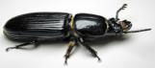 | 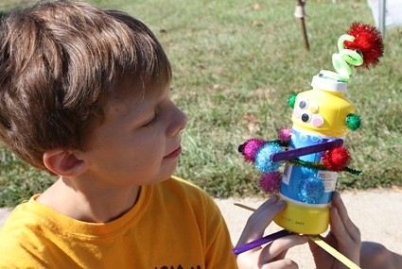  Draw a picture of your Robot creation and write about it. What will you name it? What does it do? Where would it live? Does it have a superpower? If so, what is it?
Draw a picture of what you ate for breakfast and write 2 sentences about it. Remember to use your No-Excuse words, periods, capitols, and good spacing between your words  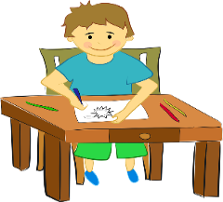 | 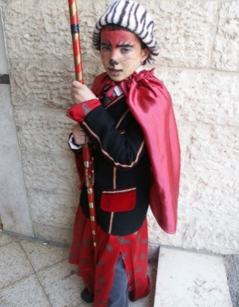  Pretend you are a character from one of the books you read and write about how you would have felt during the story!
Home suggestions for Kindergarten week 7 May 11-15

