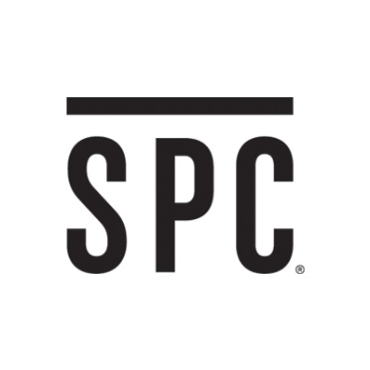
GET MORE WITH SPC
Save more when you shop.

GET YOUR SPC CARD NOW & SUPPORT YOUR SCHOOL!
SPC Card is a student discount program for students with offers and discounts at Hundreds of stores and restaurants across Canada.

If you are a student, simply present your SPC Card at participating retailers and you instantly receive discounts on each visit, it’s that easy!

Offers vary, but generally around 10 to 15%.

Some partners include:

• Aerie
• ALDO
• American Eagle Outfitters
• Ardene
• BENCH
• Bentley

• Booster Juice
• Pizza Pizza
• Burger King
• Call It Spring
• Kernels Popcorn
• Forever 21

• Bluenotes
• Journeys
• Little Burgundy
• PINK
• Payless Shoe Source
• Topshop/Topman

Why buy your SPC at your school?
- We give the school $3.50 for every card purchased.
- Year-round savings from Aug 1, 2018 – July 31, 2019
- Bonus offers!

Can’t wait until September? Pre Order your SPC Card online and still support your school!

TO BUY YOUR CARD ONLINE ON JUNE 1st:
- Go to www.spccard.ca/purchase
- Fill out your info & use promo code : 100929
- SPC Fundraising Team

