Canterbury High School
Grade 6 – 8 School Supply List for 2017-2018

- $25 Student Fee
- Gym clothes and sneakers (Sneakers must be able to be laced up properly, no skater shoes please)
- Pencil case
- 1 package of index cards
- 1 package of sticky notes
- 1 large glue stick
- Scissors
- markers
- pencil crayons
- Geometry set – please not dollar store brand
- 30 cm ruler
- Spiral bound sketch pad (8 ½ x 11)
- a pack of good quality sketch pencils
- a package of white paper
- white erasers
- 1 roll of tape
- 2 boxes of Kleenex
- 1 small package of page protectors
- 1 graphing notebook or package of graph paper (0.5 cm squares would be best)
- Pencils – please send some in and store the rest at home for students to bring in as needed
- Loose-leaf – please send 2 packages and store the rest at home for students to bring in as needed
- USB flash drive for Tech class
- 1 inch binder for math
- 1 inch binder for literacy
- duo-tang with pockets for French
- one orange duo-tang
- notebooks for science, social studies, music, art, health, Phys. Ed and tech
- Students are not expected to use pens, but they may, if they would like to.
- If your child would like to use pens, please purchase pens with blue or black ink only.
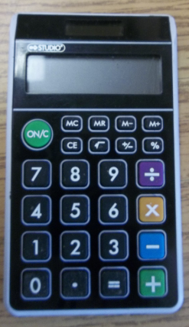

Grade 7 and 8 only – calculator with percent, square root, plus/minus *NOT SCIENTIFIC
The Dollarama dollar store has wonderful calculators – (see picture).

Grade 6 only - One 1½ inch white, hard binder with a clear cover insert for a front title page.

