Canterbury High School
Grade 6 – 8 School Supply List for 2018-2019

- $25 Student Fee
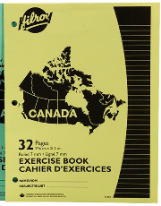
- 2 boxes of Kleenex
- 4 Hilroy notebooks for science
- Hilroy notebooks for art, Phys. Ed, and tech
- 1 inch binder for literacy, health, PDCP, Social Studies
- 2 duo-tangs with pockets (one for French and one for Music)
- 10 Hilroy notebooks for math
- 1 graphing notebook (0.5 cm squares would be best)
- Geometry set – please not dollar store brand
- 30 cm ruler
- Pencils – please send 24 pencils and store the rest at home for students to bring in as needed
- Pencil case
- Loose-leaf – please send 3 packages and store the rest at home for students to bring in as needed
- Spiral bound sketch pad (8 ½ x 11)
- a pack of good quality sketch pencils
- 2 white erasers
- 1 package page dividers
- a package of white paper
- 1 package of index cards
- 1 package of sticky notes
- 1 large glue stick
- Scissors
- markers
- pencil crayons
- USB flash drive for Tech class
- Gym clothes and sneakers (Sneakers must be able to be laced up properly, no skater shoes please)

- If your child would like to use pens, please purchase pens with blue or black ink only. Please include corrector tape or whiteout.
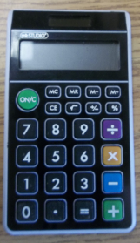
Grade 7 and 8 only – calculator with percent, square root, plus/minus
*NOT SCIENTIFIC
The Dollarama dollar store has wonderful calculators – (see picture).

Grade 6 only - One 1½ inch white, hard binder with a clear cover insert for a front title page. (This is kept at school and used as a portfolio gr. 6-12)

