Health Announcements K-5 2019
October – Vaccines Work
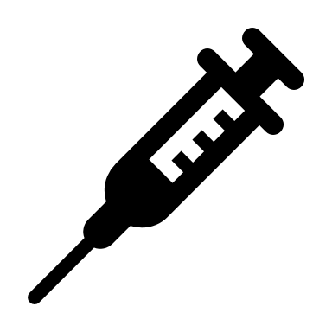
- Nobody likes getting needles. But shots, called vaccines, keep us from getting diseases that could make us very sick. We thank our doctors and nurses who gave us vaccines when we were little to keep us healthy.

- The best way not to get sick (like with the flu) is to take care of yourself. Eat well, drink lots of water and get enough sleep. Remember to wash your hands after you use the bathroom, touch your face, as well as before and after you eat. Getting the flu vaccine helps!

- Vaccines keep us healthy. Knock, knock. Who’s there? Needle. Needle Who? Needle a little help not to get sick?

- Interesting fact – 60 years ago there was a disease called small pox. Since the invention of the small pox vaccine, the disease does not exist anymore. A big thank you to our friends who got rid of small pox by getting that needle a long time ago. Vaccines get rid of diseases! Hooray!

- This month we remember how it is important to stay healthy by eating well, drinking lots of water, washing our hands and getting a good night’s sleep. When we get our vaccines, we protect ourselves and other people around us from getting sick. Three cheers for us!

