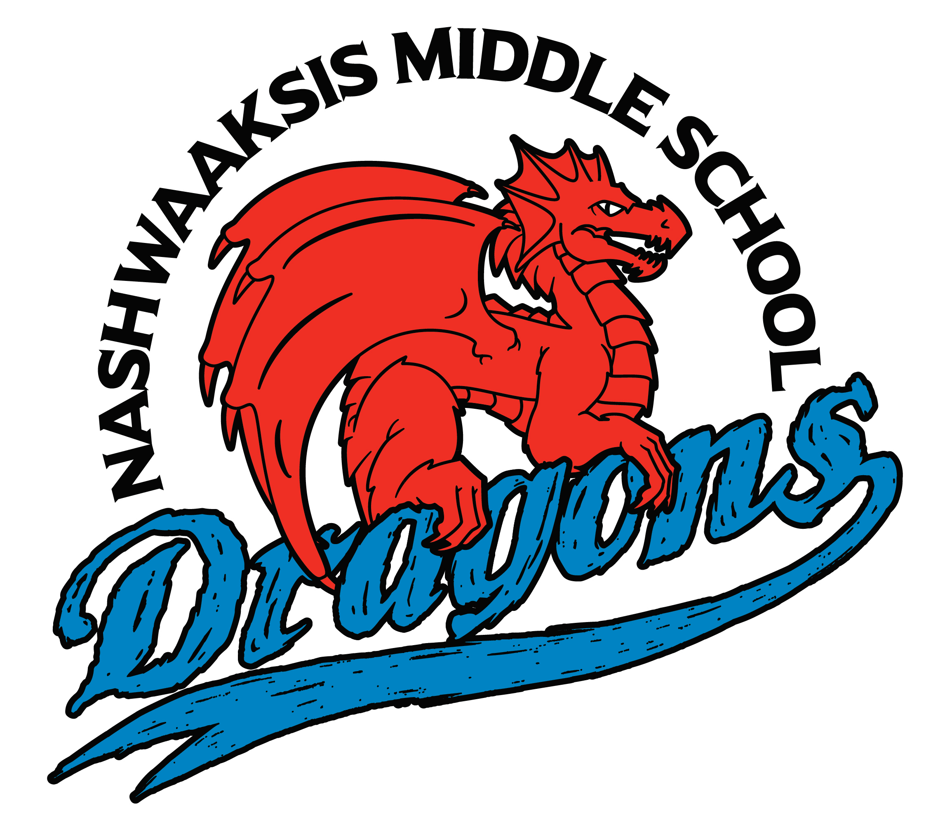

Nashwaaksis Middle School
324 Fulton Avenue, Fredericton, NB E3A 5J4
Phone: (506) 453-5436 FAX: (506) 444-4129

Principal Vice Principal
Kendra Frizzell Marcie Connors

Greetings to our new Dragon Families and soon to be our Grade 6 DRAGONS!!!!

The NMS Dragon Family is excited to welcome you to the Dragon Family in the fall! We know that you are missing our traditional Grade 5 Orientation, tour and Grade 5 Parent Night; however, we are very excited to share that we are working hard at compiling a virtual orientation, virtual tour, and a video message about what Grade 6 might look like in the fall. We will send these to your schools soon.

At this time, we do not know what our return in the fall will look like, but we plan to send out any updates to help with questions. Typically, Grade 6 students have their own special day for the first day of school and we always send out a FAQ’s document for families to help alleviate the worries that might start popping up over the next few months.

Our Grade 6 team has already connected with all your Grade 5 teams to start transitioning students from our feeder schools. Your elementary school will miss you, but they also know you are ready to become a DRAGON in the fall.

We can’t wait to meet you!

From: NMS Dragon Family

