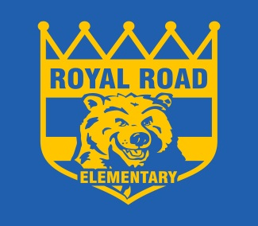
ROYAL ROAD ELEMENTARY SCHOOL
340 Royal Road, Fredericton, NB, E3G 6J9
http://royalroad.nbed.nb.ca
PHONE: (506) 453-5438
FAX: (506) 444-5268
Sheila Legere Principal
Mary Brophy Vice- Principal
To Learn, To Grow, To Lead
Dear Parents/Guardians,
Royal Road School will be providing your child with the opportunity to go skating at the York arena this year. Classes will skate on two separate occasions with two other classes. Transportation will be provided to and from the rink via a school bus for students and teachers only. This year will be a free skate experience. Parents and guardians are welcome to meet classes at the rink and help out with laces as well as skating. All adults and children must have a pair of skates and children must have skating helmets on the ice. Bicycle helmets are NOT permitted to be worn. Mittens/gloves and appropriate winter clothing must be worn while skating. We are also asking that no strollers, or outdoor boots go on the ice as this is a safety concern. If your child does not have skates or a helmet, our school has a few that can be loaned out.
Please sign and return the bottom half of this form to your child’s homeroom teacher.
If you have any questions or concerns please feel free to contact the school. Please see schedule below:
Tuesday, January 15th from 9-10am: Desjardins, Black, Connolly
Tuesday, January 15th from 10-11am: Denovan, Waugh, Brooks
Wednesday, January 16th from 9-10am: Goggin, Perreaux, Carroll
Wednesday, January 16th from 10-11am: Dyker, Hughes (Sidik), Bragdon
Tuesday, January 22nd from 9-10am: Desjardins, Black, Connolly
Tuesday, January 22nd from 10-11am: Denovan, Waugh, Brooks
Wednesday, January 23rd from 9-10am: Welch, El-Khoury, Gomes
Wednesday, January 23rd from 10-11am: Goggin, Perreaux, Deveau
Wednesday, January 30th from 9-10am: McGraw, El-Khoury, Dressaire
Wednesday, January 30th from 10-11am: Dyker, Hughes (Sidik), Bragdon
Tuesday, February 5th from 9-10am: Carroll, Deveau, Theriault
Tuesday, February 5th from 10-11am: Dressaire, Gomes, Welch
Wednesday, February 6th from 9-10am: McGraw, Theriault

Please complete and return portion of the form to your child’s teacher.
Name of student: _________________________________Homeroom Teacher:___________________
Medicare # : __________________________ Parent signature: _________________________________
Are you able to volunteer: _____________ (Y or N)

