Parent Tip

Accuracy

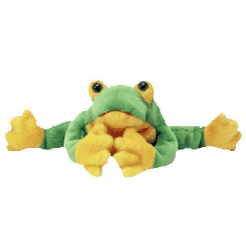Our focus for reading this week will be on using the accuracy strategy, **Skippy Frog**. Most students are able to use Lips the Fish, Stretchy Snake, and Chunky Monkey, however, when these strategies don’t work, they must learn to skip the word and read on. Skippy Frog teaches us to skip the unknown word after first trying to sound it out; we skip the word, read on to the end of the sentence, and then go back and reread the sentence again. Often, by reading on, we learn more about the context of the unknown word, thereby making it easier to figure out. Encourage your child to try skipping an unknown word (after trying to sound it out), read on, and go back to try again.

Title of book: _________________________________________________

Reading Level: ___________

Record how many times you used the reading strategy Skippy Frog and how many times it worked for you.

I used Skippy Frog ______ time(s).

Skippy Frog helped me read a word ______ time(s).

[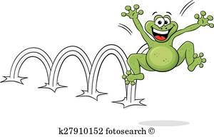](http://www.google.ca/url?sa=i&rct=j&q=&esrc=s&source=images&cd=&cad=rja&uact=8&ved=0ahUKEwj06Iedhc7YAhWM7IMKHVvjCo8QjRwIBw&url=http://www.fotosearch.com/clip-art/skip-frog.html&psig=AOvVaw2jwhwD10yeCmBbAA2CjARD&ust=1515695856633127)