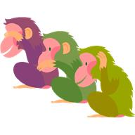
We will be working on the following curriculum outcomes this month:

- Meet the Teacher – Information will be going home regarding this
- Becca Schofield Day-Sept.28th
- Orange Shirt Day-Sept. 30th
- Terry Fox Walk-Oct. 1st

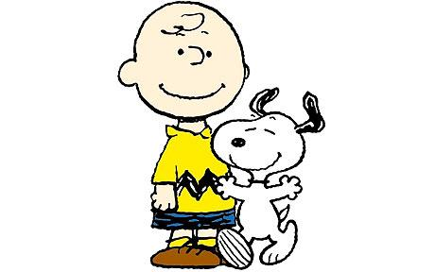
September
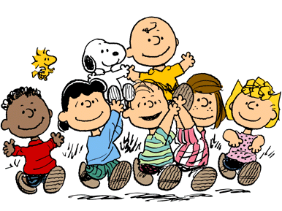

You & Your World is a combination of health, science & social studies.

We will focus on:
- “All About Me”
- Bucket Filling

Reading:
- Accuracy (reading unknown words correctly) – Review of Eagle Eye, Lips the Fish, Stretchy Snake, & Chunky Monkey
- Fluency (reading smoothly with expression) – We will learn how to select “good fit” books so that we can read smoothly with good expression when reading out loud.
- Expand our Vocabulary (using interesting words) – We’ll learn what being a voracious reader means.

Writing:
-Deciding on an idea to write about and starting the writing process by drawing all the exciting details.

Mila
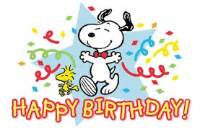

In math we will focus on:

Mental Math
- Make 5 review
- Add and subtract 0 with numbers up to 20. i.e. 9+0, 15+0, 0+12, 6-0, 18-0, 11-0, etc.

Numbers
- One more, one less; two more two less
- Skip count by 2s, & 10s to 100 forward/backward both orally and written

Measurement
- Using a calendar (know days of the week; months of the year & be able to answer calendar questions)

http://priestmanstreet.nbed.nb.ca
The school website is an excellent way for you to see the wonderful things that happen day-to-day in our class.
- Special Events
- Photo Galleries
- Homework
- Parent Tips
- Videos
- Games

