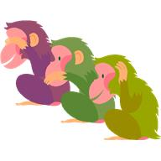
We will be working on the following curriculum outcomes this month:

Meet the Teacher – Tues., Sept. 12 from 6:30 – 6:55.

Scholastic Book Order – Keep an eye out for the flyers. I will send them home as soon as I receive them.

http://priestmanstreet.nbed.nb.ca
The website is an excellent way for
you to see the wonderful things
that happen day-to-day in our class.
- Special Events
- Photo Galleries
- Homework
- Parent Tips
- Videos
- Games


September
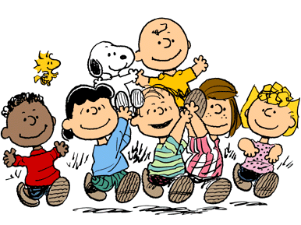

You & Your World is a combination of health, science & social studies.

We will focus on:
- “All About Me”
- Bucket Filling

In reading we’ll focus on:
- Accuracy (reading unknown words correctly) – Using Crawly Crab to monitor if what we read looks right, sounds right and makes sense. Using “Eagle Eye” to look at the pictures; using “Lips the Fish” to make our lips say each sound of the word.
- Fluency (reading smoothly with expression) – We will learn how to select “good fit” books so that we can read smoothly with good expression when reading out loud.
- Expand our Vocabulary (using interesting words) – We’ll learn what being a voracious reader means.

In writing we’ll focus on:
-Deciding on an idea to write about and starting the writing process by drawing all the exciting details.
-Spelling – The students will do a spelling test to assess grade 1 & 2 spelling words (“No Excuse” words).

Tallon & Kaitlyn
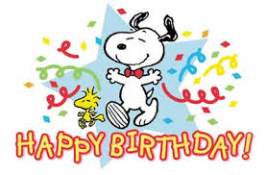

In math we will focus on:

Mental Math
- Add 0, 1, and 2, to numbers up to 20. i.e. 9+0, 15+1, 6+2

Numbers
- Skip count by 2s, & 10s to 100 forward/backward both orally and written
- Odd/even numbers to 20

Measurement
- Use a calendar (know days of the week; months of the year & be able to answer calendar questions)

