Parent Tip

This week our focus for reading is helping the children know what strategies to use when they encounter a word they don’t know how to read. At school the students have learned strategies to decode unknown words. Please find included the “Stuck on a Word” accuracy reading strategy bookmark. Ask your child to explain each strategy to you. Encourage your child to use these strategies when they come to a difficult word.
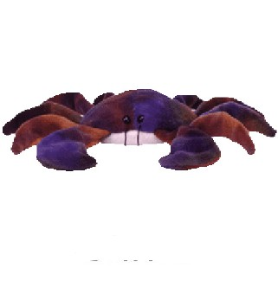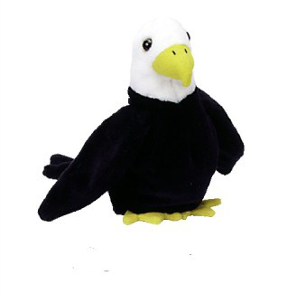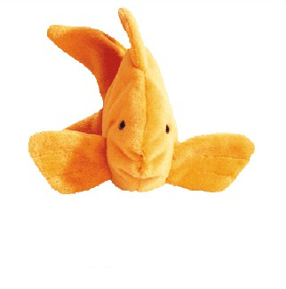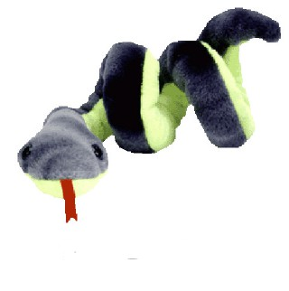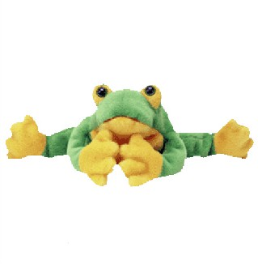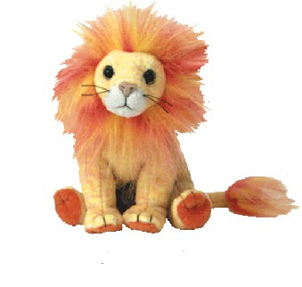
Reading Homework:

You may read part of the story each night until it is finished, or if it is a short book you can read it all the first night and practice reading it fluently the next 2 nights; however, try to read for at least 10 minutes each night.

Title of Book: ____________________________
Level: ____ (on the back of the book)

(Complete after reading the story)

A word I had difficulty reading was _____________________

The reading strategy I found most useful was ______________
_________________________________________________
_________________________________________________

Another word I had difficulty reading was _________________

A different reading strategy I used was __________________
_________________________________________________
_________________________________________________

