Parent Tip

This week our focus for reading is reviewing the accuracy strategies we have learned. We have been continually helping the children know what strategies to use when they encounter a word they don’t know how to read. Please see below the decoding strategies animals. Have your child explain each strategy to you. (Refer to the reading goals checklist in front of binder if needed) Encourage your child to use these strategies when they come to a difficult word.
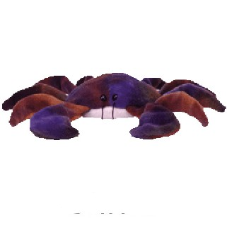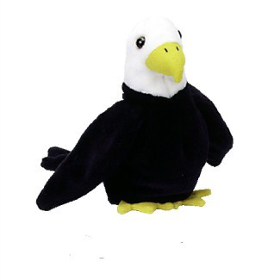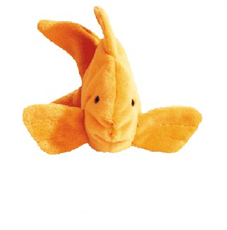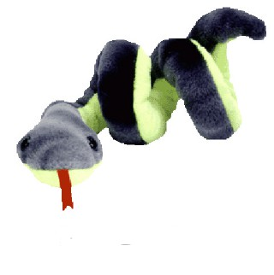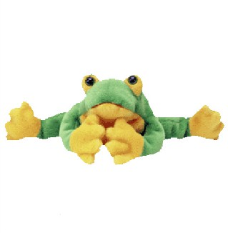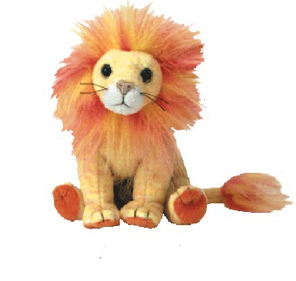
Crawly Crab Eagle Eye Lips the Fish Stretchy Chunky Skippy Tryin’ Lion Helpful
Snake Monkey Frog Kangaroo
Reading Homework:

You may read part of the story each night until it is finished, or if it is a short book you can read it all the first night and practice reading it fluently the next 2 nights; however, try to read for at least 10 minutes each night.

Title of Book: ____________________________
Level: ____ (on the back of the book)

A word I had difficulty reading was _____________________

The reading strategy I found most useful was ______________
_________________________________________________
_________________________________________________

Another word I had difficulty reading was _________________

The reading strategy I found most useful was ______________
_________________________________________________
_________________________________________________

