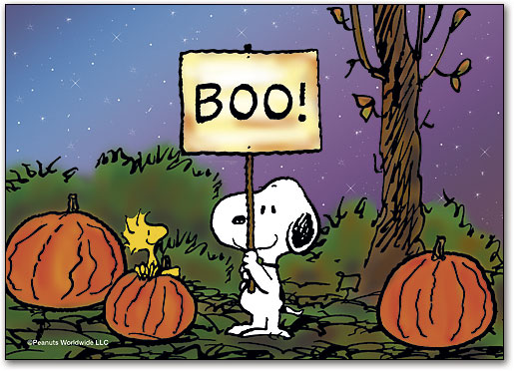
October

We will be working on the following curriculum outcomes this month:

Reading
Comprehension (understanding what we read) – we will make predictions before and while we read
Accuracy (reading unknown words correctly) – we will work on letter sounds and familiar words
Fluency (reading smoothly with expression) – we will work on our sight word lists
Expand our Vocabulary (using interesting words) - we will continue learning unfamiliar words

Writing
- Thinking of ideas to write about, and sticking to our idea
- Adding labels to our pictures
- Writing at least 2 sentences with a capital letter and period.

We will be learning about:

- Personal, and fire safety

- Zones of Regulation

Math Facts

Adding and subtracting with 0 up to 20.

Adding and subtracting 1 and 2 up to 20.

Numbers
Skip counting by 2s to 20 and, 10s to 100 forward and backward

Representing, ordering and describing numbers up to 20

Measurement
Using a calendar (know days of the week; months of the year & be able to answer calendar questions)





Joanne
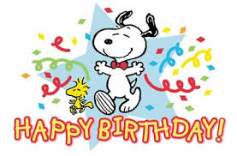

http://priestmanstreet.nbed.nb.ca
Check out:
- Songs and games that support what we are learning

