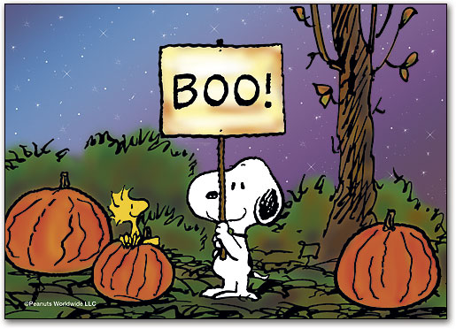
October

We will be working on the following curriculum outcomes this month:

Reading
Comprehension (understanding what we read) – Using Predicting Penguin to predict before and while we read.
Accuracy (reading unknown words correctly) – Using “Eagle Eye” to look at the pictures; using “Lips the Fish” to make our lips say each sound of the word; using “Stretchy Snake” to stretch out unknown words; using “Chunky Monkey” to find chunks we know; and Flippy Penguin to flip the sounds.
Fluency (reading smoothly with expression) – change our voices to read sentences that end in periods, exclamation marks & question marks.
Expand our Vocabulary (using interesting words)-We will learn about “Million $” words.

Writing
- Coming up with ideas to write about, and sticking to our idea
- Fixing up our writing by ensuring we are spelling “no excuse” words correctly, beginning our sentences with uppercase letters, and using the correct end punctuation.

Math Fqcts
Batman and Robin: Subtracting 1 and 2 from numbers to 20.

“Get in a Flash” -Recognizing dots on a 10-frame instantly
i.e. This shows 6
“Make 10” – what numbers add together to make 10
i.e. 1+9, 2+8, 3+7, 4+6, etc.

Numbers
- Skip counting by 2s and, 10s to 100 forward and backward
- Odd & even numbers to 20
- Representing, ordering and describing numbers up to 20
Graphing
- Gather and record data about self and others

We will be learning about:
- Personal, fire, bus and school safety
- Dealing with conflict and the 3-Step Plan
- The Zones of Regulation



Trish, Dahlia
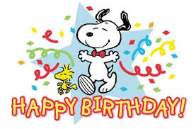

Picture Day – Oct. 4
Scholastic Book Order – Oct. 4
Popcorn sales begins – Oct. 4
Thanksgiving Holiday – Oct. 14

http://priestmanstreet.nbed.nb.ca
Check out:
- Songs and games that support what we are learning

