 HOMEWORK – Nov. 12th – Nov. 15th
SPECIAL MESSAGES:
- Parent-teacher interviews: Nov. 21st & 22nd. Please go to my doodle poll at the
following link to sign up: https://doodle.com/poll/g83wz949cu9k7zgt
- Library Books – Due Friday
- Popcorn - $2 on Friday (if you did not purchase a punch card).
TUESDAY – THURSDAY
Please see below your child’s homework, which is to be completed by Friday. Thank you!

Sight Words
Practice reading 5-10 unchecked words on your sight word list each night.
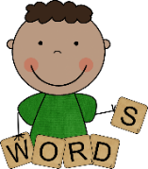
Spelling
This week we will have a review test of all 25 words studied to date – the first 5 lists. Please make sure to practice all of the words, especially the ones your child found most challenging.
Reading

The RAH RAH book your child has selected is in the pocket of their homework binder. Read at least 10 minutes each night and reread for fluency. See the back of the RAH RAH sheet for parent tips.

Math Facts
Please sign and have your child correct the math facts test from last week (in the weekly work section).
This week we will continue to practice what numbers add together to Make 10. Please practice each night using the flash cards with missing numbers (in the baggie). There will be a test on Friday.
Weekly Work
Please take some time to go through your child’s weekly work section with them and have them make any corrections and finish any incomplete work.
Please have your child complete the homework by Friday and initial once it is all finished.
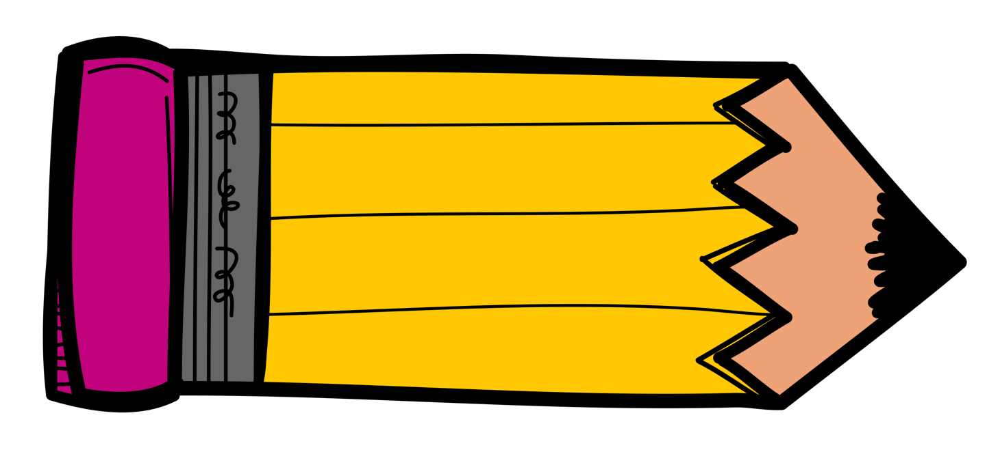
Thank you! Parent Initials: _________

