 HOMEWORK – Oct. 15th - 18th
http://priestmanstreet.nbed.nb.ca
SPECIAL MESSAGES:
- Library Books – Due Friday
- Popcorn - $2 on Friday (if you did not purchase a punch card).
TUESDAY – THURSDAY
Please see below your child’s homework, which is to be completed by Friday. Thank you!

Sight Words
Practice reading 5-10 unchecked words on your sight word list each night.
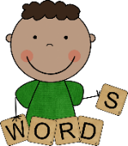
Spelling
The words we are practicing this week are: had is his I as
If your child can already spell these words, please choose 5 other words from their list to work on.
Our Friday spelling test is in the orange Heritage notebook. Your child will need to print any misspelled words 3 times each. Do these corrections on the same page. Please sign the page.

Reading
Please see RAH RAH introduction letter in a plastic sleeve in front of binder. The book your child has selected (at their reading level) is in the back pocket of their binder.
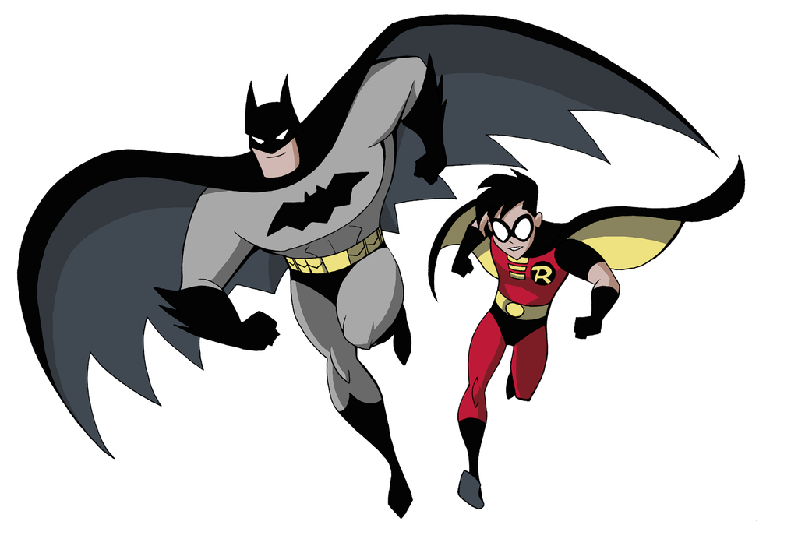
Math Facts

Please sign and have your child correct the math facts test from last week.

“Invisible Woman/Batman and Robin”. We will review all the adding and subtracting strategies taught so far. Please practice each night using all of the flashcards sent home to date. (These flashcards can be kept at home from now on.) There will be a review test on Friday.
Math
In math we are learning the names and values of each of the Canadian coins. Record the name and value (use the cent symbol – C) of each coin.
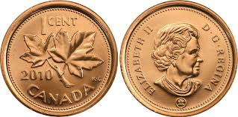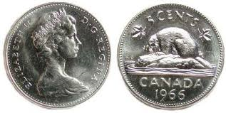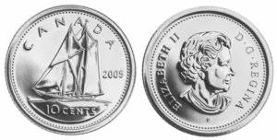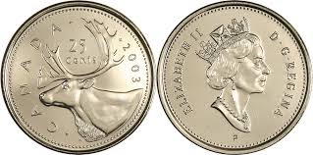
Name: _____________ Name: _____________ Name: ____________ Name: ______________
Value: ________ Value: ________ Value: ________ Value: ________
Weekly Work
Any paper work we have completed is there for you to talk about with your child. Some students have work to be completed or corrected.
Please have your child complete the homework by Friday and initial once it is all finished.
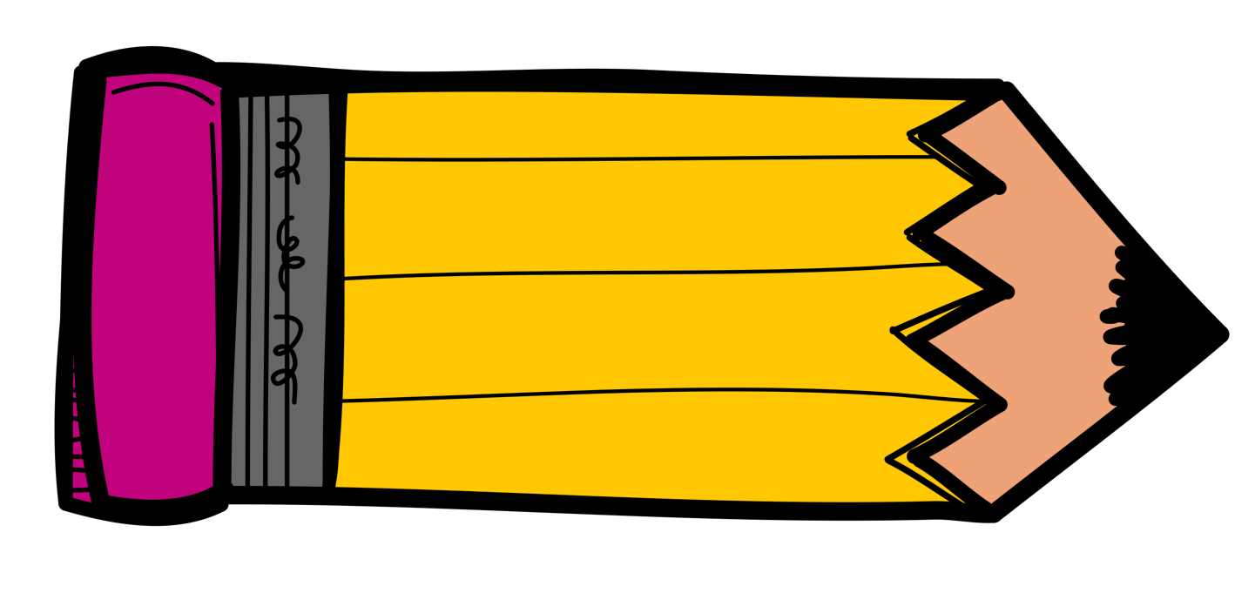
Thank you! Parent Initials: _________

