 HOMEWORK – Jan. 22nd–26th 
http://priestmanstreet.nbed.nb.ca/teacher/mrs-davies
SPECIAL MESSAGES:
- Milk order for February – due Jan. 24th - $7.00
- Popcorn – Fri. $1.00 a bag.
- Library books – due back Friday.
MONDAY – THURSDAY
Please see below your child’s homework, which is to be completed by Friday. Thank you!
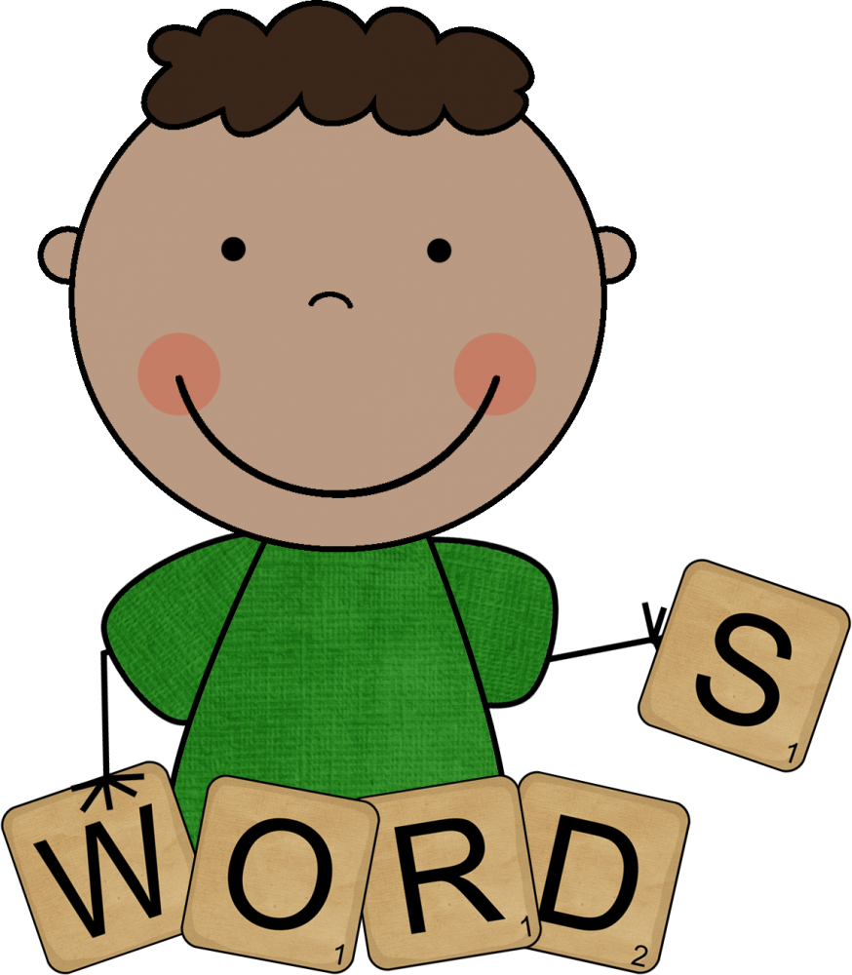
Spelling
The words we are practicing this week are: all put into will just
If your child can already spell these words, please choose 5 unknown words from their list to work on. You may use the notebook in writing section to practice.

Sight Words
Practice reading 5-10 words on your sight word list each night.


RAH RAH
“Skippy Frog” – We will review Skippy Frog again this week..
Please have your child read aloud from their “Good Fit” RAH RAH book each night and complete the Skippy Frog activity after the story is read. (Some books take longer to read, so read for about 10 minutes each night.)

Math Facts
“Spiderman Near Doubles”. We will be reviewing this strategy again this week. There will be a test on Friday.
Sign and correct the review test from last week.


Writing
Have a look at your child’s latest piece of writing. Have them read it to you and celebrate the great work they are doing! Please leave it in the binder as I will be collecting it on Friday.

January Math Challenge – Optional
Reminder that this optional challenge is due January 26th. (Earn Extra stickers on your bucket.☺)

Please complete the homework by Friday and initial once it is all finished. Thank you! Parent Initials _________

