HOMEWORK – Apr. 26th – April 30th
http://priestmanstreet.nbed.nb.ca

SPECIAL MESSAGES:
- A HUGE thank you to Xander and his family for providing us all with a happy meal on Friday as a birthday surprise for Xander. What a treat!!
- May 7th – No school for students.
MONDAY – THURSDAY
Please see below your child’s homework, which is to be completed by Friday. Thank you!
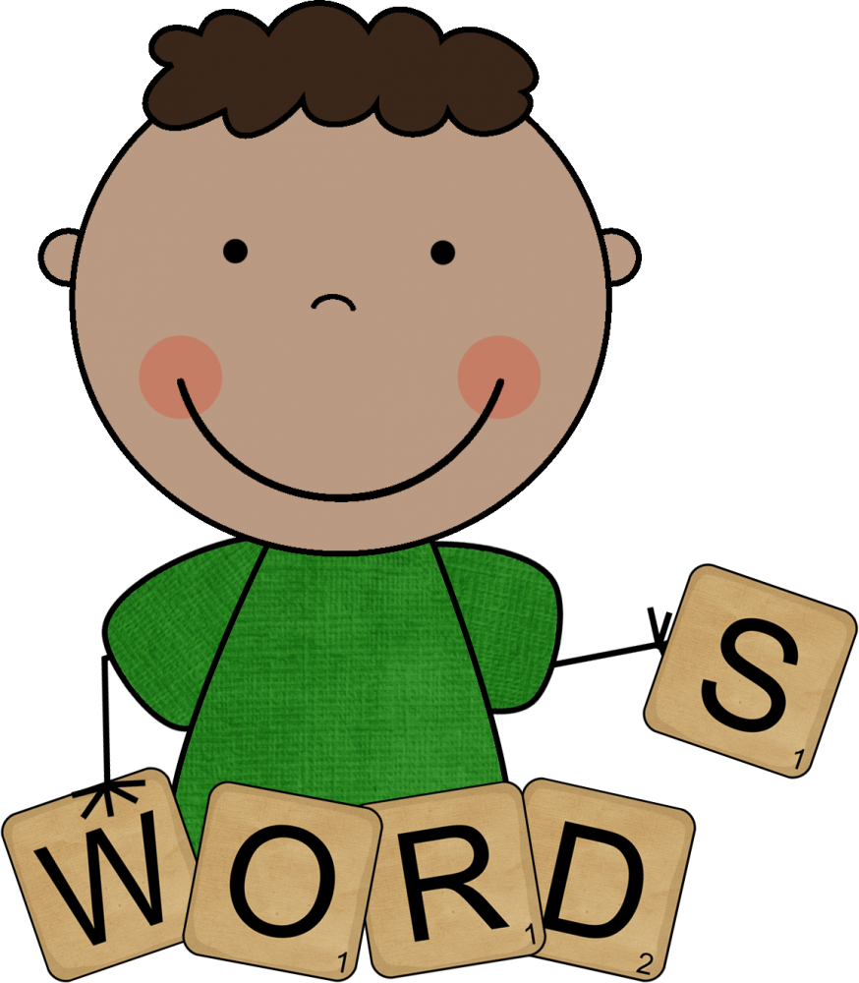
Spelling
We will be practicing List 19 words this week: away play make came day saw
This week’s number words are: seventeen eighteen
There will be a test on all 8 words on Friday
Please sign test from last week in the campfire notebook.

Sight Words
Practice reading 5-10 words on your sight word list each night.

Number sight words – Practice reading 5-10 of the unchecked words each night.

RAH RAH
Please make sure to read at least 10 minutes each night. You can read from your good fit book or log on to Razkids if you have the technology. Please have your child retell the story in their own words to check for comprehension.

Squiggle Park
Try to go on a few times a week.

Math Facts
“Green Arrow – Adding with 8” – We will use what we learned about adding 9 to a number to learn how to add 8. Ie. When we see 8 + 6 = ?, we should think “I can make the 8 a 10 (which we know as a friendly number) by taking 2 from the 6, so the new fact is 10 + 4 = ?. There will be a test on adding with 8 and 9 on Friday.

Xtra-Math - Math fact practice. It only takes a few minutes for each session, so if you have the technology, please have your child log on a few times a week.
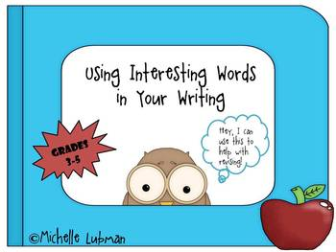
Writing
Write a sentence each night using 1 of these million $ words: marched, gazed, dashed, hurried, whispered, shouted, gobbled, gulped, thrilled, unhappy. You should have 4 sentences in total using 4 different words from the list. Remember to start with a capital letter and end with a period.

Please complete the homework by Friday and initial once it is all finished. Thank you! Parent Initials _________

