There’s no homework this week!

Do you want to know the reason?
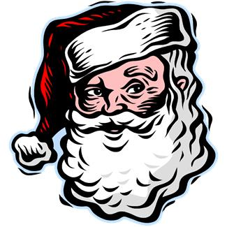
Because it’s such a busy time…

Relax, enjoy the season!

HAVE A WONDERFUL
HOLIDAY SEASON…

Reminders for the next week:
- All library books are due.
- Dec. 18th is the Christmas basket draw.
- “Polar Express” Day on Friday, Dec. 22nd. Kids can come dressed in their pajamas on this day and bring a stuffy.
- Last day before the holiday is Friday, Dec. 22nd. Dismissal is at 11:00.

- First day back after the holiday is Monday, Jan. 8th, 2018.

…AND A HAPPY NEW YEAR!

