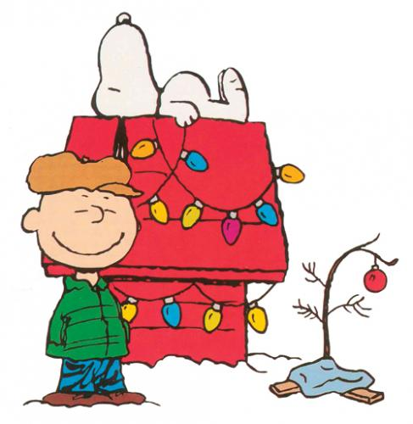
December

We will be working on the following curriculum outcomes this month:

Reading:
Comprehension (understanding)– “Predicting Penguin”-what will happen next using text/picture clues
Accuracy (reading unknown words correctly) – We will review “Crawly Crab” who tells us to ask “Does it sound right?”, “Does it look right?”, “Does it make sense?”
Fluency (rereading the text & phrasing and rate) – We will learn that it is important to read not too fast or too slow. We can practice our rate by rereading a text.
Expand our Vocabulary (using interesting words) – We’ll continue to build our knowledge of new words.

Writing:
Writing lists and letters and the characteristics of these genres.
Conventions – capital letters, punctuation, and spelling “no excuse” words correctly.

You and Your World:
The difference between needs and wants

Consumer and the concept of supply and demand

Mental Math:
“Adding Doubles”
2+2= 8+8=

Numbers to 100
-Continue to count with coins
-Showing numbers in different ways
-Pace value

Patterning (Repeating Patterns)
-Describing, comparing, and extending
-Predicting elements (what is missing, incorrect, what comes next)
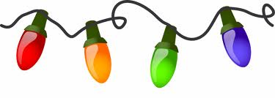

Last Day of School – Dec. 21st

First Day back – Jan. 8th

http://priestmanstreet.nbed.nb.ca
Check out:
What’s happening at school
Math/Literacy Games/Videos

Bryson, Sairaj, Silas
