http://priestmanstreet.nbed.nb.ca
Check out:
Songs and games that support what we are learning

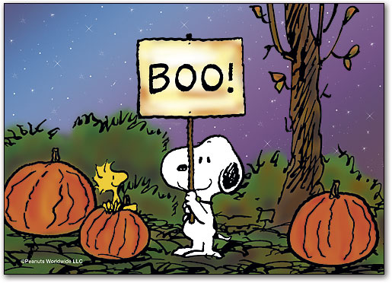
October

We will be working on the following curriculum outcomes this month:

In reading we’ll focus on:
- Comprehension (understanding what we read) – Using Predicting Penguin to predict before and while we read.
- Accuracy (reading unknown words correctly) – Using “Stretchy Snake” to stretch out unknown words; using “Chunky Monkey” to find chunks we know; Flippy Penguin to flip the sounds.
- Fluency (reading smoothly with expression) – change our voices to read sentences that end in periods, exclamation marks & question marks.
- Expand our Vocabulary (using interesting words) We will learn about “Million $” words.

This month in writing we’ll focus on:
- Sticking to our main idea.
- Fixing up our writing by ensuring we are spelling “no excuse” words correctly, beginning our sentences with uppercase letters, and using the correct end punctuation.

In math we will focus on:

Mental Math
- “Get in a Flash” -Recognizing dots on a 10-frame instantly
i.e. This shows 6
- “Make 10” – what numbers add together to make 10
i.e. 1+9, 2+8, 3+7, 4+6, etc.

Numbers
- Skip counting by 2s, 5s, 10s to 100 forward and backward
- Odd & even numbers
- Representing, ordering and describing numbers up to 50
Graphing
- Construct and interpret concrete graphs to solve problems

We’ll be incorporating Safe Schools Week into You & Your World this month.

We will be learning about:
- Personal, fire, bus and school safety
- Dealing with conflict and the 3-Step Plan
- The Zones of Regulation



Safe School Week – Oct. 16th – 20th
Thanksgiving Holiday – Oct. 9th
Picture Day – Oct. 13th
Scholastic Book Order – Oct. 13th

Aiden


