Grade Two Music Enrichment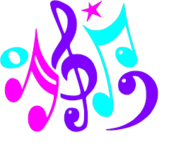
Do as many of these as you like….if you don’t have time that’s ok! This is optional! 😊
Contact me at: susan.hayward@nbed.nb.ca
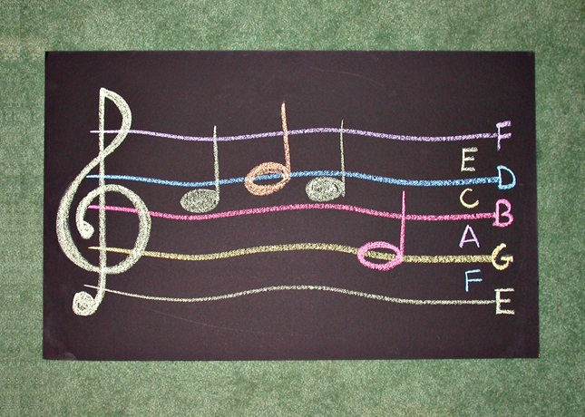
Sidewalk Staff:
Grade two has worked on rhythm reading and solfeg but this is still a new concept so just have fun exploring music symbols.
If you can get the lines and spaces concept that is a bonus!
The Idea of note names is a SUPER BONUS!!
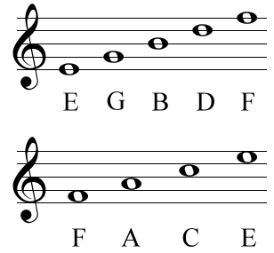

1.
With an adult, choose a safe outdoor place such as a sidewalk to play this fun game that adults and children both enjoy. Use sidewalk chalk to draw a musical staff -Five lines/four spaces.
(See above)
2.
Start by drawing a treble clef at the beginning of your music staff. The lines on the staff represent the following notes, in order from the bottom up: E, G, B, D, and F. An easy way to remember this order is by using a mnemonic such as Every Good Boy Deserves Fudge. The spaces between the lines represent the following notes, in order from the bottom up: F, A, C, and E. FACE in the SPACE.
3.
Have fun jumping on the lines and spaces
4.
Practice making music symbols all over your driveway or sidewalk! 😊Decorate and show the neighbours how much you love Music!
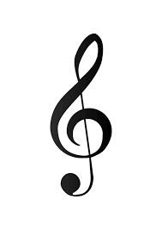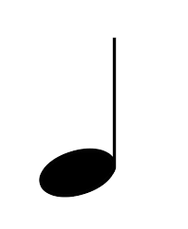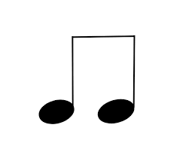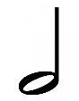

EXTENSION LESSONS:
5..
Play a game of musical rock toss. Toss a rock into the staff and then figure out the note name.
6.
Try composing words using the staff (CAGE, DAD, BEAD, ED, EDGE and so on).(Grade 3 and up)

MUSIC MASTER LEVEL:
7.
Get some pictures of music or sheet music and write the first line of the song in chalk.
8.
Player one writes a well known tune and player two must read the music and hum/sing the music to figure out the song . (Grade 5 and up)

