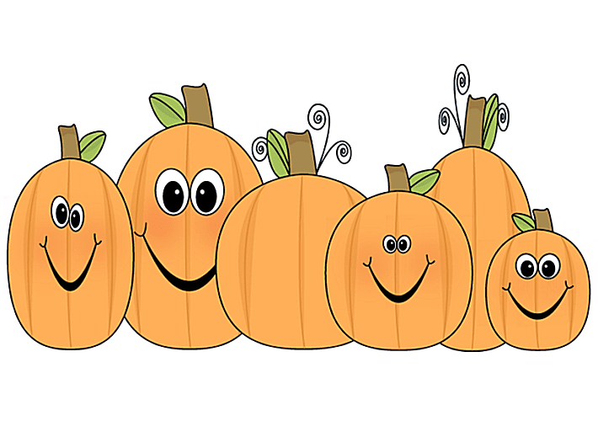
NMS Library Presents: The Storybook Pumpkin Patch

The Nashwaaskis Memorial Library is growing a Pumpkin Patch and we need your help! Students in all grades can decorate a pumpkin to look like their favourite book character and bring it to their class to plant in our Storybook Pumpkin Patch.
No carved or cut pumpkins will be accepted!
- Think of your favourite book character and design your pumpkin based on that character.
- Purchase (or pick!) a pumpkin that is no bigger than a soccer ball.
- Gather your supplies. Acrylic paint or permanent markers work best. Watercolours tend to run, and spray paint will dissolve the pumpkin (they need to breathe!). You could also try gluing on yarn, fun foam, buttons, google eyes, etc. Use your imagination and what you have at home!
- Decorate your pumpkin without carving, cutting or poking holes. Pumpkins with broken skin will not be accepted.
- Fill out the Storybook Pumpkin Patch page so we know who you are and who your character is. Make sure to bring in your paper with your pumpkin!
- Bring your pumpkin and your entry page to your classroom beginning Monday, October 19th. A favourite from each classroom will be chosen on Wednesday, October 21st and those favourites will then move to the stage for our prize pumpkin patch. Pumpkins not chosen can be taken home at the classroom teacher’s direction (Mrs. Moeller will probably get a photo first!).
- The pumpkin patch can be viewed by students until Wednesday, October 28th, when you can take them home to enjoy. Any pumpkins that are not taken home will be disposed of by 3:30 that afternoon.
- Participation is completely voluntary! This is just for fun!
- Have fun and be creative!
- Need ideas? Mrs. Moeller and the HES students grew a pumpkin patch last year. You can check out some of the entries on my Instagram page at https://www.instagram.com/mrs.moellerreads/ Just scroll down, you can’t miss them!
Thanks for playing in our pumpkin patch!
Mrs. Moeller (Library Worker, NMS 2020-21)

