Good afternoon NMS families,
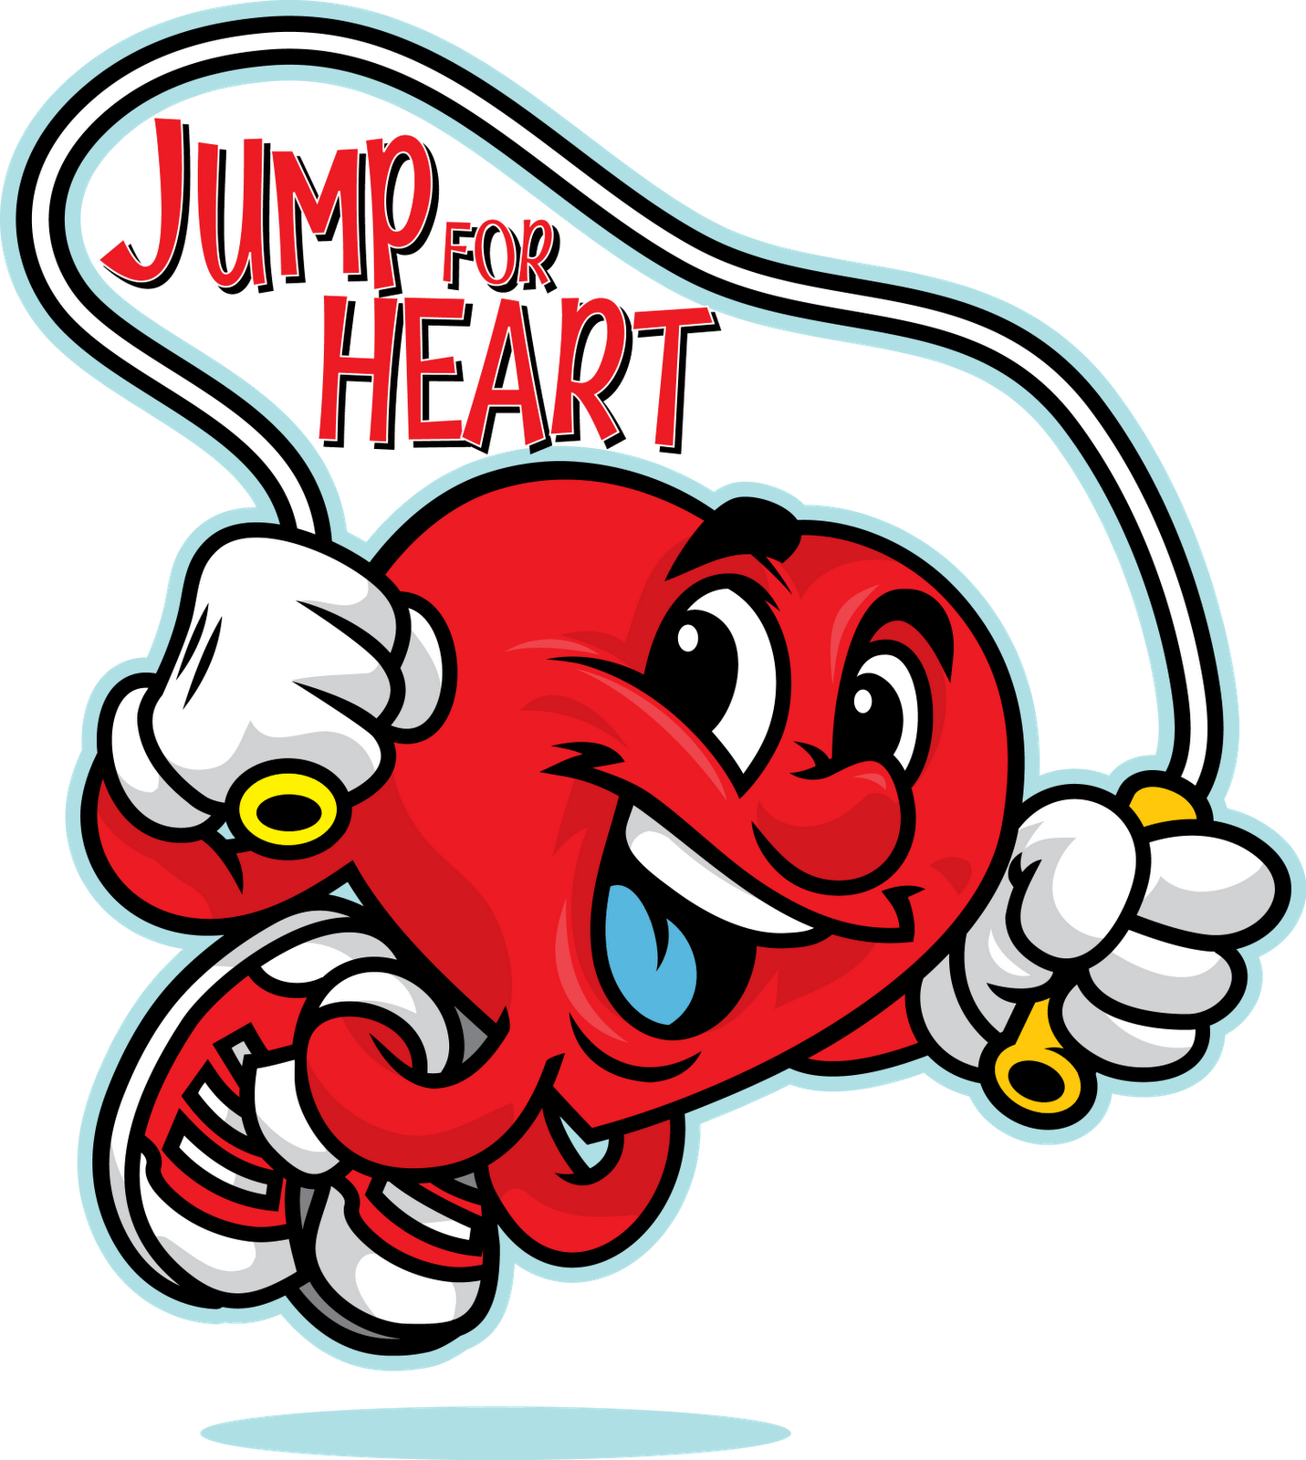
NMS is running some Wellness challenges from April 4th until May 13th – Heart Healthy Schools and Jump Rope for Heart! You will receive your Jump Rope for Heart Envelop and a sheet that outlines the Heart Healthy Schools challenges.

Jump Rope for Heart – students can fundraise using their envelop or online to raise money for the Heart and Stroke Foundation. Please return your envelop any time before April 13th).

Heart Healthy Schools – There are 3 challenges students and families can participate in: Healthy Eating (April 4-15th), Screen Time Challenge (April 18th – 29th ) and The Water Challenge (April 2-13th ). Entries can be filled in on their sheet or online Heart Healthy Schools - Participant Tracking Form 2022 (office.com)
