What's it Worth?
Each symbol has a numerical value. The total for the symbols is written at the end of each row and column.
Can you find the missing total that should go where the question mark has been put?

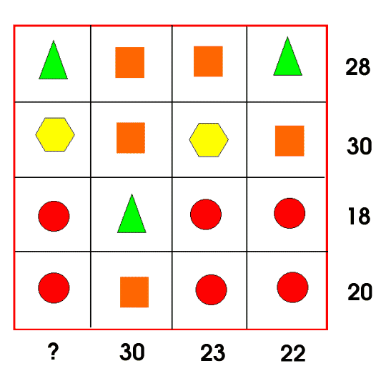

Fruity Totals

Below, each fruit has a value between 1 and 15 inclusive.
The sum of the values of the fruit in each row and column is shown.
Can you work out the value of each individual fruit?

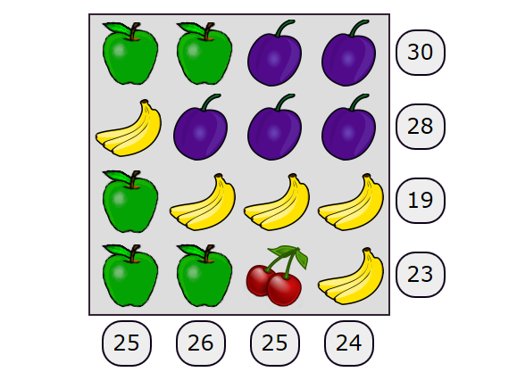

A Square of Numbers

Can you put the numbers 1 to 8 into the circles so that the four calculations are correct?

