N1:
Do human beings live for as long as a million hours?
If you have been alive for a million seconds, how many birthdays have you had?
Could you run one thousand meters in one minute?

If you get Heads on the first try then the prize is two dollars, each extra toss required doubles the prize. How many tosses would it take to get as close to one million dollars as possible?

In how many ways can the number 1 000 000 be expressed as the product of three positive integers?

The phone rings and a friend offers you a chance to be a millionaire. He tells you he won $ 2 million in a contest. The money was sent to him in two suitcases, each containing $ 1 million in five-dollar bills. He will give you one suitcase of money if your mom or dad will drive him to the airport to pick it up.

Could your friend be telling you the truth?
Can he make you a millionaire?
Can $ 1 000 000 in five-dollar bills fit in a standard-sized suitcase?
If not, what is the smallest denomination of bills
you could use to fit the money in a suitcase?
Could you lift the suitcase if it contained $ 1 000 000 in five-dollar bills?

This square contains 100 pennies.

How many squares like this is a million pennies?
Would a million pennies fit on the top of your desk?
On the classroom floor? Explain.

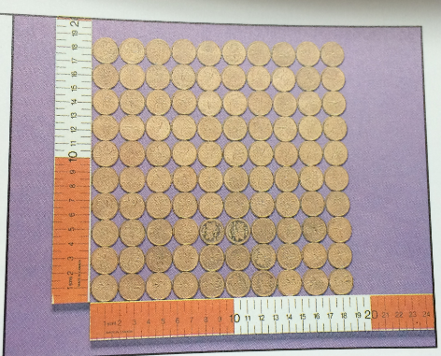
N2:

Use any digits except 0 to form two numbers with a sum close to 900 000 and a difference close to 200 000. Find other pairs that do the same.

Louis Scorpio Jr. set a world record when he did 60 405 sit-ups in 24 hours. To achieve his record, about how many did he have to do each hour? Each minute?

When a 3-digit number is multiplied by a 1-digit number the answer is about 3000.
Write 3 pairs of possible factors.

Counting Swallows:

How many times do you normally swallow when drinking a glass of water, milk, juice, or soft drink? About how many times do you swallow when drinking in a week? In a month?

N3:
One Grain of Rice
Rani asked the raja to help feed his village but to make it sound like he wasn’t asking a lot, he asked for one grain of rice on the first day, two on the second, and four on the third so that it doubled the previous day’s total each day. How many grains would he have at the end of thirty days?

Use mental math strategies to complete this multiplication sentence, using each of the other digits from 1 to 9 once.

__38 x ___ ___ = ___ ___ ___ 6

Think of any 3-digit number.
Multiply by 7.
Then multiply the product by 11.
Finally, multiply that product by 13.

Try other 3-digit numbers.
What happens each time? Explain.

N4:

Cindy went shopping on Monday and spent $16 on groceries.
On Wednesday she spent twice as much on groceries as she did on Monday.
On Saturday she spent half as much on groceries as the total of what she spent on both Monday and Wednesday.

What was the cost for the week?
If Cindy paid for her groceries in loonies and $5 bills, how many different combinations of bills could she make to pay for her groceries?
Show all your work to solve the problem.
N5:
What do you notice below? Please explain.

32 x 46 = 1472
23 x 64 = 1472

The digits in this multiplication have been reversed, and the answer has stayed the same! Is this surprising? Can you find other examples where this happens? What do you notice about the pairs of two-digit numbers that produce this special result?

Arrange the digits 2, 3, 4, and 5 to make the greatest product. Use each digit only once.
How did you decide how to arrange the digits?

The local movie theatre has changed the prices to go see a movie.
Adult tickets are $16 and children tickets are $11.
A theatre that is full to capacity earns about $10 000.

How many tickets of each type need to be sold in order for the theatre to reach this goal? How many possibilities can you create?

N6:
The solider ant, Joe, is feeling left out. His troop has 25 ants and they cannot figure out a way to group themselves that he will not be left out of a row.

What are the ways in which the ants could arrange themselves into rows?

If there were 36 ants in the troop, how many different arrangements of rows would be possible?

How many arrangements of rows would be possible if there were 100 ants in the troop?

A school has 500 students. There are 400 who come to school by bus and each bus carries the same number of students. How many students might be on a bus?
How many reasonable answers can you find? (For example, school buses cannot carry 200 students, so 2 buses is not reasonable.)

What is the lowest number which always leaves a remainder of one, when divided by any of the numbers from 2 to 10?

N7:
I mixed up some lemonade in two glasses. The first glass had 200 mL of lemon juice and 300 mL of water. The second glass had 100 mL of lemon juice and 200 mL of water. Which mixture has the stronger tasting lemonade?

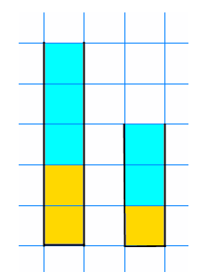

How many apples are there in the bowl if:
One quarter were apples,
and one quarter were oranges,
and there were also 4 bananas, 3 pears, and 3 plums?

A little monkey had 60 peaches.
On the first day he decided to keep $\frac{3}{4}$ of his peaches. He gave the rest away.
Then he ate one.
On the second day he decided to keep $\frac{7}{11}$of his peaches. He gave the rest away.
Then he ate one.
On the third day he decided to keep $\frac{5}{9}$ of his peaches. He gave the rest away.
Then he ate one.
On the fourth day he decided to keep $\frac{2}{7}$ of his peaches. He gave the rest away.
Then he ate one.
On the fifth day he decided to keep $\frac{2}{3}$ of his peaches. He gave the rest away.
Then he ate one.

How many did he have left at the end?

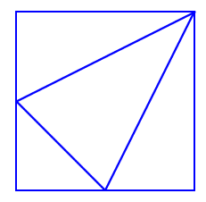
I drew this picture by drawing a line from the top right corner of a square to the midpoint of each of the opposite sides. Then I joined these two midpoints with another line. Can you see four triangles in the square? What fraction of the area of the square is each of these triangles?

N8:
Look at a map.
Which decimal describes the amount of the Earth taken by each land mass?

Africa Antarctica Eurasia Australasia The Americas

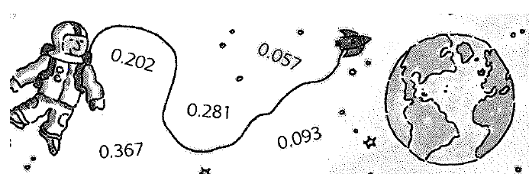

Identify a situation in which 0.09 represents a small amount and one in which it represents a very large amount.

Use each of the digits 0, 3, 6, and 9 once.
Make a number that is less than six but greater than one.
Find as many numbers as you can.
Explain the strategies you used.

N9/N10:

Explain why 0.750 is equivalent to $\frac{3}{4}$.

There are 679 pieces of a 1000 piece jigsaw puzzle already in place.
What part of the puzzle has been completed?
What part of the puzzle has yet to be finished?
Represent these numbers in as many ways as you can.

Janet predicted that $\frac{1}{3}$ would not be an exact number of tenths or hundredths.
Is she correct? Explain.

Marty continued the pattern below for 5 more fractions:

$\frac{1}{20}$ = 0.05 $\frac{2}{20}$ = 0.10 $\frac{3}{20}$ = 0.15

What fraction would Marty have written that is equivalent to 0.55? What fraction is equivalent to 0.75?

What fraction of the numbers from 1 to 1000 have more than one 5 in the digits (e.g., 55)? Express this as a decimal.

Describe each length below as part of a metre. Use fractions and decimals in each answer you give.

    - 6cm
    - 68cm
    - 68mm
    - 3dm

Explain how 0.3, 0.30 and 0.300 are the same and different. Use pictures, words and/or numbers to explain.

Use the chart about cereal below (next page) to answer these questions:

- Which cereal has the most sugar?
Which cereal has the least?
- Which cereals are about half sugar?
Which cereals are about one third sugar?

- Which cereal has the most fibre?
Which cereal has the least?
- The recommended daily amount of fibre is about 30 g. Which cereal provides about one third of your daily fibre in each serving?
- About how many servings of cereal are in the package with the greatest mass?
About how many servings of cereal are in the package with the least mass?
- What are the fibre and sugar contents of your favorite cereal in this chart?
Can you find other cereals that contain more fibre and less sugar that would be a healthier choice?
- Each decimal describes the portion of a cereal that is sugar. Make up a name that you think best describes the sweetness of each box of cereal.
- Box A: 0.09
- Box B: 0.60
- Box C: 0.96
CEREAL | Grams of Sugar per 30g serving | Grams of fibre per 30 g serving | Package size in grams (mass)
All Bran | 5.3 | 10 | 400
Sugar Crisps | 13 | 1.2 | 400
Fruit Loops | 14 | 0.5 | 275
Shreddies | 4.7 | 2.7 | 675
Rice Krispies | 2.9 | 0.3 | 350
Alpha-Bits | 15 | 0.8 | 400
Sugar Crisp | 13 | 1.2 | 400

N11 :
Fill in the boxes so that the answer for each of the questions is 0.03. A zero cannot be used to the right of the decimal points.

.

.

₊
0
.
0
3

.

.

₋
0
.
0
3

₊
₌

.

OR

.

0
.
0
3

Using the each of the digits 0 to 7 only once, create two numbers:

- with digits in the thousandths
- whose sum is close to two
- whose difference is close to one.
Explain your choices. Show your work.

Create a word problem that can be solved by subtracting two decimals with thousandths. Solve your problem and show your work.

A 33 gram box of cereal contains 0.7 grams of fibre.
About how much fibre would be in a 400 gram box?

A creature is ill and has a fever of 27.3 °C. Using the information in the chart below, which creature(s) might it be?
How do you know?

Average Body Temperature (in °C)

Dolphin | 35.5
Alligator | 25.6
Cow | 39.9
Salmon | 23.5
Porcupine | 37

