- At most how many students can sit in a row of 25 chairs, if seated students must be separated by at least two empty chairs?
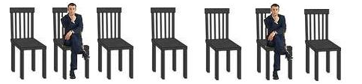

- What is the perimeter of this shape ?
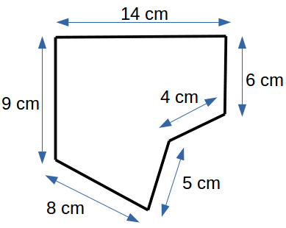

- Mr. Young gives his 4 children 50 Cents for each year of their age so that they can donate that money to their favourite charity in their name. David is 13, Anne is 11, Michael is 7 and Adam is 5 years old. How much money will the children donate in total?
HINT (for participants from outside North America): 1 Dollar = 100 Cents.
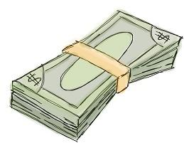

- How many points do the shapes in the table have in total?
For example, has 4 points.
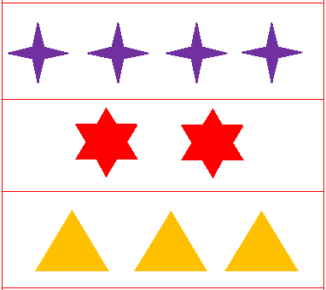

- Find a pattern in the following sequence of numbers: 12, 16, 20, 24, 28, ... . What is the next number?

- At the Yellow Star Taxi company Sandra is a receptionist and Dave is a driver. Not including Sandra there are 4 receptionists. Not including Dave, there are 21 drivers employed. How many receptionists and drivers in total are employed by the taxi company?

- Tom has 2 blue and 3 red toy cars. Eric has 1 blue and 2 yellow cars. When they run down a track, the blue cars go twice as far as the red cars and the yellow go three times as far as the red cars. If the blue cars go 4 m (metres) each, what is the total distance travelled by all the cars?

- Nicu chooses a number, adds 1 to it, then subtracts 2 from the result, then multiplies the new result by 3, then divides the outcome by 4 and finally obtains 6. What was the number chosen at the beginning?

- The first time after midnight when all digits of a digital clock are different and even is 0:24 am. What is the last time before noon when all digits on the clock are different and even?

- Alice has forgotten the pin number of her credit card. She remembers that
1) It is a 4 digit number.
2) There are no repeated digits.
3) It is an even number.
4) It is the birthday of her dog (DD/MM)
What could be her pin number?

- Maria has a number of lollipops. After she offers each of her friends 4 lollipops (all accepted the offer ☺), Maria is left with 3 lollipops. Which of the following can be the number of lollipops that Maria had initially?

- 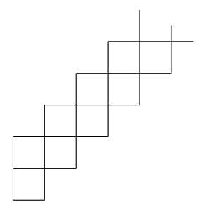
A shape consisting of 2018 squares is made by continuing the pattern shown above. Each small square has a side length of 2 cm. What is the length, in cm, of the perimeter of the whole shape?

- Steve plants twelve trees every thirty minutes. If he continues planting at the same rate, how long will it take him to plant 240 trees?

- The date 01/03/05 (March 1, 2005) is the first of the 21st Century in which the date contains three consecutive odd numbers in ascending (increasing) order. How many such dates are there in the 21st century (in the form DD/MM/YY)?

- A school has two types of rooms: rooms for smaller classes with 2 windows and rooms for bigger classes with 3 windows. There are 58 windows in the school, and 25 rooms. How many rooms are for smaller classes?

For solutions:

https://www.cariboutests.com/test/view_solutions.php

