Native Studies 120 Stereotypes Name:
- What are some generic traits of a good student?
___________________________________________________________________________
___________________________________________________________________________

- Briefly describe one commercial that dehumanizes an individual or group
___________________________________________________________________________
___________________________________________________________________________

- Give an example in recent news where an individual or group was dehumanized.
___________________________________________________________________________
___________________________________________________________________________

- Briefly describe a character in a cartoon, movie or book that you think is naïve. Who is it and what events or actions support this view?
___________________________________________________________________________
___________________________________________________________________________

- Look at the following picture
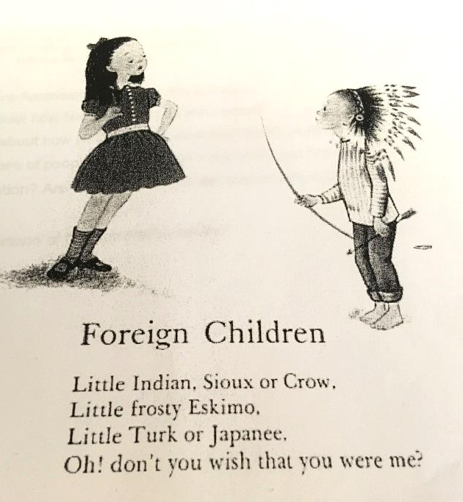
What stereotypes about Natives are depicted here?
__________________________________________
__________________________________________
This was published all over England and North America, what does the title suggest to the children in this country about Native Americans?
__________________________________________
__________________________________________
Look at the clothes, body language and details in the illustration. How do they reinforce the dominant role of the non-Native?
__________________________________________
__________________________________________

How to Tell the Difference

A) LOOK AT PICTURE BOOKS:
A.1) In ABC books, is “E” for “Eskimo” or “I” for Indian present?
A.2) In Counting books, are “Indians” counted?
A.3) Are children shown as “playing Indian”?
A.4) Are animals dressed as “Indians”?
A.5) Do “Indians” have ridiculous names, like “Indian Two Feet,” or “Little Chief”?

B) LOOK FOR STEREOTYPES:
B.1) Are Native peoples portrayed as savages, or primitive craftspeople, or simple tribal people, now extinct?
Select Only Books in which Native peoples are shown as human beings, members of highly defined and complex societies.

B.2) Are Native societies oversimplified and generalized? Are Native people all one color, one style?
Select Only Books in which Native societies are presented as separate from each other, with each culture, language, religion, dress, unique.

B.3) Is the art a mishmash of “generic Indian” designs?
Select Only Books which pay attention to accurate, appropriate design and color, and in which are clothes, dress, houses drawn with careful attention to detail.
C) LOOK FOR LOADED WORDS:
C.1) Are there insulting overtones to the language in the book? Are racist adjectives, like “primitive,” “pristine,” “simple,” “Injun” or “savage” used to refer to Indian peoples?
Select Only Books in which the language respectful, and worthy of use in reference to any other technologically advanced person or group of people.

D) LOOK FOR TOKENISM
D.1) Are Native people depicted as stereotypically alike, or do they look just like whites with darker faces?
Select Only Books in which Native people are depicted as genuine individuals, having unique and complex qualities and characteristics.

E) LOOK FOR DISTORTION OF HISTORY
E.1) Is there manipulation of words like “victory,” “conquest,” or “massacre” to justify Euro-American conquest of the Native homelands? Are Native Nations presented as being responsible for their own “disappearance?” Is the U.S. government only “trying to help?”
Select Only Books in which is history put in the proper perspective: the Native struggle for self-determination and sovereignty against the Euro-American drive for conquest and greed.

F) LOOK FOR VICTIMIZATION
F.1) Does the story encourage children to believe that Native peoples accepted defeats passively?
Select Only Books in which the story show the ways in which Native people actively resisted the invaders or continue to work for self-determination and sovereignty today.

F.2) Are Native heroes limited to those who, in some way or another, are believed to have aided Europeans in the conquest of their own people (Examples include some popular depictions of Pocahontas, or La Malinche)?
Select Only Books in which Native heroes are admired because of what they do for their own people.

G) LOOK AT THE LIFESTYLES
G.1) Are Native cultures presented in a condescending manner? Are there paternalistic distinctions between “them” and “us?” Are Native peoples depicted as needing aid from outsiders, and having no ability to govern their own land and people effectively?
Select Only Books which focus on respecting Native peoples and understanding of the sophistication and complexity of their societies.

G.2) Are Native peoples discussed in the past tense only, supporting the “vanished Indian” myth? Is the past unconnected to the present? (Be thorough – use of the past tense is a pervasive issue in books about Native peoples. Remember that any general reference to a tribe which is not explicitly to historical events, should be written in the present tense. For example, the sentence “Many California tribes used acorn in their meals” should actually have been written in the PRESENT tense, as this is still a widely consumed food among many California Natives.)
Select Only Books in which the continuity of cultures represented. Look for values, religions, and morals, as an outgrowth of the past, connected to the present, and taking the people into the future.

G.3) Is a society portrayed in a distorted or limited way? Are religions described as “superstitions,” with backward or primitive connotations?
Select Only Books in which Indian religions and traditions are described accurately, in the context of their civilizations, and commanding as much recognition and legitimacy as any practice or belief in the Christian or any other major religion.

G.4) Is there an ethnocentric Western focus on material objects, such as baskets, pottery, rugs? Examples include depicting these objects strictly as “art,” or as a means to trade with Euro-Americans.
Select Only Books in which the writer shows an understanding of the relationship between material and non-material aspects of life.

G.5) Are Native peoples shown as “relentlessly ecological”?
Select Only Books in which Native societies are described as coexisting with nature, having achieved such delicate balance as a result of their advanced understanding of Earth systems, scientific process, and principles of sustainability.

H) LOOK AT DIALOG
H.1) Do the People speak in either a sort of “early jawbreaker,” broken English, or in the oratorical style of the “noble savage”?
Select Only Books in which the People use language with the consummate and articulate skill of those who come from an oral tradition.

I) LOOK FOR STANDARDS OF SUCCESS
I.1) In modern times, are Indian people portrayed as childlike and helpless? Does a white authority figure – pastor, social worker, teacher – know better than Native people themselves what is “good for them?” Are Indian children “better off” away from their families?
Select Only Books in which Native adults seen as mature individuals who work hard and make sacrifices, in order to take care of their families, and for the well-being of the people

I.2) Do Native people and their communities contrast unfavorably with the “norm” of white middle-class suburbia?
Select Only Books in which Native people and their communities are seen as their own cultural norm.

I.3) Does it require Native people to adhere to “white” values and standards in order to get ahead or experience success?
Select Only Books in which Native values of cooperation, generosity, sharing, honesty, and courage are seen as integral to growth and development.

J) LOOK AT THE ROLE OF WOMEN
J.1) Are women completely subservient to men? Do they do all the work, while the men loll around, waiting for the next hunt?
Select Only Books in which women are portrayed as the integral and respected part of Native societies that they really are.

K) LOOK AT THE ROLE OF ELDERS
K.1) Are elders treated as a dispensable burden upon their People, to be abandoned in times of trouble or famine? Are they portrayed as querulous, petulant, demanding, nagging, irritating, or boring?
Select Only Books in which elders are treated as loved and valued custodians of the People’s history, culture, and life ways. They should be depicted as active members of the community, whose contributions are valued and appreciated. They should be as cherished in the words of the writer as they were and are in the lives of the People depicted.

L) LOOK FOR THE EFFECTS ON A CHILD’S SELF-IMAGE
L.1) Is there anything in the story that would embarrass or hurt a Native child? Are there any explicit or implicit lessons that would be harmful if instilled upon a child, Native or non-Native?
Select Only Books in which there is one or more positive role models with which a Native child can identify. Children should feel empowered and inspired by the literature they read.

M) LOOK AT THE AUTHOR’S OR ILLLUSTRATOR’S BACKGROUND
M.1) Is the background of the author and illustrator devoid of qualities that enable them to write about Native peoples in an accurate, respectful manner? Is there an ethnocentric bias that leads to distortions or omissions?
Select Only Books for which the author’s and illustrator’s background qualifies them to write about Native peoples. Their perspectives should strengthen the work.

