PDCP – Interview Assignment – Careers and Volunteering

Name:____________________________________________

4.2 Examine how risk taking and positive attitudes towards self and work are important to the life/work building process
4.4 Explore volunteerism as a personal development and community enhancement strategy.
4.5 Engage in decision making that is supportive of one’s life/work goals.

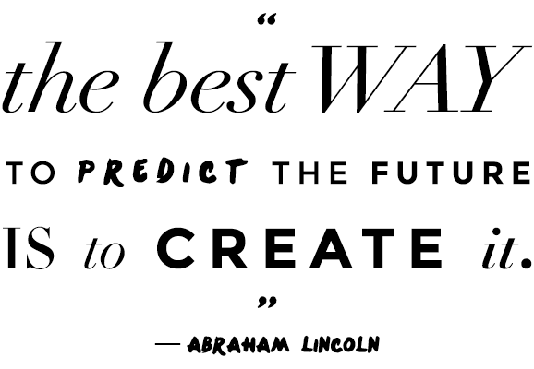
- As we have discussed in class, decisions regarding careers and course selection are stressful. This is very normal! Remember, there is lots of help available – teachers, guidance counselors, your parents, plus a number of online resources (ex. myBlueprint, university/college websites). You should feel empowered to do the necessary research, and make informed decisions.

- Making decisions with the information available at the time is all we can ever really do. It’s OK if you need to change your mind, whether that’s 1, 5, 10, or 20 years down the road!

- One of the best ways to learn about this decision-making process is to talk to someone who has experienced it. This assignment provides a chance to do just that. Write down the answers to each question on loose-leaf. You may interview the same person for both sets of questions.

PART A: Interview #1 with _____________________________ regarding careers.

**BONUS – Interview someone who is currently in a job you’re interested in. If you don’t know anybody in that job, google someone local. People love helping students interested in their job, and will either answer over the phone, or you can offer to email them the questions (ask me for electronic copy).

- What is your present job? What does your typical day look like?
- What do you like most about your job? The least?
3. Did you want to do this when you left high school? Why?
4. Describe your career path, starting with your first jobs, and what lead you to your current position.
5. How many times have you changed jobs? Why did you change jobs?
6. What do you consider to be the most important skills to have in your career?
7. Have you taken any courses and, if so, how were they helpful? Were any not helpful?
8. What was the best career decision you ever made? Explain why it was the best.
9. Is there anything throughout your career path you would have done differently?
10. What advice would you give to your 16 year old self?
PART B: Interview #2 with _____________________________ regarding volunteering.

**For best results, try to find someone who has a lot of volunteering experience. This can be an adult, or another student who volunteers with a school club (ex. Best buddies, feed the lions, etc.). You may also interview teachers who are involved with these programs and/or volunteer outside of school time.

- Describe your experience(s) volunteering.
- What do you feel you have gained from this experience?
- Is there anything you would change about your volunteer experience, or wish you had done differently?
- What advice would you give to young people regarding volunteering?

PART C: Reflection – Answer directly on this sheet. Please staple your interview answers to this handout before handing in.

- Explain what you have learned about career paths from your interview. How will this new information help you going forward?

- Explain what you have learned about volunteering from your interview. How will this new information help you going forward?

