Math 11 Finance & Workplace – Chapter 2 Major Assignment
Name: ____________________

Introduction: This section of chapter 2 focuses on “spatial sense” – being able to picture and/or draw an object in different ways. This is an important skill in many jobs, from trades to interior design. This skill can range from artistic to industrial, so to pursue your interests and strengths, you are provided with the following options:

You will complete 3 of the following 5 tasks:

- Create a scale drawing of your bedroom.
  - Done on graph paper.
  - Label each measurement and show the scale used.
  - Include the door, window(s), and at least two other objects (ex. bed, table, desk, etc.)

- Create an orthographic scale drawing of an object (ex. house, building, block design).
  - Front, Top, and Side views, each to scale and properly labeled.

- Create a 3-D (isometric) image of an object (ex. house, building, block design).
  - Use isometric grid paper. Label each measurement and show the scale used.

- Create a One Point Perspective drawing of your choice.
  - May be done on graph paper or unlined paper.

- Create an exploded view of a 3-D object of your choice.
  - May be done on graph, isometric, or unlined paper.
  - Include measurements of each component.

***TIP – Do draft copy sketches first, then a good copy.

Rubric

Item #1 - _____________ | Item #2 - _____________ | Item #3 - _____________
Self – Assessment…….. /10 Included all criteria …… /10  Effort………………… /10  Total………………….. /30 | Self – Assessment…….. /10 Included all criteria …… /10  Effort………………… /10  Total………………….. /30 | Self – Assessment…….. /10 Included all criteria …… /10  Effort………………… /10  Total………………….. /30

Total: /90

Examples:

1) Bedroom to scale: 2) Orthographic drawing:

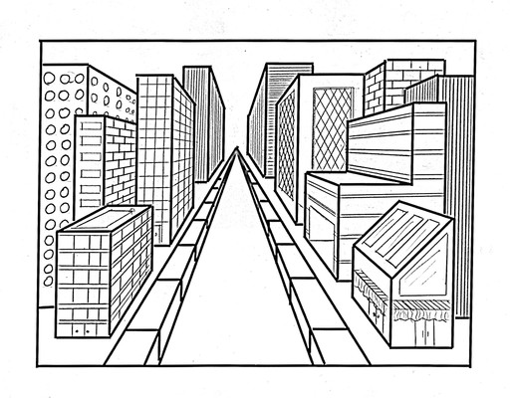
3) Isometric Drawing 4) Perspective Drawing

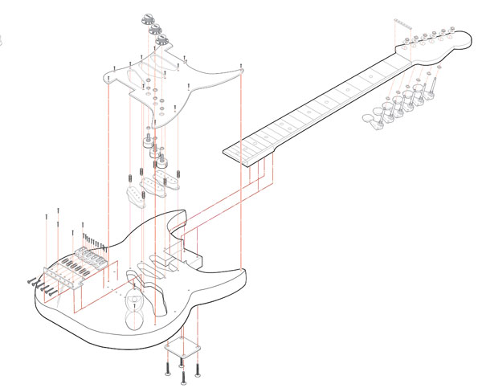

5) Exploded View

