The Story of Canada

You will create a digital presentation using Microsoft Sway to teach your classmates about one of Canada’s provinces or territories. You will gather your research from books in our classroom. You must put the information in your own words before adding it to your Sway. You and your partner must decide which 3 of the 6 sections you each will complete.
CHOOSE 2: | CHOOSE 1:
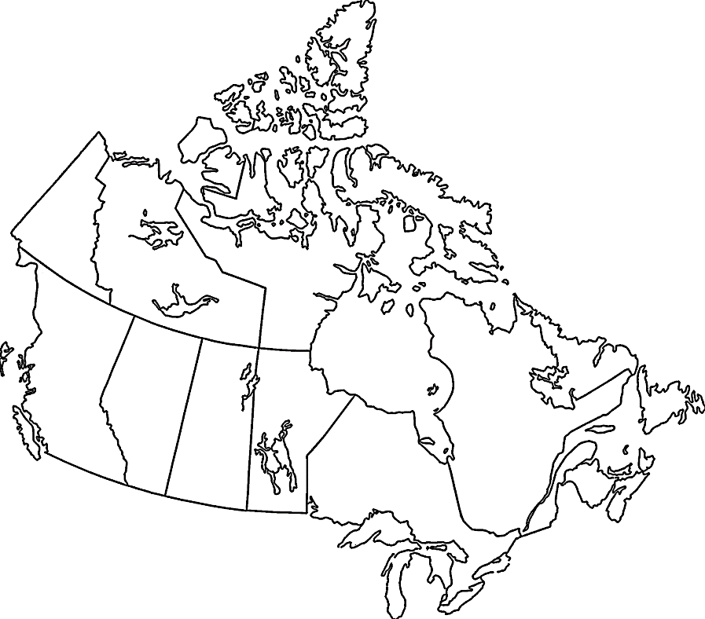  Welcome to…  Introduce your province! Include what the province stands for/what it represents, its flag, provincial flower/bird/gemstone and current population.  Did You Know?  Include 3 interesting points about this province.  A Bit of History  Share 3 facts about this history of province.  Points of Pride  Name 3 aspects of this province its residents are proud of. | Maps  You will need to have 2 maps: 1 will be a close-up of your province with the capital city and 1 will indicate where in Canada the province is located.  Pictures  Choose 3 pictures that represent elements of your province’s culture. Each picture is required to have a short caption below that identifies connections to the province.

______________________ will complete the following 3 sections:
- _______________________________________________

- _______________________________________________

- _______________________________________________
______________________ will complete the following 3 sections:
- _______________________________________________

- _______________________________________________

- ________________________________________________________

