How do numbers relate to everyday life? Come up with some examples of where you see numbers?
You will design a poster that will represent your life in NUMBERS!
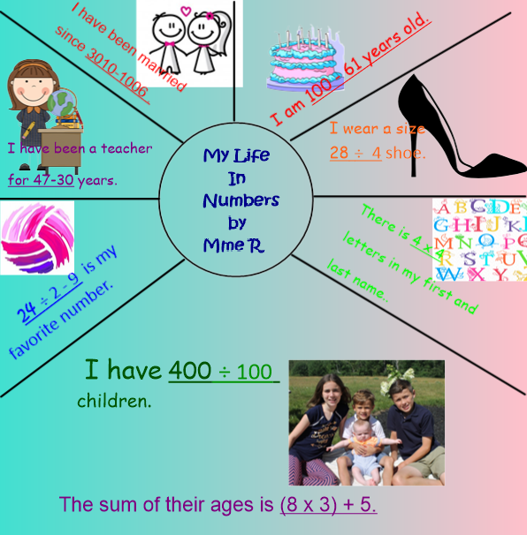
Here are some ideas how math could relate to your everyday life:
- time you wake up/ go to bed
- your favorite number
- your birthday
- # of years playing an instrument/sport/hobby
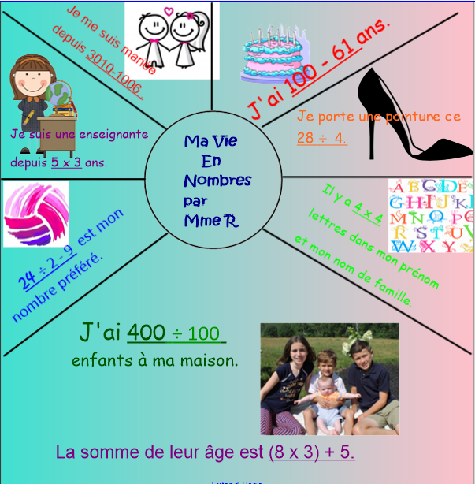
- # of sports you play
- Grade you are in
- house number
- age
- # of siblings
- # of pets
- height / weight
- # of places you have travel
- The time you spend on Homework each week
- The time you spend on activities (sports, watch tv) a week

Here is an example of how you can represent your life in numbers!

