Snake Dice
4
5
3
2

9
10
8
6

11
12

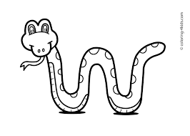

Directions:
Take turns rolling dice.
Add the dice together and put a counter/ button /cheerio or a Lego on that number.
.
If your sum is 7, you have to cover a snake.
Winner is the one who covers all
of the numbers before the snakes.

