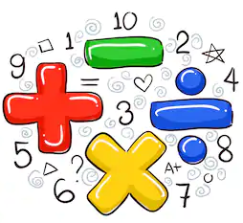
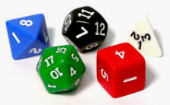
Math
Is
Everywhere!
“Without mathematics, there’s nothing you can do. Everything around you is mathematics. Everything around you is numbers”
-Shakuntala Devi

Tips to engage your children at home;
- Play various games – dice, cards, board games, online Math games
- Cook/bake with your child – it involves measuring, ordering, estimating, adding, problem solving
- Discuss everyday activities using the calendar-read the days of the week, countdown to special days/events, read the numbers and talk about changes and patterns of the seasons
- Restaurants and shopping involves money, counting, number identification, estimating, adding and subtracting
- Planning dinners/parties- involves planning and counting one to one, estimating, adding, subtracting, money (budget)
- Gardening- involves measuring, counting, and geometry
- Sorting- toys, crayons, foods/snacks, things you find at the beach (seashells, rocks)

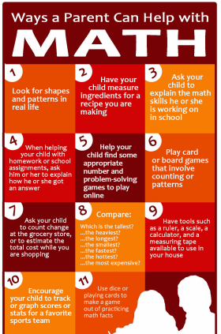

ONLINE GAMES
https://www.topmarks.co.uk/
http://www.abcya.com/
https://www.mathplayground.com/
http://www.jmathpage.com/
http://gregtangmath.com/

