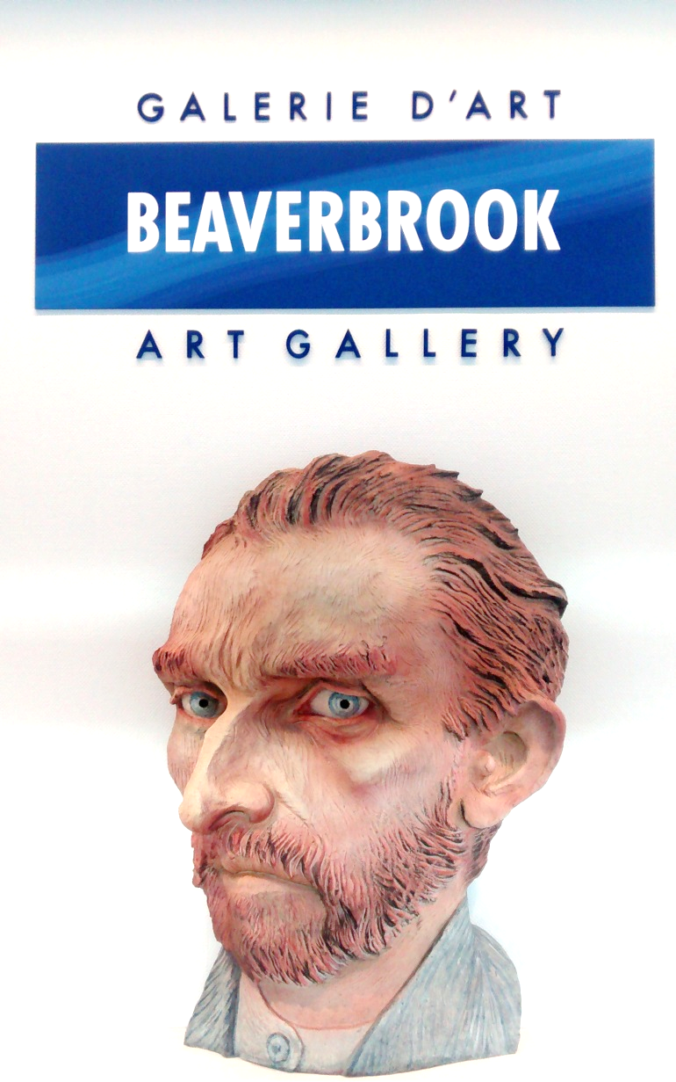
ART AFTERSCHOOL
Art is all around us! Draw, paint, and sculpt! Develop your creative skills
With Brittany Schuler
GRADES 3-5 3-5pm
Thursdays
6 weeks: March 14- April 18
AT GIBSON NEILL
REGISTRATION FORM

Student Name:

Grade:

Birthdate:

Parents’ Name:

Email:

Emergency Number:

Special Considerations (Behavioural issues, allergies, etc.):

$90 FOR THE 6-WEEK PROGRAM

Registration can be completed through Beaverbrook Art Gallery. Payments can be made by phone, in person, or by cheque..
By signing below, I authorize the use of my child’s photo and images of artwork for Gallery publications.
Opt out for child’s photo
Opt out for child’s artwork

Signature:

506-458-2028. 703 Queen Street, F’ton, NB emailbag@beaverbrookartgallery.org
ART AFTERSCHOOL
Art is all around us! Draw, paint, and sculpt! Develop your creative skills
With Brittany Schuler
GRADES 3-5 3-5pm
Thursdays
6 weeks: March 14- April 18
AT GIBSON NEILL

REGISTRATION FORM

Student Name:

Grade:

Birthdate:

Parents’ Name:

Email:

Emergency Number:

Special Considerations (Behavioural issues, allergies, etc.):

$90 FOR THE 6-WEEK PROGRAM

Registration can be completed through Beaverbrook Art Gallery. Payments can be made by phone, in person, or by cheque..
By signing below, I authorize the use of my child’s photo and images of artwork for Gallery publications.
Opt out for child’s photo
Opt out for child’s artwork

Signature:

506-458-2028. 703 Queen Street, F’ton, NB emailbag@beaverbrookartgallery.org

