The Hourglass Newspaper Article
Name:_____________________________ Total_________/30
Instructions: Students will demonstrate their knowledge of the hourglass format by crafting a 750 word article on a school-based or local topic of their choice.
Criteria | 4 | 3 | 2 | 1
Lead | -Includes all relevant 5 w’s  -No more than 35 words  -Summarizes news story and answers readers’ questions  -High level of interest and engagement  - A clear angle for their story is evident | -May have missed 1 of the relevant w’s  -No more than 35 words  -Summarizes news story and answers most of the readers’ questions  -Adequate level of interest and engagement | -Lead misses more than 1 of the relevant w’s  -Is significantly shorter or longer than 35 words  -Does not adequately summarize news story, nor answer most of the readers’ questions  -Low level of interest and engagement | -Lead is missing or address limited relevant w’s or feature lead is written instead  -Does not summarize news story, nor answer any of the readers’ questions  -Minimal level of interest and engagement
Structure | -Skillfully follows an hourglass format  With a clear top, turn, and narrative focus. | -Follows an hourglass format with a clear top, turn, and narrative focus. | -Somewhat follows an hourglass format. The top, turn, and/or narrative focus may not be clear to identify. | -Does not attempt to follow pyramid style.
Providing Information | -All information is newsworthy  -There is no opinion or bias in reporting  - Interviewer has chosen an interviewee that highlights the issue well | -Most information is newsworthy  -There are a few instances when opinion or bias is detected in reporting  - The interviewee supports the angle of the news story | -Very little information is newsworthy  -There are many instances when opinion or bias is detected in reporting  - The interviewee may provide context, but not necessarily the best response for the interviewers angle | -Story lacks any newsworthiness  -Story shows an obvious or consistent bias
Quotes | -All quotes are relevant  -All quotes have their own paragraphs  -All sources are attributed  - Evidence of past lessons have been carefully followed. | -Most quotes are relevant  -Most quotes have their own paragraphs  -Most sources are attributed. | -Some quotes are relevant  -Some quotes have their own paragraphs  -Some sources are attributed. | -No quotes used and/or are irrelevant  -Quotes do not have their own paragraphs  -None of the sources are attributed.
Formatting | The following elements are all included:  - heading  - photo  - caption  - name /affiliation  - single-spaced  - size 12 font  - new paragraphs by skipping lines | 6 of the following elements are included:  - heading  - photo  - caption  - name /affiliation  - single-spaced  - size 12 font  - new paragraphs by skipping lines | 5 of the following elements are included:  - heading  - photo  - caption  - name /affiliation  - single-spaced  - size 12 font  - new paragraphs by skipping lines | 4 or fewer of the following elements are included:  - heading  - photo  - caption  - name /affiliation  - single-spaced  - size 12 font  - new paragraphs by skipping lines
Grammar / Punctuation | There are no errors in grammar, punctuation, and / or spelling that make it difficult to understand the article. | There are a few (2-4) errors in grammar, punctuation, and / or spelling that make it difficult to understand the article. | There are several errors (5+) in grammar, punctuation and / or spelling that make it difficult to understand the article. | There are numerous errors in grammar, punctuation and/or spelling that make it difficult to understand the article.
Photo | The photo is clear. The camera shot style and image capture the angle used in the story. | The photo is a bit blurry OR the camera shot style and image do not quite capture the angle used in the story. | The photo is a bit blurry. AND the camera shot style is impersonal (too many shadows/the angle is impersonal). | The photo quality is poor.
Headline (2 points) | The headline is powerful, engaging, but does not appear to be sensationalistic. It avoids using excess articles (the, and, etc.) |  | The headline is present and captures the main idea of the topic.
The Hourglass Structure
Clark said the hourglass story can be divided into three parts:

THE TOP. Here you deliver the news in a summary lead, followed by three or four paragraphs that answer the reader's most pressing questions. In the top you give the basic news, enough to satisfy a time-pressed reader. You report the story in its most concise form. If all that is read is the top, the reader is still informed. Because it's limited to four to six paragraphs, the top of the story should contain only the most significant information.

THE TURN. Here you signal the reader that a narrative, usually chronological, is beginning. Usually, the turn is a transitional phrase that contains attribution for the narrative that follows: according to police, eyewitnesses described the event this way, the shooting unfolded this way, law enforcement sources and neighbors agree.

THE NARRATIVE. The story has three elements: a beginning, middle and end. The bottom allows the writer to tell a chronological narrative complete with detail, dialogue, and background information.

The hourglass form summarizes the news, then shifts to a narrative. The top delivers the news, the turn acts as a transition, the narrative tells the story.
The hourglass can be used in all kinds of stories: crime, business, government, even to report meetings. It's best suited, however, for dramatic stories that can be told in chronological fashion. In the right hands, as the following story from The Miami Herald illustrates, the hourglass is a virtuoso form that provides the news-conscious discipline of the inverted pyramid and the storytelling qualities of the classic narrative.
BEHIND THE HOURGLASS

1. THE TOP

Shots Fired While He Stabbed Ex-Wife
By Conie Piloto and Molly Hennessy-Fiske
The Miami Herald
Aug. 9, 1998
It wasn't the first time that Dennis Leach had violently terrorized his ex-wife. But it will be the last.
Leach, 37, was shot by Davie police Saturday afternoon after he disregarded their orders to drop his knife and instead plunged it repeatedly into Joyce Leach outside her duplex at 6110 SW 41st Ct.
Dennis Leach was pronounced dead at the scene. His ex-wife, who asked police, "Why did you shoot him?" as she was loaded into the ambulance, was taken to Memorial Regional Hospital in Hollywood, where she was listed in stable condition.
The mayhem was witnessed by Dennis Leach's parents and some neighbors. The neighbors said turmoil at the Leach home was nothing new.
In May, Dennis Leach was charged with aggravated assault when, according to police, he showed up with a hammer, broke a window and chased his ex-wife around the duplex, shouting, "I'm going to kill you!"

In the first five paragraphs, the story conveys all the information the time-pressed reader needs to know: Police shoot to death a man who refuses their commands to drop his knife and stabs his ex-wife instead. The top answers several of the five W’s: who, what, where, when, why, as well as how. A special feature of this lead is the first paragraph, which departs from the usual summary lead: Police shot and killed a 37-year-old Davie man after he disregarded their orders to drop his knife. Instead the writer draws in the reader with an indirect approach that sums up the situation with chilling finality.

2.THE TURN

Police and neighbors gave this account of the latest domestic violence:

The transition is short, alerting the reader that the news report is shifting to storytelling form and indicating the sources for the chronicle to come.

3. THE NARRATIVE

Dennis Leach became angry with his 37-year-old ex-wife after he went to a neighborhood bar Friday night. He stormed into her duplex Saturday afternoon and threatened her with a butcher knife.
A terrified Joyce Leach dashed next door to the adjoining home of Leach's parents.
"He's got a knife, and he's gonna kill me!" Leach's mother, Reba Leach, said her daughter-in-law screamed.
At the same time, 15-year-old April Leach, one of their six children, called from a convenience store blocks away.
"Your father is going to kill me!" Joyce Leach yelled.
April Leach hung up and dialed 911.
When officers arrived at the duplex, Dennis Leach was chasing his ex-wife with a knife.
Police ordered him to drop the weapon, said Davie Capt. John George.
Instead, Leach started stabbing her.
An officer fired at Dennis Leach, striking him around a knee, but he wouldn't stop plunging the knife into his ex-wife, neighbors said.
An officer or officers fired again, this time hitting Leach in the chest. He collapsed and died on the side of the road. His parents were watching from inside their home.
Davie police would not say whether more than one officer fired at Dennis Leach, nor would they identify the officer or officers.
Neighbors say they heard at least five shots.
As police carried Joyce Leach to an ambulance, the knife still stuck in her right shoulder, she turned to police and said: "Is he dead, is he dead. ... Why did you shoot him?" said next-door neighbor Shannon Schmitzer.
As Joyce was hoisted into the ambulance and police placed a yellow tarp over Dennis Leach's body, April Leach and a brother arrived.
The two siblings cried and tried to run to their mother and father but were escorted away.
Police later drove them to Memorial Regional Hospital to be with their mother.
Dennis and Joyce Leach lived for years in the duplex owned by Leach's parents.
"They've had a lot of trouble in the past," Schmitzer said.
As the couple's problems escalated, the Department of Children and Family Services stepped in. The state took custody of the children for a while, placing them in foster homes, neighbors said.
Joyce Leach got a job at Dunkin' Donuts, just blocks away, but Dennis Leach couldn't stay out of trouble.
In May, Davie police charged him with domestic violence and aggravated assault after the incident with the hammer. He was convicted and jailed for 90 days.
He got out Tuesday night and returned to his family's house, his mother said.
"We weren't supposed to let him stay here," his mother said. "But he just showed up."
The time had come to tell the story of what transpired the night Dennis Leach died. The writer tells the story chronologically, drawing together information gleaned from interviews with the sources identified in the turn. As with all stories, the narrative section has a beginning, a middle that describes the main action, and an end, with the climactic cry of the abused ex-wife, "Why did you shoot him?" The conclusion wraps up the story with background about the couple's troubles and then, like many good stories, ends on a note that echoes back to the beginning. Note how the writer uses dramatic quotations and vivid details, such as the yellow tarp that covers Dennis Leach's body, to show the narrative scene that the reader is merely told about in the top.
The hourglass is a form that satisfies editors who prefer a traditional approach to news writing as well as impatient readers who tire easily of leisurely approaches to stories that take forever to get to the point. Readers who want a more complete story, who like to see a story unfold as they read it, are happy as well. The hourglass serves readers' need for news and their natural desire for story.
Retrieved from: https://www.poynter.org/news/hourglass-serving-news-serving-reader

Yankees See Alex Rodriguez as a Starter, as Long as He Earns It
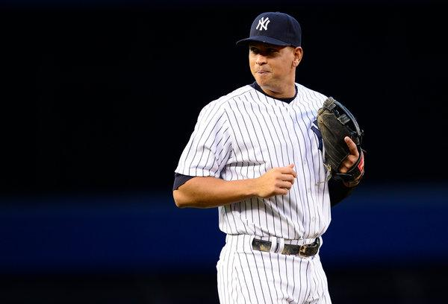
Yankees Manager Joe Girardi said the Yankees expected Alex Rodriguez to be the Yankees' third baseman in 2015.CreditCreditBen Solomon for The New York Times
By David Waldstein
Less than 24 hours after his team’s final game of 2014, Manager Joe Girardi returned to Yankee Stadium on Monday and addressed questions about the failures of the season and the preparations for 2015.
Not surprisingly, a main topic was Alex Rodriguez. The Derek Jeter era had only just ended, and it already felt as if the Rodriguez era had begun.
Girardi said the Yankees expected Rodriguez to be their third baseman in 2015, but he also said it was a position Rodriguez must earn.

“He hasn’t played in a year,” Girardi said. “That’s not easy to do. I’ve got to see where he’s physically at, see from a playing standpoint where he’s at. Do we expect him to be a player on our team? Absolutely. Do we expect him to play third base? Yes. But in fairness, I think you have to see where he’s at.”
Image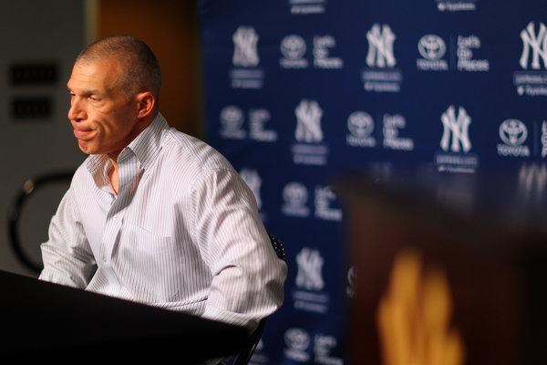
Manager Joe Girardi spoke to reporters at Yankee Stadium on Monday.CreditChang W. Lee/The New York Times
Rodriguez is in the final month of a season-long suspension for performance-enhancing drugs, which ends the day after the World Series. He has been working out, but Girardi said that until the Yankees saw Rodriguez playing in spring training games, they would not know if he could be an everyday player.
Could that mean that Rodriguez, who is owed a minimum of $61 million over the next three years, barring a buyout or a medical dispensation, would be a bench player?
“Hey, I can’t tell you what’s going to happen,” Girardi said. “But we expect him to be our third baseman.”
Girardi also said the Yankees had not spoken to Rodriguez about the possibility of playing first base. But he said he had texted with Rodriguez once or twice a month since the season began, just to check in on him.
There will be a great deal of attention placed on Rodriguez as he tries to come back, and some of it will be negative. But Girardi said that if anyone was capable of handling that, and perhaps thriving on it, it was Rodriguez.
“I have a good relationship with Alex,” Girardi said. “Our teammates enjoy Alex, his presence in the clubhouse, the way he likes to teach the game and talk about the game. I don’t think that will be an issue. Will he have to deal with some angry fans? Yeah, but we’ll help him get through that. When was the last time that Alex hasn’t had to deal with that? So it’s not like it’s something he’s not used to. Sometimes players thrive on that, so maybe it will help him.”
If Rodriguez is capable of hitting at all, the Yankees want him. Their offense was terrible, the primary reason Girardi was giving a postmortem news conference Monday instead of announcing his starting rotation for the playoffs.
The Yankees scored only 633 runs. Yes, offense has declined over all in baseball, but the Yankees may have suffered a greater decline than most teams, in part because of defensive infield shifts against them, which have proved torturous to Mark Teixeira and Brian McCann, who hit in the middle of the batting order. Their batting averages have declined in the past few years, and much of that can be attributed to shifts.
Girardi said the Yankees would address ways to beat the shifts.
“Will it be something we work on in spring training?” he said. “Yes, it will be.”
Asked about the coaching staff, Girardi was vague, saying the coaches would be evaluated, including himself. He said he saw the same approach and quality of work from Kevin Long, the hitting instructor, as he did when Long presided over an offense that scored 915 runs in 2009.
“I really still believe that there’s enough talent in that room, when you put all the pieces on the field, to score runs,” Girardi said. “We didn’t do it enough this year; I understand that. But I still believe there is enough talent in that room. Time is going to tell. We’ll have 150 days to think about it, and then about 45 days to get ready. And then we’re going to find out.”

