Poetry Analysis Assignment: TP-CASTT
Ms. Stiles
Grade 10 English
Quarter 1

Students will analyze a poem using the TP-CASTT framework explained in class. Students will select, read, and identify figurative meaning as well as the overarching theme of the poem.
Steps:
- Choose a poem from poetryinvoice.com (Go to the tab that says “poems” and then click on “roulette” to access poems)
- Choose a poem that is no less than 25 lines in length and shows evidence of complex word choice and figurative language (this will be helpful during the paraphrasing stages of this poem).
- Have Ms. Stiles pre-approve your poem before beginning.
- Write the poem neatly on loose-leaf. The structure and line breaks should be as close as possible to the original version.
- Jot down some point form ideas on the handout on the back of these guidelines (to be used during conferences).
- Type the good copy of your analysis in size 12 font, single-spaced. Follow the MLA format as shown below:
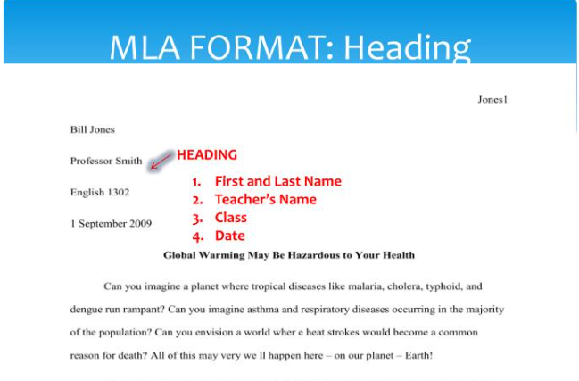
Structure
- See the back for more details
Criteria for Success (points per stanza)
- The student selected a poem that is challenging to analyze.

- The student followed the TPCASTT framework closely.
- The student identified the line number and used quotations marks where necessary.

TOTAL: /30
Submission Date: _______________
Rubric
Title: /2

Consider the title and make a prediction about what the poem is about.
Paraphrase: /10

Translate the poem line by line into your own words on a literal level. Look for complete thoughts (sentences may be inverted) and look up unfamiliar words.
Connotation: /6

Examine the poem for meaning beyond the literal. Look for figurative language, imagery, and sound elements (at least three examples have been identified and explained).
Attitude / Tone: /3

Notice the speaker’s tone and attitude. Humor? Sarcasm? Awe? (consult your tone list).
Shifts: /3

Note any shifts or changes in speaker or attitude. Look for key words, time change, punctuation.
Title Revisited: /2

Examine the title again, this time on an interpretive level.
Theme: /4

Briefly state in your own words what the poem is about (subject), then what the poet is saying about the subject (theme).

Total:_____________/30

