Macbeth – Writing Activity
Outcome 2.2: Students will adapt language and delivery for a variety of audiences and purposes in informal and formal contexts, some of which are characterized by complexity of purpose, procedure, and subject matter.

Outcome 10.3: Students will use technology effectively to serve their communication purposes (design texts they find aesthetically pleasing and useful).

As we have seen over the course of the past two weeks, the tragedy of Macbeth can best be appreciated by viewing its use of language and presentation style. Many of the soliloquies and witches’ incantations show evidence of film shots/angles that have been intentionally used to develop atmosphere and tone.

For this assignment, you will demonstrate your performance skills by choosing one of the following:
- A group incantation (maximum three)
- A soliloquy (individual)

Assignment A: A Group Incantation
Scenario: Imagine you and two fellow witches will summon a thing or action into being. Script the conversation you have as you plan an evil curse on some poor member of humankind.

Guidelines:
- Select a victim. (Use good judgment! We’re not going to maliciously poke fun at someone. A celebrity or “distant” figure would work best.)
- Write your lines using rhyming couplets and trochaic tetrameter (30 line – minimum). You may use ‘Shakespearean’ language or a more modern interpretation.
- Consider how you will convey the atmosphere and tone by carefully considering camera angles (if applicable), voice, and movement. All group members must participate.
- An incantation is usually organized by the following:
A welcoming: individual members address each other around the cauldron.
An introduction: The witches identify who or what thing is the cause of the gathering.
The Description: The witches describe the person or thing in question, revealing its personality.
The Outcome: The witches consider how best to deal with this person or thing.
- Get ready to share. This may be done by sending me a video of your performance or by presenting in front of the class.

Remember to use trochaic tetrameter – a stressed syllable followed by an unstressed syllable.
/ U / U / U / U
Double, double, toil and trouble
/ U / U / U / U
Fires burn and cauldrons bubble

Sample Script for a group of 3:

All: Double, double, toil and trouble
Fires burn and cauldrons bubble

1: Tell me, tell me, tell me now
Who has heard that cat meow?

2: I have heard it, late at night
Screeching, screaming in a fright

3: Sounds of terror make me stir
Shrieks of fury from that fur

1: Tell me, tell me, what to do
Shall we wreak a curse anew?

2: Can we? Can we? Please say yes!
At last that cat will meet his mess.

3: Bring the cat and hold him high
He will wish he’d been more shy

1: Around the cauldron we shall meet
There to dip his fur-lined feet

2: In the cauldron pour our brew
That cat will surely make good stew

3: No more nights without our sleep
Nights will come without a peep

All: Double, double, toil and trouble
Fires burn and cauldrons bubble.

Assignment B: A Soliloquy
Scenario: Imagine yourself through the persona of a celebrity, politician, or character from Macbeth. You are overcome by emotion my an issue and choose to reveal your inners thoughts through a private speech.

Guidelines:
- Select an individual and consider their issue. You will write a private speech that provides insights about an individual’s personality through verse.
- Write your lines using iambic pentameter (10 line – minimum). You may use ‘Shakespearean’ language or a more modern interpretation.
- Consider how you will convey the atmosphere and tone by carefully considering camera angles (if applicable), voice, and movement.
- A soliloquy is usually organized by the following:
Exposition: The character reflects on a frustrating situation, character or conflict.
Complication: The character explains why the situation has become more complex.
Crisis: The character reaches a turning point in their thought process on the issue.
Resolution: The character shares their possible response to this issue (think: the struggle between good and evil).
Denouement: The character reveals their final decision and course of action.

- Get ready to share. This may be done by sending me a video of your performance or by presenting in front of the class.

Remember to use iambic pentameter – an unstressed syllable followed by a stressed syllable.
U / U / U / U / U /
This deed I’ll do before this purpose cool:

U / U / U / U / U /
But no more sights!—Where are these gentlemen?

Shot Types
There is a convention in the video, film and television industries which assigns names and guidelines to common types of shots, framing and picture composition. The list below briefly describes the most common shot types (click the images for more details).
Notes:
- The exact terminology varies between production environments but the basic principles are the same.
- Shots are usually described in relation to a particular subject. In most of the examples below, the subject is the boy.
- See below for more information and related tutorials.
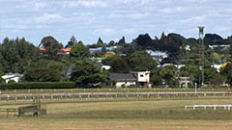
EWS (Extreme Wide Shot)
The view is so far from the subject that he isn't even visible. Often used as an establishing shot.
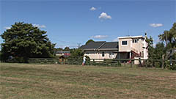
VWS (Very Wide Shot)
The subject is visible (barely), but the emphasis is still on placing him in his environment.
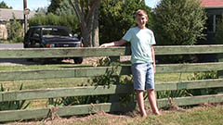
WS (Wide Shot)
The subject takes up the full frame, or at least as much as comfortably possible.
AKA: long shot, full shot.
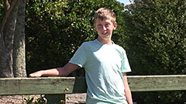
MS (Mid Shot)
Shows some part of the subject in more detail while still giving an impression of the whole subject.
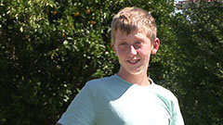
MCU (Medium Close Up)
Half way between a MS and a CU.
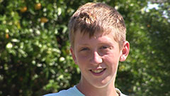
CU (Close Up)
A certain feature or part of the subject takes up the whole frame.
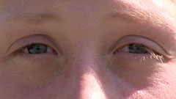
ECU (Extreme Close Up)
The ECU gets right in and shows extreme detail.
Variation: Choker
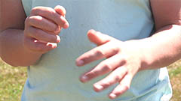
Cut-In
Shows some (other) part of the subject in detail.
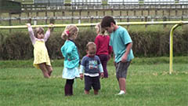
CA (Cutaway)
A shot of something other than the subject.
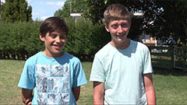
Two-Shot
A shot of two people, framed similarly to a mid shot.
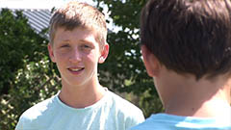
(OSS) Over-the-Shoulder Shot
Looking from behind a person at the subject.
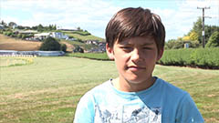
Noddy Shot
Usually refers to a shot of the interviewer listening and reacting to the subject.
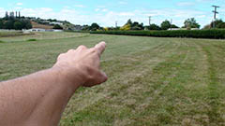
Point-of-View Shot (POV)
Shows a view from the subject's perspective.
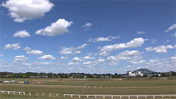
Weather Shot
The subject is the weather. Can be used for other purposes, e.g. background for graphics.

Camera Angles
The term camera angle means slightly different things to different people but it always refers to the way a shot is composed. Some people use it to include all camera shot types, others use it to specifically mean the angle between the camera and the subject. We will concentrate on the literal interpretation of camera angles, that is, the angle of the camera relative to the subject.

Eye-Level
This is the most common view, being the real-world angle that we are all used to. It shows subjects as we would expect to see them in real life. It is a fairly neutral shot.

High Angle
A high angle shows the subject from above, i.e. the camera is angled down towards the subject. This has the effect of diminishing the subject, making them appear less powerful, less significant or even submissive.

Low Angle
This shows the subject from below, giving them the impression of being more powerful or dominant.

Bird's Eye
The scene is shown from directly above. This is a completely different and somewhat unnatural point of view which can be used for dramatic effect or for showing a different spatial perspective.
In drama it can be used to show the positions and motions of different characters and objects, enabling the viewer to see things the characters can't.
The bird's-eye view is also very useful in sports, documentaries, etc.

Slanted
Also known as a dutch tilt, this is where the camera is purposely tilted to one side so the horizon is on an angle. This creates an interesting and dramatic effect. Famous examples include Carol Reed's The Third Man, Orson Welles' Citizen Kane and the Batman series.
Dutch tilts are also popular in MTV-style video production, where unusual angles and lots of camera movement play a big part.
Retrieved from: https://www.mediacollege.com/video/camera/angles/

