Podcast Project: Shakespeare’s A Midsummer Night’s Dream
Student Outcome: 10.3 – Students will experiment with the use of technology in communicating a range of purposes.
What is a podcast?
A podcast is “a digital or video file or recording, usually part of a themed series, that can be downloaded from a website to a media player or computer” (https://www.dictionary.com/browse/podcast)
Steps:
- Choose a topic for A Midsummer Night’s Dream. Identify your topic, angle, purpose and audience.
- Complete a brainstorming sheet on loose leaf. You will need to submit this on Wednesday. Your sheet must contain the following:
-The interviewer’s name and role (student, media, journalist, fan, etc.)
- The interviewee’s name and role (an actress, English teacher, parent, peer, etc.)
- Your topic and angle (See the “One Topic = 18 Ways” handout)
-Five key quotes (and the character who delivers them) you feel are most
relevant/important to your topic
- Choose a partner. You will take turns being the interviewer for each other.
- After you have a partner, you each must come up with 6-7 questions you want your partner to ask you. Remember: Your job is to answer the questions. Your partner will not be assessed on their presentation skills, they are merely making the podcast appear authentic.
- When you have the questions finalized, create a neat script of that contains your questions and answers to those questions in a script format. You will submit this paper copy to me.
- Create your podcast using the free app, Anchor. If you do not own a phone, you may record your audio on a laptop. Please see me well in advance if this is the case.
- Save your podcast under your full name (for example: Suzie.Quentin) and submit/share your podcast with me at Robyn.Stiles@nbed.nb.ca

Due Date: ______________________________________

Resource: Before starting your project, preview a podcast online!
- https://www.folger.edu/shakespeare-unlimited

Possible Topics
Just make sure you have proof from the text to support your statements.
1. LOVE is… (narrow down to a specific idea, such as unfair, Love is True, Love is Blind, everyone needs love)
2. Love is portrayed in many different ways in the play.
3. There are many different TYPES of love in the play. (forced love, romantic love, parental love, friendship love…)
4. The characters in the play will do anything for love.
5. The characters are VICTIMS to love. (love is identified as a concrete object here, who bullies)
6. Argue FOR or AGAINST Lysander’s quotation, “The course of true love never did run smooth”.
7. The love portrayed among the four lovers is similar to love among teens today (the times have remained unchanged).
8. Hermia was treated unfairly by her father and the “Athenian Law”.
9. Oberon is the root behind all of the problems in the play.
10. Puck is the root behind all of the problems in the play.
11. __________(character) is… (give 3 characteristics of a character and explain how/why they are true.
ex: Helena puts all women to shame … she is desperate, insecure, and a liar.)
12. Hermia and Lysander will have a prosperous marriage.
13. Comment on the use of the word “ass” in the play.
14. Comment on the use of the word “dream” in the play.
15. Comment on Shakespeare’s use of magic in the play (ex: Shakespeare uses magic to create conflict, establish an atmosphere, etc.).

16. Egeus needs to “get with the times”…he needs to set his old-fashioned ways behind him.
17. Comment on Hippolyta’s love for Theseus… is it true or is she faking it?
18. Comment on the love between any two of the couples.
19. Oberon and Titania are not suited for marriage.
20. If I was a director, these actors/actresses would best portray _________ (Lysander, Hermia, etc.)
21. Discuss Shakespeare’s use of comedy in the play.
22. Almost, Maine is a better representation of teenage love because ____________.
23. A government official in London, England, during the sixteen hundreds whose name was Samuel Pepys said after he saw the play performed, that it was the most dull and ridiculous play that Shakespeare ever wrote. Pepys became famous for his dairy, which included his personal comments about social customs of the time. Do you agree or disagree? Explain.
24. Explain how the elements of comedy are used in the play (slapstick, wordplay, character comedy, insults, one-liners etc.).
25. If the essence of each scene could be captured in a song, ________ would work because ______.

Shakespeare Podcast Rubric
Name:________________________________________ Overall Total:___
CATEGORY | Excellent | Good | Adequate | Unsatisfactory | POINTS
Introduction | 4 points | 3 points | 2 points | 1 point | ___/8
 | Catchy and clever introduction. Provides relevant information and establishes a clear purpose engaging the listener immediately. | Describes the topic and engages the audience as the introduction proceeds. | Somewhat engaging (covers well-known topic), and provides a vague purpose. | Irrelevant or inappropriate topic that minimally engages listener. Does not include an introduction or the purpose is vague and unclear.
 | Tells who is speaking, date the podcast was produced, and where the speaker is located. Interlude music is included and adds to the atmosphere of the podcast. | Tells most of the following: who is speaking, date of the podcast, and location of speaker. Interlude music is included. | Alludes to who is speaking, date of the podcast, and location of speaker. Interlude music is not included. | Speaker is not identified. No production date or location of the speaker is provided. Interlude music is not included.
Content | 4 points | 3 points | 2 points | 1 point | ___/16
 | Creativity and original content enhance the purpose of the podcast in an innovative way. Accurate information and succinct concepts are presented. | Accurate information is provided succinctly. | Some information is inaccurate or long-winded. | Information is inaccurate.
 | Vocabulary enhances content. Literary terms introduced in class (pun, double entendre, etc.) are included. | Vocabulary is appropriate. | Vocabulary is adequate. | Vocabulary is inappropriate for the audience.
 | Includes a wide variety of appropriate and informative quotes. Quotes and sources of information are credited appropriately. | Includes appropriate and informative quotes. Source quotes are credited appropriately. | Includes some variety of informative quotes. Source quotes need some editing and some credits are missing. | Includes no source quotes.
 | Keeps focus on the topic. | Stays on the topic. | Occasionally strays from the topic. | Does not stay on topic.
Delivery | 4 points | 3 points | 2 points | 1 point | ___/8
 | Well rehearsed, smooth delivery in a conversational style. | Rehearsed, smooth delivery. | Appears unrehearsed with uneven delivery. | Delivery is hesitant, and choppy and sounds like the presenter is reading.
 | Highly effective expression, and rhythm keep the audience listening. | Expression and pacing are effective. | Expression and rhythm are sometimes distracting. | Expression, and rhythm are distracting throughout the podcast.
Interview | 4 points | 3 points | 2 points | 1 point | ___/4
 | Well thought out questions that draw interesting and relevant information from the interviewee. | Well thought out questions that are used appropriately. | Open ended questions and follow-up questions are occasionally irrelevant to the topic. | Only yes-or-no questions are used. No follow-up questions are asked.
Graphic and Music Enhancements | 4 points | 3 points | 2 points | 1 point | ___/8
 | Music enhances the mood, quality, and understanding of the presentation. | Music provides supportive background to the podcast. | Music provides somewhat distracting background to the podcast. | Music is distracting to presentation.
 | Transitions are smooth and spaced correctly without noisy, dead space. | Transitions are smooth with a minimal amount of ambient noise. | Transitions are uneven with inconsistent spacing; ambient noise is present. | Transitions are abrupt and background noise needs to be filtered.
TOTAL POINTS |  |  |  |  | ___/44
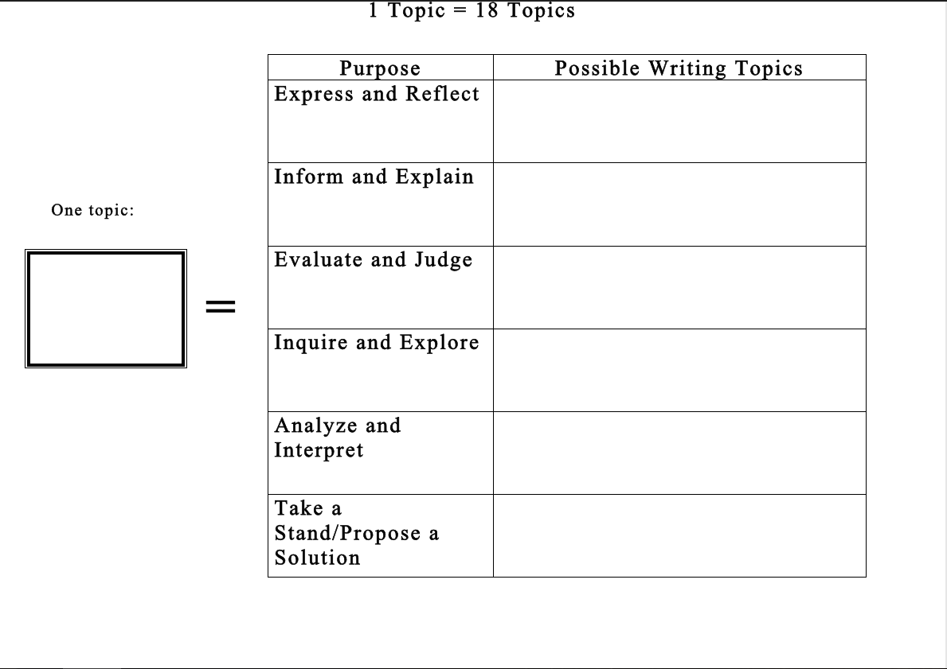

Brainstorming Sheet
(This is worth 10 points and is due on_____________. Any incomplete assignment will receive a value of 0 after the due date.)
Interviewer’s Name: ____________________________Interviewer’s Role:______________________
Interviewee’s Name:____________________________Interviewee’s Role:______________________
Topic - My podcast will examine: _____________________________________________________________________________________
_____________________________________________________________________________________
By the end of my podcast, the audience will have learned:
_____________________________________________________________________________________
_____________________________________________________________________________________
Quote #1: Act ______, Scene _________, Line(s)______________ Speaker:____________________
This passage shows:
_____________________________________________________________________________________
_____________________________________________________________________________________
Quote #2: Act ______, Scene _________, Line(s)______________ Speaker:____________________
_____________________________________________________________________________________
_____________________________________________________________________________________
Quote #3: Act ______, Scene _________, Line(s)______________ Speaker:____________________
_____________________________________________________________________________________
_____________________________________________________________________________________
Quote #4: Act ______, Scene _________, Line(s)______________ Speaker:____________________
_____________________________________________________________________________________
_____________________________________________________________________________________
Quote #5: Act ______, Scene _________, Line(s)______________ Speaker:____________________
_____________________________________________________________________________________
_____________________________________________________________________________________

Podcast Outline
Hook:
- Brief statement, rhetorical question, controversial quote, etc. (“Here’s the assignment. Fourteen lines in iambic pentameter…Now add Taylor Swift.”)
Music Interlude:
- This should be brief and mimic the overall tone of your podcast
Introduction (music should still be playing lightly in the background):
- Introduce branding/affiliation, episode number, and the angle of your podcast series (“From the Folger Shakespeare Library, this is episode number 8 of ‘Shakespeare Unlimited’, the only podcast that examines…”)
- Introduce speaker and any guests (“I’m Michael Whitmore, the Folger Director and long-time supporter of all things Shakespeare.”)
- Provide podcast background: where this podcast takes place, when this podcast takes place, who is in studio with you for the podcast, and what it is you will be exploring (“This episode titled, “Pop Sonnets” was recorded in our Fredericton studio on Thursday, October 13th, 2018. Today I have long-time Shakespeare enthusiast and English teacher, Laura Byron, joining us from Fredericton High School. Laura will be here today to discuss…”)
Provide Context for Podcast:
- What play are your covering?
- What is your purpose/angle?
- Perhaps give a brief summary of the play (very brief, remember this is a well-known play)
Begin your Interview:
- Begin asking your interview questions (use open-ended questions only)
- When you do quote Shakespeare, make sure it is very clear when this quotation begins and ends (read the passage in a different tone or make sure these quotes are outlined by music)
Closing Remarks:
- Parting words from the interviewee: this should provide the purpose/opinion behind the topic
- Farewell: Thank your interviewee for coming and reinforce who they are/their role
Sign-Off:
- Production Notes: who helped produce, direct, and present the podcast? (“Press Among the Throngs” was produced by Garland Steeves. It was edited by Katie Long. Special thanks to our contributing actors…”)
- Final Lines: One last time identify the branding/affiliation of the podcast and your name (“Shakespeare Unlimited comes to you from the Folger Shakespeare Library. You can find out more at FolgerShakespeare.com. From the Folger Shakespeare Library, I am director…”)
- End in music

Steeves 1
Taylor Steeves
English 10
Ms. Stiles
30 November 2018
Podcast Script: Title of Podcast
MICHAEL WITMORE: OK, here’s the assignment. Fourteen lines. All in iambic pentameter … Five iambs, two syllables each. The rhyme scheme is: a-b-a-b, c-d-c-d, e-f-e-f, g-g. Then, add in Taylor Swift. Ready? Go!
From the Folger Shakespeare Library, this is Shakespeare Unlimited. I'm Michael Witmore, the Folger's director. It’s always surprising how Shakespeare, this 450-year-old playwright, continues to crop up in popular culture, and at the time we originally broadcast this podcast, in 2015, this was the latest example.
For two years at that point, a New York software developer named Erik Didriksen had been taking the lyrics to songs by pop stars—50 Cent, Adele, Sir Mix-a-Lot—and converting them into Shakespearean sonnets. The results were hilarious. And like the songs that inspired them, they became immensely popular. At the time we recorded this, Erik had just published a book, titled Pop Sonnets: Shakespearean Spins on Your Favorite Songs. We invited him in to talk about it.
We call this podcast: Press Among the Popular Throngs. Erik Didriksen was interviewed by Barbara Bogaev.
[MUSICAL INTERLUDE]
BARBARA BOGAEV: How does this happen? One day you just wake up and you say to yourself, "There just aren't enough pop songs out there that have been rewritten in the form of Shakespearean sonnets?"
ERIK DIDRIKSEN: I was wondering around the wilderness of the Internet one day, couple of years ago, and came across a Tumblr post. Someone had screenshotted a Twitter account that purportedly takes pop lyrics and turns them into Shakespearean verse, but they weren't doing a terribly good job of it. And someone had posted this on Tumblr and said, "Not in iambic pentameter. Do not accept." And someone responded to it, a gentleman named Johnny from the UK, responded with a perfectly set Shakespearean sonnet version of Macklemore's "Thrift Shop."
BOGAEV: Was it impressive?
DIDRIKSEN: It was one of the funniest things I've ever seen in my life. And I immediately wanted to see more, so I dug through Johnny's Tumblr, and found that that was sadly the only one. And, at the time, I was mildly obsessed with Carly Rae Jepsen's "Call Me Maybe" and wanted to see a "Call Me Maybe" sonnet "so bad," that when I couldn't find one, I decided that I had to do it myself.
[CLIP from CARLY RAE JEPSEN, “CALL ME MAYBE”:]

