Dear Parents and Guardians:
As the Christmas Season approaches, we have a great opportunity for a fundraiser at Central New Brunswick Academy. However, quick action is needed to make it work. We have a great source for fresh cut Christmas trees from Miramichi. We have ordered trees from here in the past, and they have been beautiful trees each year. We invite you and your student to contact friends, family and neighbours whom you think will want a tree. Trees will be available for pick up only at the CNBA Christmas Bazaar on Saturday, November 30th from 9:00am to 12:30 pm. Collect as many names as you can and fill in the attached form. All forms, with funds, must be returned to homeroom teachers this Thursday morning, November 20th. All proceeds from the fundraiser will go to the Grad Class of 2020 & Tech Crew at CNBA to purchase new technology equipment.
Any students who sells a tree (s) will have his/her name put in for a draw on a $50.00 gift card (one ballot for each sale).
Smaller trees: Approx. 6 ft tall are $25.00 (smaller and slimmer)
Larger trees: Approx. 8 ft tall are $30.00 (bigger and fatter)
Trees are generally taller than mentioned above, but we can cut your tree to the exact height you want before you take it home.
Thank you for your support.

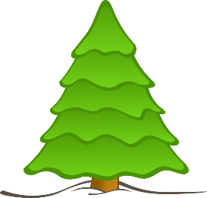
CNBA FUNDRAISER – CHRISTMAS TREES
Trees will be available for pick-up on Saturday, November 30,
from 9 a.m. until 12:30
@ CNBA Christmas Market
Small (6 ft) $25.00 Large (8 ft) $30.00
(Approximate sizes – trees are generally taller, but can be cut to size upon pick-up)
Local fresh-cut trees from Richardson’s Christmas Trees, Miramichi, NB.
(Please return order forms for Thursday, November 21.)
Name | Phone | Small | Large
Homeroom: __________ Seller’s Name: _________________________________

