BLISS CARMAN MIDDLE SCHOOL

2019-2020

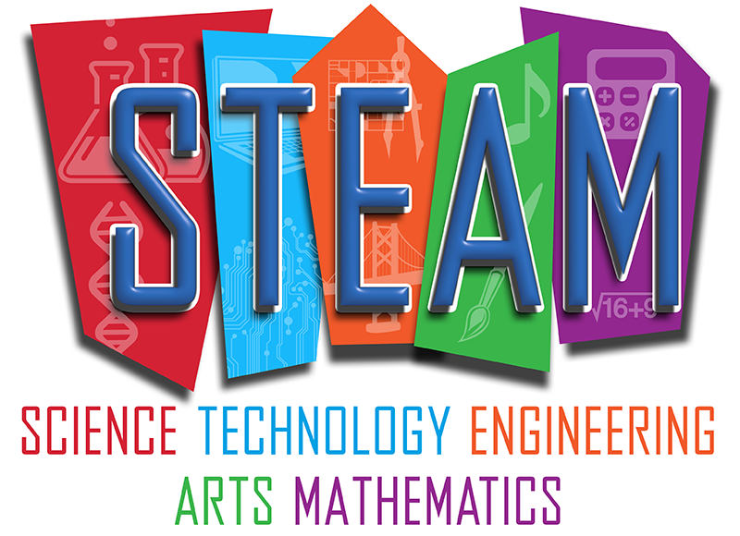

BCMS STEAM Expo
Wednesday, February 19th, 2020
(Storm date: Thursday, February 20th, 2019)
STEAM Expo Project Timeline – 2019/2020

Student: _______________________ Parent:________________

WEEK 1 Nov. 12th - 15th
- Review of the Scientific Method and STEAM Expo was given during class time.

WEEK 2 Nov 18th – 21st
- Students will be given some class time to explore a topic of their choice for their projects, and will receive all handouts needed to complete their project.
- By Monday Nov. 25th all students must have chosen a presentation type, and if they plan to do an experiment they must have their problem and question ready to share with me.

Some possible STEAM Categories to Explore:
Biotechnology and Pharmaceutical Sciences, Computing and Engineering, Earth and Environmental Sciences, Health Sciences, Life Sciences, Physical and Mathematical Sciences.

Start your EXPERIMENT, INVENTION, or INNOVATION now!
If things do not work, you’ll need time to make new plans. Talk to your teacher!

WEEK 3 Nov. 25th – Nov. 28th
Presentation type and topic due.
- Students are expected to complete their experiment / invention / innovation handout by Monday, Dec. 2nd.
- Students should be gathering materials, and planning the time and locations they will perform research, testing, and experiments outside of class time.
- Students can schedule time to meet with me to discuss their projects either at lunch or after school.

WEEK 4+5 Dec 2nd – Dec 13th
Experiment/Investigation/Innovation handout due.
- Students are expected to perform their research, tests, and experiments, and correct any problems that come up.
- Students are expected to hand in their first draft of their written report on Monday, Dec. 16th.

WEEK 6 Dec. 16th – Dec. 20th
First draft of written project due.
- Students should begin working on their display: create a title, plan the location of each section on the board, pictures, results, etc.
- Students may take advantage of the Winter Break to revisit any tricky tests or experiments, or to revise, edit and finalize their written reports (due Monday, January 13th).

WEEK 7 Jan. 7th – Jan 10th
- Prepare a 2-3 minute oral presentation.
- Complete final copy of the written report to be handed in on Monday, January 13th.
- Last touch-ups on your display board.

WEEK 8 Jan 13th – Jan 17th
Final copy of written report due.
- Buffer week to prepare for presentations next week.
- Students should review presentation expectations and practice with friends or family if possible.

WEEK 9 Jan. 20th – Jan 24th
Students present their projects in class.
- A select amount of students will be chosen from a list of those interested in participating in the BCMS STEAM EXPO.
- Selections will be made according to the scoring provided by the STEAM EXPO guidelines.

The tentative date for our BCMS STEM EXPO is Wednesday, February 19th, 2020.
*Snow Date, Thursday February 20th

** Anyone is able to participate in the District STEAM Expo (date to follow). You must register online prior to the event. Be sure to check out the guidelines. See your teacher or Mr. Jones for further information.

STEAM EXPO Projects

Project Guidelines:

1. The project must fall into one of three possible categories:

- An experiment is an attempt to answer a question by designing and conducting an original experiment in which variables are considered and controlled. Examples of this type of project might be:

- an experiment to determine the effect of temperature on the growth of mould.
(variables such as light and moisture must be considered)
- an experiment to determine if boys are faster runners than girls.
(variables such as age and size would have to be considered)
- an experiment to determine which brand of detergent was most effective.
(variables such as water temperature and type of dirt would have to be considered)

- An invention is a unique or novel device, method, composition or process. The invention process is a process within an overall engineering and product development process. It may be an improvement (innovation) upon a machine or product, or a new process for creating an object or a result. Both, an invention and innovation, require, like conducting an experiment, that the developer follow a set of steps from conception to production. Students should have a working model of their invention/innovation with which they can conduct trials/tests.

2. Each project must include some form of display, a written report, and a prepared presentation.

3. The projects will be evaluated on the basis of effort, scientific understanding, originality and format.

4. Some class time will be given for students to research their topics and complete written reports, but most of the hands-on work will be done at home. Students can take the opportunity to drop in at lunch or after school if they have questions about their project or need support.

5. Students are encouraged to get help from a variety of sources: friends, brothers, sisters, mom, dad, aunts or uncles. We would encourage parents and other family members to provide guidance and encouragement. However, the student must demonstrate that they themselves have done a significant amount of the work involved and that they have learned something in the process.

STEM EXPO Projects

Creating your Project
Now that you have your topic, the fun part begins: the actual project.

Experiments
If you are asking a question, you’re doing an experiment. Try to come up with a way to find the answer to your question, and test it. You may not know a way – in this case, ask a teacher or parent for help! You may be able to test your question a lot of different ways, but pick one way for this project. Use the Experiment Handout to help you in the steps for the experiment.

You may want to come up with a title after you finished the experiment. Your title needs to be catchy, and fun – something to grab people’s attention, but still relates to your experiment.

Question, write down the question you are trying to answer. Make sure it is in a testable form.

Hypothesis, you are making a prediction. Before you can start your experiment, you need to make a really good guess about what is going to happen. You may be wrong, it’s ok. That is why you are doing the experiment. Why do you think that what will happen? Write this down.

Materials, make a list of the materials you’ll need for your experiment. Write them down, too. Forgetting to write something down could be a really big mistake when you’re doing the experiment.

Procedure, this section is the steps for doing your experiment. Be really clear – anybody should be able to read your procedure and be able to do the same experiment you did.

Observations and Results, this can take many forms. You may include a data table, chart, graphs, to show the results of your trials. The more trials you have the more valid your results will be. The results section is for communicating what happened during your testing phase.

Conclusion, was your hypothesis correct. Why or why not. This is where you communicate the final results of your testing. Now that you’ve completed your testing, has it raised any further questions? What would you do differently next time?

Inventions

What is the problem? Why are you creating this new invention?

The idea for an invention may be developed on paper or on a computer, by writing or drawing, by trial and error, by making models, by experimenting, by testing and/or by making the invention in its whole form.
Before you can build your invention, you need to research a little about what you are building. If it’s a model of something like a light switch it should be able to work when you’re done.

As with the experiment, you want to come up with a catchy title that grabs peoples’ attention, and tells them what your invention is. You can think of this later, if you can’t think of it now.

The next part you should determine is why this technology is important. In other words, why are you building this invention? You can’t just say “because it’s neat”. How will people use it? Why do we need it?

Next, think of all the materials you’ll need to build your model. Write them down in a list. If you need more space, write on the back of the page.

After you have all the materials written down, write down the steps/procedure you need to follow to actually build your model. You may need a lot of help with this part, and that’s okay – but you are the one doing the work!

Once your procedure is finished, you can move on to actually building the model and testing it out. You should keep track (journal, data table, etc…) of your testing phase. A daily journal of what went right and what went wrong could work. This is your observations/results section.

In your conclusion you will identify if were indeed able to solve your initial problem with your invention. If so, how does it solve the problem? Are there improvements you would make on your next model? If not, what went wrong? What would you do differently next time?

Innovations

Innovation happens when someone improves on or makes a significant contribution to something that has already been invented. When you can take a current object, technology, idea, and find a new use for it or modify it to serve a purpose for which it was not designed.

As with the experiment, you want to come up with a catchy title that grabs peoples’ attention, and tells them what your invention is. You can think of this later, if you can’t think of it now.

The next part you should determine is why this technology is important. In other words, why are you building this invention? You can’t just say “because it’s neat”. How will people use it? Why is it necessary?

Next, think of all the materials you’ll need to build your model. Write them down in a list. If you need more space, write on the back of the page.

After you have all the materials written down, write down the steps/procedures you need to follow to actually build your model. You may need a lot of help with this part, and that’s okay – but you are the one doing the work!

Once your procedure is finished, you can move on to actually building the model and testing it out. You should keep track (journal, data table, etc…) of your testing phase. A daily journal of what went right and what went wrong could work. This is your observations/results section.

In your conclusion you will identify if were indeed able to solve your initial problem with your invention. If so, how does it solve the problem? Are there improvements you would make on your next model? If not, what went wrong? What would you do differently next time?

Experiment Display Board

Left Side Centre Right Side
Question Title Conclusion

Prediction or Observations Mistakes…
Hypothesis

Pictures or illustrations
of experiment in progress

Materials List Thanks

Procedures Bibliography

Display Items in front of board

Invention/Innovation Display Board

Left Side Centre Right Side

Problem Title Conclusion

Why this Model Pictures Thanks
is important

Material List Bibliography

Procedure

Display model in front of board

Project Ideas

Experiments

Which metals conduct heat best?
Which material makes the best heat insulator?
Do black bottom pools keep the water warmer?
Which materials work best to conduct sound?
What happens to dissolved substances during freezing?
How well do various fabrics absorb dye?
Strength of different woods.
Compare the moisture content of varieties of apples.
Does aspiring affect the life of a cut flower?
How does our vision affect taste?
How does smell affect taste?
Does a blindfold person walk in a circle?
The difference between age and reflex time.
The difference between gender and reflex time.
Effects of caffeine on blood pressure.
Lung power of different age groups.
How does age affect memory?
Which pre-wash products work best?
Which uses more water – a shower or a bath?
Which bread has the longest shelf life?
Which battery is the best buy?
Which detergent cuts the grease best?
How do solvents affect freezing temp?
How does the temperature of water affect the solubility?
How do metals compare in density and buoyancy?
What is the effect of vinegar on different metals?
Is depth perception affected by using only one eye?
How does temperature affect yeast?

STEAM EXPO WEBSITES

http://www.sciencebuddies.org/science-fair-projects
(My recommendation)

http://www.all-science-fair-projects.com/

http://sciencepage.org/scifair.htm

http://science-project.com/

http://school.discoveryeducation.com/sciencefaircentral/

http://mathforum.org/teachers/mathproject.html

http://science-project.com/

