Poetry Unit Inventory
Name__________ Date___________
- 1) Limerick Poem Title:______________________________
Line 1: 8-9 syllables.
Line 2: 8-9 syllables, rhymes with line 1.
Line 3: 5-6 syllables
Line 4: 5-6 syllables, rhymes with line 3.
Line 5: 8-9 syllables, rhymes with lines 1 and 2.

2) Haiku Poem
Title: ____________________________
The Haiku is only three lines long.
The Haiku must follow the correct syllable count exactly.
The traditional Haiku follows the syllable format of 5-7-5 on its three lines.

3) Diamante Poem Title: _____________________
Noun
Adjective, Adjective
Verb, Verb, Verb
Noun, Noun, Noun, Noun
Verb, Verb, Verb
Adjective, Adjective
Noun

Nouns. (Person, place, thing)
Adjectives (Describe the nouns)
Verbs (Action words)
4) Spoken word Poetry Title_______________________
- Poem must be original.
- Poem must contain figurative language.

5) Concrete Poetry Title____________________
Creating concrete poetry, first you must select a topic of your choice.
- Then star writing some words down they are associated with this topic.
- Then you must decide the shape in which you would like to write your poem.
6) Blackout Poetry
Title____________________

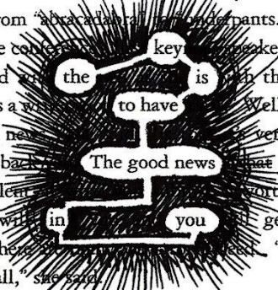 Blackout poems can be created using the pages of old books or even articles cut from yesterday’s newspaper. Using the pages of an existing text, blackout poets isolate then piece together single words or short phrases from these texts to create a masterpieces.

