Student ____________________________ Class ____________ Due Date: ______________________
Instructions: COMPLETE ALL QUESTIONS AND MARGIN NOTES using the reading strategies practiced in class. This requires reading of the article three times.
Step 1: Read (skim) the article using these symbols as you read:
(+) agree, (-) disagree, (*) important, (!) surprising, (?) wondering
Step 2: Read the article carefully and make notes in the margin.
*** Your margin notes are part of your score for this assessment. Notes:
o Comments that show that you understand the article (A summary or statement of the main idea of important sections; inferences made)
o Connections you make (text-to-self, text-to-text, text-to-world)
o Questions you have - show what you are wondering about as you read.
o As needed - notes that differentiate between fact vs opinion, cause vs effect.
o Observations about the writer’s craft (organization, word choice, perspective, support/evidence) and choices affect the article.
Step 3: A final quick read noting anything you may have missed during the first two reads.
Step 4: Answer questions on looseleaf. Remember to use complete sentences and to always include details (the evidence) to support your answer.
Remember you are evaluated on all your work, annotations, margin notes, and question answers.
By Associated Press, adapted by Newsela staff on 02.08.17  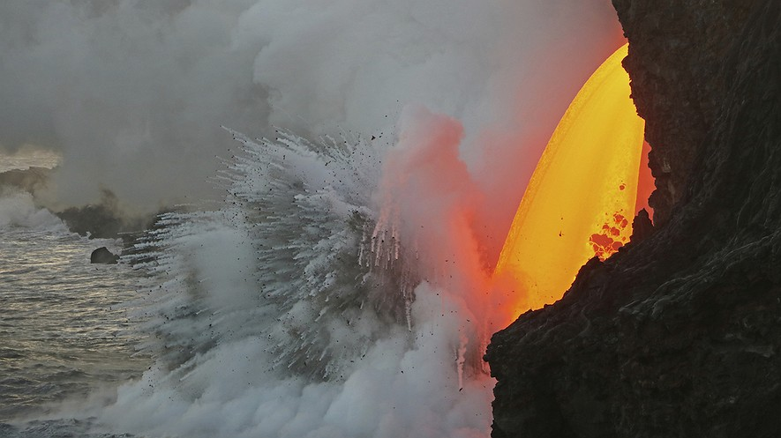  TOP: A January 29, 2017, photo provided by the U.S. Geological Survey shows a lava stream pouring out of a tube on the sea cliff at the Kamokuna ocean entry at Hawaii Volcanoes National Park on the Big Island of Hawaii. Photo from: U.S. Geological Survey via AP BELOW: Hawaiian Volcanoes National Park. Photo by: Anton Backer  HONOLULU, Hawaii — A dramatic stream of molten hot lava continued to shoot out of a sea cliff Wednesday on Hawaii Island. It was splashing into the Pacific Ocean and exploding upon hitting the water.  Molten lava is rock that is so hot it has become liquid. It can pour out of the top of volcanoes, but also out of natural tunnels known as lava tubes.  The new massive lava flow originates from within the Kilauea volcano. It is gushing from a lava tube exiting at the Kamokuna ocean entry, located on the southeast side of the Big Island. The tube was exposed when a huge, 26-acre lava delta collapsed into the ocean on New Year's Eve. A lava delta is new land formed when lava cools and becomes solid. The collapse of this delta triggered massive explosions and giant waves.  The lava stream has been dubbed a "firehose" flow because it shoots lava outward from the source. It started out as a drizzle coming down the sea cliffs after the New Year's Eve collapse, but it has recently increased in strength. The molten lava is now arching out and falling about 70 feet to the ocean below.  When Hot Lava Hits Cool Water ... Boom!  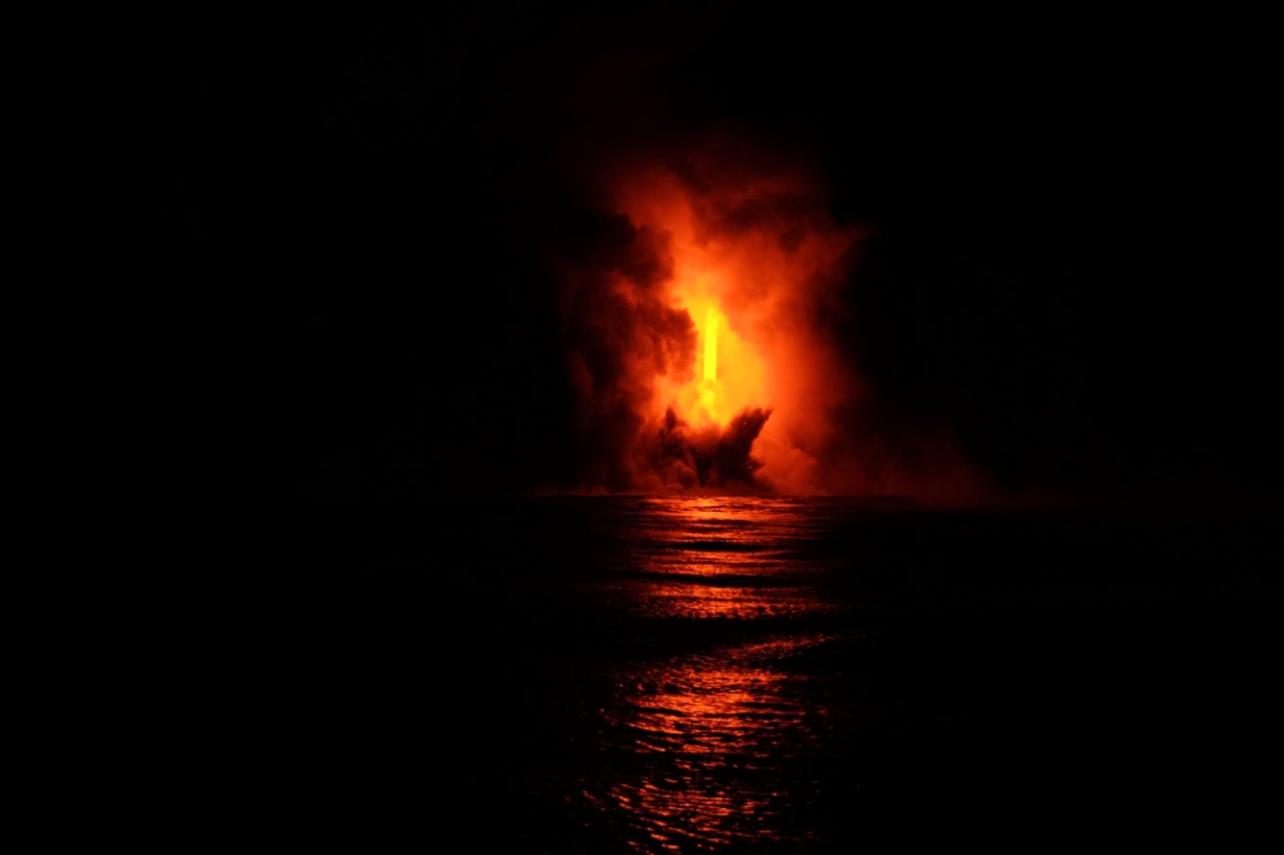  When the molten lava hits the cool seawater, it explodes. These explosions can throw large chunks of hot rock inland and seaward.  Tour boat captains whose vessels cruise along the shoreline are constantly watching the cliffs and lava to keep their passengers safe, said tour boat owner Shane Turpin. "We've never had an incident," he said. "We're always watching for what the cliff is doing. Is it moving? Are the rocks rolling down the cliff? We can actually see the changes throughout the day."  Turpin said the latest flow is "definitely the most dramatic firehose event I've ever witnessed." Turpin has been viewing such events for 30 years.  On land, the National Park Service is responsible for the safety of visitors along the shore. It has restricted the areas that people can enter to view the flow. However, Turpin said he frequently sees people on the cliff edge where they shouldn't be.  Cliff Edge Could Collapse Without Warning  The cliff edge is part of a large lava bench. Lava benches are ledges of land formed from cooling lava that sit above the level of the original shoreline. They can collapse at any time without warning. If someone was on the edge during a collapse, they would likely lose their life, said Cindy Orlando, the superintendent of Hawaii Volcanoes National Park.  Despite signs and roped-off areas, people still cross the boundaries and go to the edge of the cliffs near the lava flow, Orlando said.  Park rangers have issued tickets to people who cross into off-limits areas. However, it is nearly impossible to prevent everyone from breaking the rules, Orlando said.  One of the biggest concerns is a large "hot crack" in the rock above the firehose flow, said government geologist Janet Babb. The crack runs parallel to the sea cliff and makes the surrounding land likely to collapse. When the large delta collapsed on Dec. 31, it sent hot rocks and lava spatter flying into the air and giant waves outward.  "The seaward side of that crack could fall away," said Babb, who works at the Hawaii Volcano Observatory. "That is of great concern because if it does, it's going to drop a lot of hot rock into the water." Explosions will result once the hot rock mixes with cool seawater.  Steam Plume Is Equally Dangerous  The steam plume created by the lava reaching the water is also a concern. "It's super-heated steam laced with hydrochloric acid" and also contains "shards of volcanic glass," she said. "It's something to be avoided."  Babb said this firehose event is unusual because it has lasted so long. Usually when a flow opens up like this, the lava quickly builds new land below and plugs the entry.  "In this case, there's no evidence of a new delta forming," Babb said. Babb suspects this might be because the ocean floor along that stretch of coast is very steep. The lava is likely rolling down the incline, instead of pooling and forming new land along the shore.  Kilauea has been erupting continuously since 1983. The most recent vent flow that is reaching the ocean has been ongoing since last summer.  "There's no indication of it slowing down or stopping," Babb said.  Article from Newsela | Margin Notes  (my thoughts, reactions and questions; Facts vs Opinions; Causes/Effects; Summary; Writer’s Craft)  Margin Notes  (my thoughts, reactions and questions; Facts vs Opinions; Causes/Effects; Summary; Writer’s Craft)  Margin Notes  (my thoughts, reactions and questions; Facts vs Opinions; Causes/Effects; Summary; Writer’s Craft)

Comprehension Questions
- Using your highlighter, highlight the subtitle of the section where you find the idea that the lava flow is unique because it has been flowing for a long time?

Answer the following questions on looseleaf. Use complete sentences. Always include relevant supporting information from the text to support what you are saying.

- Explain HOW the lava flow started.

- Read the following sentence from the section "When Hot Lava Hits Cool Water ...
Boom!" Tour boat captains whose vessels cruise along the shoreline are constantly watching the cliffs and lava to keep their passengers safe, said tour boat owner Shane Turpin.
What is the BEST definition of the word "vessel" as used in the sentence? Explain.

- Read the following paragraph from the introduction [paragraphs 1-4].
The lava stream has been dubbed a "firehose" flow because it shoots lava outward from the source. It started out as a drizzle coming down the sea cliffs after the New Year's Eve collapse, but it has recently increased in strength. The molten lava is now arching out and falling about 70 feet to the ocean below.
Which word from the paragraph helps you to understand that the flow began with a small amount of lava and is now a much larger flow?
- What are two things we can learn from this extreme in nature?

