Student ____________________________ Class ____________ Due Date: ______________________
Instructions: COMPLETE ALL QUESTIONS AND MARGIN NOTES using the reading strategies practiced in class. This requires reading of the article three times.
Step 1: Read (skim) the article using these symbols as you read:
(+) agree, (-) disagree, (*) important, (!) surprising, (?) wondering
Step 2: Read the article carefully and make notes in the margin.
*** Your margin notes are part of your score for this assessment. Notes:
o Comments that show that you understand the article (A summary or statement of the main idea of important sections; inferences made)
o Connections you make (text-to-self, text-to-text, text-to-world)
o Questions you have - show what you are wondering about as you read.
o As needed - notes that differentiate between fact vs opinion, cause vs effect.
o Observations about the writer’s craft (organization, word choice, perspective, support/evidence) and choices affect the article.
Step 3: A final quick read noting anything you may have missed during the first two reads.
Step 4: Answer questions on looseleaf. Remember to use complete sentences and to always include details (the evidence) to support your answer.
Remember you are evaluated on all your work, annotations, margin notes, and question answers.
By Associated Press, adapted by Newsela staff on 02.08.17  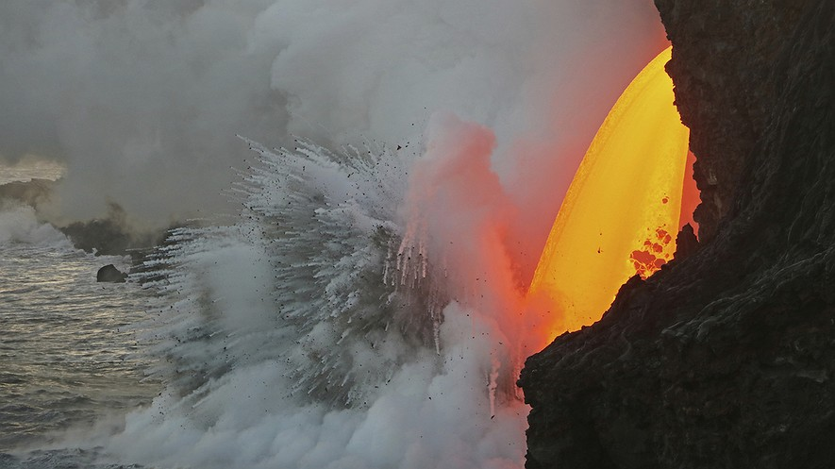  TOP: A January 29, 2017, photo provided by the U.S. Geological Survey shows a lava stream pouring out of a tube on the sea cliff at the Kamokuna ocean entry at Hawaii Volcanoes National Park on the Big Island of Hawaii. Photo from: U.S. Geological Survey via AP BELOW: Hawaiian Volcanoes National Park. Photo by: Anton Backer  HONOLULU, Hawaii  A giant stream of molten hot lava is shooting out of a sea cliff on Hawaii Island. The lava is pouring into the Pacific Ocean. It is exploding as soon as it hits the water.  Molten lava is rock that is so hot is has become liquid. It can erupt out of the mouth of volcanos. It can also pour out of natural tunnels known as lava tubes.  The huge new lava flow originates from within the Kilauea volcano. It is gushing from a lava tube exiting on the southeast side of the Big Island.  The tube was exposed when a huge lava delta broke off and fell into the ocean on New Year's Eve. A lava delta is new land formed when lava cools and becomes solid. The collapse of this delta triggered huge explosions and giant waves.  Firehose Lava Flow Shoots Outward  The lava stream is being called a "firehose" flow because it is shooting outward, like a hose. It started out as a drizzle coming down the sea cliffs, but it has recently increased in strength. The molten lava is now arching out up into the air. It is then falling about 70 feet to the ocean below.  When the molten lava hits the cool seawater, it explodes. These explosions can throw large chunks of hot rock inland and seaward. Tour boat captains are constantly watching the cliffs to keep their passengers safe, said tour boat owner Shane Turpin. "We're always watching for what the cliff is doing. Is it moving? Are the rocks rolling down the cliff?"  Turpin said the latest flow is the biggest firehose event he has ever seen. Turpin has been viewing such events for 30 years.  Park Service Has Restricted Areas For Viewing  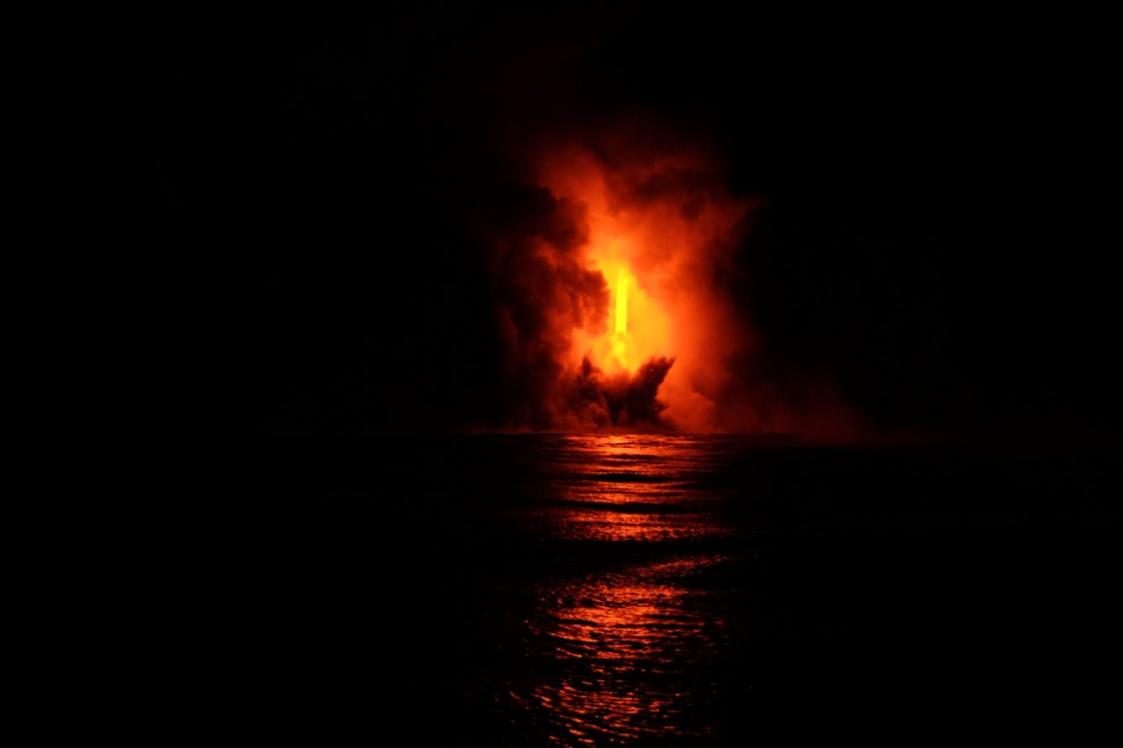  On land, the National Park Service is responsible for the safety of visitors along the shore. It has restricted the areas that people can enter to view the flow. However, Turpin said he frequently sees people on the cliff edge where they shouldn't be.  The cliff edge is part of a large lava bench. Lava benches are ledges of land formed from cooling lava. They sit on top of the original shoreline and can break off at any time without warning.  If people were on the edge as it broke off, they would likely lose their lives, Cindy Orlando said. Orlando is  the superintendent of Hawaii Volcanoes National Park.  Areas along the cliff are now roped off and danger signs have been posted. Even so, people are still going to parts of the cliff edge near the lava flow, Orlando said.  Park rangers have fined people who cross into off-limits areas. However, it is nearly impossible to prevent everyone from breaking the rules, Orlando said.  Hot Crack Makes It More Likely Surrounding Land Will Break Off  One of the biggest concerns is a large "hot crack" in the rock above the firehose flow, said government scientist Janet Babb. The crack runs parallel to the sea cliff. It makes the surrounding land likely to break off.  "The seaward side of that crack could fall away," Babb said. "That is of great concern because if it does, it's going to drop a lot of hot rock into the water." Explosions will result once the hot rock mixes with cool seawater.  The steam plume created by lava reaching the water is also a concern. "It's super-heated steam" and also contains "shards of volcanic glass," she said. "It's something to be avoided."  Firehose Keeps Going, Longer Than Expected  Babb said this firehose event is unusual because it has lasted so long. Usually when a flow opens up like this, the lava quickly builds new land below. The new land plugs the lava tube opening and stops the flow of molten lava.  This time, that doesn't seem to be happening, Babb said. Babb suspects the nearby ocean floor is very steep. Lava may be rolling away from the shore instead of building up.  Kilauea has been releasing lava continuously since 1983. So far, there is no sign of it slowing down, Babb said.  Article from Newsela | Margin Notes  (my thoughts, reactions and questions; Facts vs Opinions; Causes/Effects; Summary; Writer’s Craft)  Margin Notes  (my thoughts, reactions and questions; Facts vs Opinions; Causes/Effects; Summary; Writer’s Craft)  Margin Notes  (my thoughts, reactions and questions; Facts vs Opinions; Causes/Effects; Summary; Writer’s Craft)

Comprehension Questions
Answer the following questions on looseleaf. Use complete sentences. Always include relevant supporting information from the text to support what you are saying.

- What is a lava tube and what happened to expose the tube?

- Which sentence from the section "Park Service Has Restricted Areas For Viewing" shows a problem that the National Park Service is dealing with?

- Read the sentences below from the section "Firehose Keeps Going, Longer Than Expected".
The new land plugs the lava tube opening and stops the flow of molten lava.
What is the BEST definition of the word “plugs” as used in the sentence above? Explain.

- Read the section "Hot Crack Makes It More Likely Surrounding Land Will Break Off".
Janet Babb said that the steam from the lava has "shards of volcanic glass."
Explain what Babb meant by "shards of volcanic glass."?

- What are two things we can learn from this extreme in nature?

