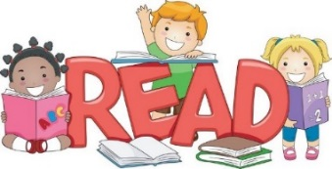
Dear Grade 1 Parents/Guardians,
On Mondays, students will be sent home with an appropriate book or two in their communication folders for the week. Your child will choose “just right” books from our classroom library.
Please keep the book(s) at home for the week. Read when you can! Please return the books in their communication folder on Monday.
If books are not returned, new books cannot be sent home. Please remember that these books are used by all students and are expensive to replace
If you receive the same book a few times, it is okay! Reading a book several times can help improve sight word recognition, fluency (reading smoothly) and can make your child feel good about knowing a book well!
How Parents Participate in the Home Reading Program
- You read the book to your child.
- You read and your child echoes back the words – pointing to each word.
- Listen to your child read the book(s).
- Have your child reread the book multiple times throughout the week.
- Look for repeating sentence patterns/predictability to help!
- Encourage your child to point to each word as they read with his/her dominant hand.
- Practice sight words (high frequency words such as: it, in, the, is, and, like, etc)
- Encourage your child to use reading strategies:
  - Eagle Eye (use picture clues)
  - Lips the Fish (look at the beginning sound!)
  - Stretchy Snake (stretch out what you see)
- Talk about the book after they have read it! Understanding what they have read is as important as reading the words!
This is a huge step in your child’s learning! It is important they practice each night in order for them to feel successful!
Thank you for your support. Please don’t hesitate to contact me with any questions!
Miss. Gorman

