Amphibian ID Workshop & Night Hike |  |  | Join conservation biologist and educator Rachel Rommel for a family friendly workshop and an evening nature walk to search for frogs and salamanders. Learn about the biology and conservation of this amazing group of animals, how to identify native species by sight and sound, and how individuals can participate in “citizen-science” by documenting calls and sightings.
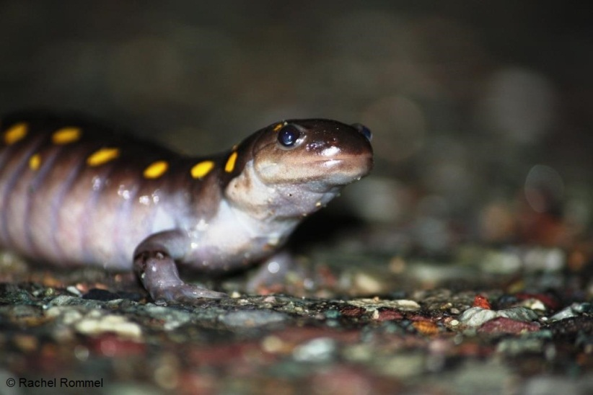
Bring a flashlight or headlamp if you wish to take part in the search after dark. Families and all who are interested in learning more about amphibians are invited to attend.

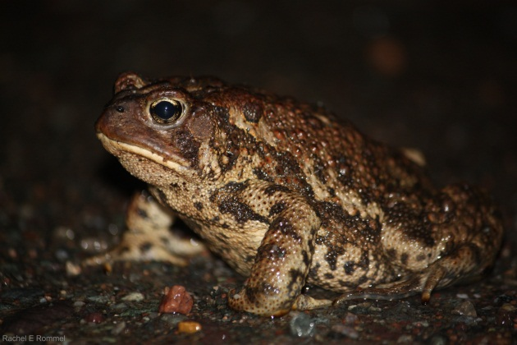
 |  | Date: Sunday, May 17, 2015  Time: Workshop at 6:00pm  Guided Hike at 7:00pm  Location: Interpretation Centre |  |  | Space is limited,  please call 658-2883 or  email connie.browne@saintjohn.ca  to reserve a seat.

