January 23, 2018

Dear Parents/Guardians of Students at Hazen-White/St. Francis School:

On January 10, 2018 the Anglophone South School District Education Council (DEC) voted in favour of engaging in a sustainability study under the process outlined in the Department of Education and Early Childhood Development Provincial Policy 409: Multi-year Infrastructure Planning.

The sustainability study follows a process that includes three public meetings. The first public meeting for Hazen-White/St. Francis will be held on Tuesday, February 20th at 6:30 pm at the school. This meeting will be for a presentation of facts about the school and information on the proposal the DEC is considering. The second public meeting will be held in March and will allow for interested individuals, stakeholders and parties to present information to be considered in the decision-making process. A registration process for this meeting will be shared following the first meeting.

The third public meeting will occur on April 11, 2018 at the regular monthly meeting of the District Education Council in the Saint John Office.

If the DEC recommendation is to close Hazen-White/St. Francis School, the Minister of Education and Early Childhood Development must approve the decision. The DEC’s proposal is for a new K to 5 school to replace Centennial and Hazen-White/St. Francis.

Policy 409 can be found by going to the Government of New Brunswick website (www.gnb.ca) and choosing the Department of Education and Early Childhood Development site under “Departments”. Under the title, “Information”, you can choose “Policies”, and this will bring you to a selection of policies, including Policy 409. The direct link to the Policy is http://www.gnb.ca/0000/policies.asp .

This information will be in the media so we wanted to provide this letter to explain the process and timeline. More information will be available at the meetings.

Yours truly,

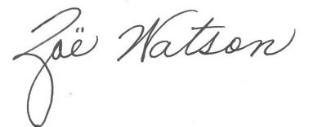
Zoë Watson
Superintendent

/cmm
Copy: Debbie Thomas, Director of Schools, Saint John Education Centre

