CELEBRATE!

June: Being Respectful

|  |  |  |  |
| --- | --- | --- | --- |
| **Roll & Respond Dice Activity \*** | **Respect Quilt \*** | **Compliment**  **Challenge \*** | **Respect Cards \*** |
| **Respect Chain \*** | **What does the “Golden Rule” look like in our school?** | **Bumper Sticker \*** | **Create a tweet about Respect** |
| **Complete ‘Being respectful is important because…’** | [**Peaceful Schools International website - many ideas!**](http://peacefulschoolsinternational.org/) | **Create a recipe for Respect \*** | **Campaign Poster \*** |
| **Watch Sesame Street**  [**Word on the Street**](https://www.youtube.com/watch?v=GOzrAK4gOSo) **and have a discussion about RESPECT** | **Interview Activity \*** | **Role Plays \*** | **Create a RESPECT Acrostic Poem** |

Resources (*)

Roll & Respond Dice Activity:

Play- “Roll and Respond about Respect” to start a conversation about respect.

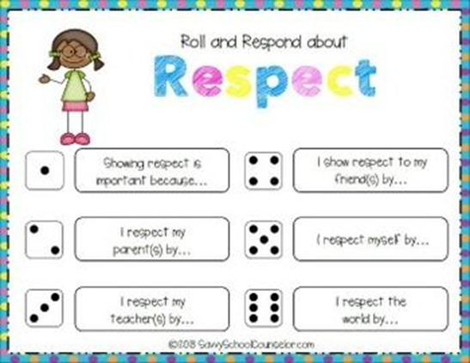

Respect Quilt:

[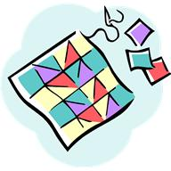](javascript:void(0))Encourage students to brainstorm ideas that demonstrate respect at school, home and in the community. Using squares of white fabric, or paper, have each student decorate a square with their respect idea. Hang the quilt in a prominent place in the classroom or school.

Respect Recipe:

Create your own recipe card for Respect. What ingredients are needed for your recipe? Are there specific instructions for your recipe?

Respect Cards:

This template, found on this [link](http://www.pbis.org/common/cms/files/student/lesson%20plans/studentrespecteachother.pdf), can be used by students to catch others being respectful and rewarding them with this ticket. These tickets can be displayed in the classroom or in the school.

**Thanks for Showing RESPECT!**

**I saw one of my classmates showing respect! **

**This is what I saw:**

**________________________________________________________________________________________________________________________________________________________________**

Respect Chain:

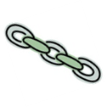 This can be a whole-school or classroom activity. Ask students to consider what they will do this year to be respectful. Pass out different-coloured strips of construction paper. Encourage students to find someone in their class to share what they plan to do to be respectful and they can staple their links together to form a chain. This pair then finds another group to discuss their ideas. This continues until all strips are joined.

Compliment Challenge:

Challenge each student to give a sincere compliment to someone every day. Create a weekly planner that will help them track their behaviour. Each day they must write who they gave the compliment to and describe their reaction.

Bumper Sticker:

Have students design a bumper sticker about respect. Have them include on the bumper sticker: the word Respect, a logo or slogan for why we should use it and at least three words that describe it.

Campaign Poster:

Have students create a campaign poster about respect. Have them include the word “Respect” and two reasons why someone would want to vote for having ‘respect’ at school. Materials include construction paper, felt pens, crayons, magazine cut-outs and templates.

Role Plays:

Have students create and act out scenarios that show respectful ways to act. Have them create scenarios for the different areas of the school. Video the role plays for further discussion.

Public Service Announcements:

Have students write and record PSAs on respect that could be used over the school intercom or at the local radio station.

Interview Activity:

Interview someone and ask what one way to show respect to another person is. Write about it.